Trend Analysis of Competitive Success in the Physical Education Games at Thailand National Sports University, Sisaket Campus

Nantawan Tongpitak
Faculty of Education, Thailand National Sports University, Sisaket Campus,Thailand

Abstract
Institutional competitive success in inter-university sport competitions is commonly reported through single-edition rankings and medal counts, which offer limited insight into whether an institution's performance is genuinely improving over time. This study analyzed the trend in competitive success achieved by Thailand National Sports University (TNSU), Sisaket Campus, in the Physical Education Games across the 41st through 48th editions (2016–2025). The objectives were to (1) determine the level of competitive success achieved across these eight editions, (2) analyze the trend in overall ranking and in gold, silver, bronze, and total medal counts, and (3) compare performance between the 41st–44th and 45th–48th Games. It was hypothesized that TNSU Sisaket Campus has shown an upward trend in its ranking at the Physical Education Games. Using a retrospective longitudinal design, official competition-result records were analyzed using descriptive statistics, percentage change, simple linear regression, the non-parametric Mann-Kendall trend test, Sen's slope estimator, and independent-samples t-tests comparing the two four edition periods. Results showed a statistically significant improving trend in overall ranking (b = −1.36 places per edition, R² = .647, p = .016; Mann-Kendall Z = −2.04, p = .042) and a statistically significant increasing trend in total medal count (b = 12.83 medals per edition, R² = .835, p = .002; Mann-Kendall Z = 2.64, p = .008), with silver and bronze medals also showing significant increases. A marked structural shift occurred between the 44th and 45th Games, after which performance rose sharply and was subsequently sustained: mean overall ranking improved from 12.75 to 5.75, and mean total medal count more than doubled, from 55.0 to 117.5, between the 41st–44th and 45th–48th Games (t(6) = 5.23 and 9.93 respectively, both p < .01). These converging results support the research hypothesis and indicate a genuine and durable, rather than transient, improvement in TNSU Sisaket Campus's competitive standing. The findings offer an evidence-based basis for athlete-development planning and resource allocation and demonstrate the value of longitudinal, multi-method trend analysis for evaluating institutional sporting performance.

Keywords: Competitive success, Trend analysis, Physical Education Games, Athletic performance,
Longitudinal analysis

Corresponding Author: Nantawan Tongpitak, Faculty of Education, Thailand National Sports University,
Sisaket Campus, Thailand, Email: ts.nantawan@gmail.com
Introduction
Inter-institutional sport competitions occupy a central place in the mission of physical education institutions, serving simultaneously as a platform for athletic talent development, an indicator of institutional sporting capacity, and a symbolic marker of organizational prestige (De Bosscher, Shibil, Westerbeek, & Van Bottenburg, 2015). Among the ranking criteria commonly used to represent competitive standing, the total medal count disaggregated into gold, silver, and bronze has long been treated as a proxy for sporting achievement at both national and institutional levels, largely because medal tallies are transparent, comparable across editions, and readily available in official competition records (Den Butter & Van Der Tak, 1995). At the same time, a single-edition medal count offers only a static snapshot; it cannot reveal whether an institution's competitive position is improving, declining, or stagnating over time. Understanding sporting performance therefore requires a longitudinal perspective that tracks results across multiple consecutive competition cycles rather than relying on isolated outcomes from a single event (Nijenhuis, Koopmann, Mulder, Elferink-Gemser, & Faber, 2024).
The Physical Education Games is a biennial, national level multi-sport competition held among physical education and sport-science institutions in Thailand, including the various campuses of the Thailand National Sports University (TNSU). For TNSU Sisaket Campus, participation in the Physical Education Games represents both a training outcome and a strategic priority, as consistent competitive success is closely tied to the campus's reputation, its ability to attract prospective student-athletes, and the effectiveness of its athlete development programs. However, despite the campus's long history of participation spanning the 41st through the 48th editions of the Games there has been no systematic, data-driven examination of how its competitive performance has evolved across this period. Coaches, administrators, and sport-science staff at the campus therefore currently lack an empirically grounded picture of whether recent investments in training and athlete development have translated into measurable gains in competitive standing. This study addresses that need by analyzing eight consecutive editions of competition results to identify the trend in TNSU Sisaket Campus's overall ranking, medal composition, and total medal count, and by comparing performance between an earlier period (41st–44th Games) and a more recent period (45th–48th Games).
(Ramchandani & Wilson, 2013) Research on competitive sporting success has traditionally approached the topic from two complementary directions: the identification of the determinants that produce success, and the empirical tracking of performance trends over time. Determinants of competitive success. (De Bosscher, De Knop, Van Bottenburg, & Shibli, 2006) proposed an influential conceptual framework later developed into the Sports Policy factors Leading to International Sporting Success (SPLISS) model that clusters more than one hundred success factors into nine policy "pillars," including financial support, governance structures, talent identification and development systems, athletic and post-career support, training facilities, coaching provision, and competition opportunities (De Bosscher et al., 2006; De Bosscher et al., 2015). This framework has since been applied and validated across numerous national contexts, demonstrating that sustained sporting success is rarely attributable to a single cause but instead emerges from the cumulative interaction of macro-level factors (such as population size and available resources) and meso-level, policy-controllable factors such as coaching quality and structured competition pathways (De Bosscher et al., 2006). Complementing this, (Emrich, Klein, Pitsch, & Pierdzioch, 2012) examined the statistical determinants of Olympic medal success and reinforced the view that medal outcomes reflect underlying systemic investment rather than short term fluctuation alone. (Den Butter & Van Der Tak, 1995) further established medal counts as a practical, widely used indicator of collective sporting welfare and achievement, providing methodological justification for using medal tallies as the core outcome variable in performance-tracking research.
Longitudinal and trend-based approaches to performance analysis. (Ganse, Kleerekoper, Knobe, Hildebrand, & Degens, 2020) A separate but closely related body of literature emphasizes that sporting performance should be examined longitudinally rather than through cross-sectional snapshots, since athletic development and institutional competitiveness unfold gradually across multiple cycles. (Nijenhuis et al., 2024), in a systematic review of talent identification and development research, found that longitudinal and multidimensional designs provide substantially more valid insight into performance progression than single-point assessments, because they capture the trajectory of change rather than an isolated result (Leyhr, Kelava, Raabe, & Höner, 2018). Similarly, in an eight-year prospective study of talented soccer players, demonstrated that tracking performance across repeated measurement points allows researchers to detect genuine developmental trends and to distinguish sustained improvement from short term variability. Applied to an institutional rather than individual level, this same logic supports analyzing an institution's ranking and medal outcomes across several consecutive competition editions as opposed to a single Games to draw valid conclusions about whether a genuine upward, downward, or stable trend exists (Zheng et al., 2024). Taken together, this literature indicates two things relevant to the present study first, that competitive success is a multidimensional outcome best represented through composite indicators such as overall ranking alongside gold, silver, bronze, and total medal counts; and second, that meaningful conclusions about performance trends require longitudinal data spanning multiple competition cycles rather than isolated results (Bačík, 2021; Nassif, 2018).
While the SPLISS framework and related studies have generated a robust understanding of the determinants of sporting success at the national and elite athlete level and while sport science research has established the methodological value of longitudinal trend analysis for tracking developmental this body of knowledge has been developed primarily in the context of national Olympic systems, professional talent academies, or individual athletes in Western sporting contexts (De Bosscher et al., 2006; Leyhr et al., 2018). Comparatively little empirical attention has been paid to institutional-level, longitudinal trend analysis within Thailand's domestic inter-university and inter-institutional physical education competition system. Specifically, no prior study has systematically documented and analyzed the trend in overall ranking, medal composition, and total medal count achieved by a single Thai physical-education institution such as TNSU Sisaket Campus across a substantial multi-edition span of the Physical Education Games, nor compared performance between distinct competition periods to test whether a statistically or descriptively meaningful upward trend exists. This represents institutional decision-makers at TNSU Sisaket Campus currently have no longitudinal, evidence-based account of their own competitive trajectory across the 41st–48th Games on which to base future athlete-development and resource-allocation decisions. The present study addresses this gap directly.
Building on the identified gap, in line with the literature reviewed above, the study is guided by the hypothesis that TNSU Sisaket Campus has shown an upward trend in its ranking at the Physical Education Games. This study contributes to the literature in three ways. First, it extends the application of longitudinal trend analysis methodology previously used mainly in individual athlete talent development research (Leyhr et al., 2018; Nijenhuis et al., 2024) to the institutional level within a Thai physical-education context, an application that has received little prior empirical attention. Second, it provides TNSU Sisaket Campus administrators, coaches, and sport-science staff with an evidence-based account of the campus's competitive trajectory that can directly inform athlete-development planning, resource allocation, and strategic goal-setting for future editions of the Games. Third, by comparing two distinct four-edition periods, the study offers a replicable analytical approach that other physical education institutions both within TNSU's other campuses and in comparable universities can adopt to monitor and benchmark their own competitive development over time.

Research objectives
1. To examine the level of competitive success achieved by TNSU Sisaket Campus in the Physical Education Games from the 41st through the 48th editions.
2. To analyze the trend in overall ranking, gold, silver, and bronze medal counts, and total medal count across these eight editions.
3. To compare competition outcomes between the earlier period (41st–44th Games) and the more recent period (45th–48th Games)

Hypothesis
Thailand National Sports University, Sisaket Campus, is trending towards a higher ranking in the Physical Education Games.

Research Methods
The methodology of this study was designed specifically to address the three research objectives 1 to establish the level of competitive success achieved by Thailand National Sports University (TNSU), Sisaket Campus, in the Physical Education Games from the 41st to the 48th editions, 2 to analyze the trend in overall ranking and medal counts across these editions, and 3 to compare performance between the 41st–44th and 45th–48th Games and to provide a rigorous empirical test of the research hypothesis that TNSU Sisaket Campus has shown an upward trend in its ranking at the Physical Education Games. Because both the objectives and the hypothesis are inherently longitudinal in nature concerned with change across competition editions rather than performance at any single edition the methodology was built around repeated-measures trend-analysis techniques rather than a single cross-sectional comparison.
Research design
In order of the study, a retrospective longitudinal descriptive design was adopted, using eight consecutive editions of official competition results (the 41st–48th Physical Education Games) as repeated time-ordered observations of TNSU Sisaket Campus's competitive performance. This design was selected because evaluating a trend as opposed to a single outcome requires ordered, repeated observations that allow year-on-year (or edition-on-edition) change to be modeled explicitly (Hughes & Bartlett, 2002). The retrospective longitudinal approach therefore aligns directly with the study title ("Trend Analysis of Competitive Success") and provides the only design capable of empirically confirming or disconfirming the hypothesized upward trend in ranking.
Data Source and Scope of the Study
Data were obtained from the official competition-result summary records of the Physical Education Games maintained by TNSU Sisaket Campus, covering eight editions the 41st through the 48th Games spanning the years 2016 to 2025 (B.E. 2559–2568). No competition was held in 2020–2021 due to the COVID-19 pandemic, creating an irregular gap in the calendar-year sequence. To prevent this gap from distorting the estimated rate of change, the study used the sequential competition order (coded 1–8, representing the 41st–48th Games), rather than calendar year, as the time variable in all trend analyses. This decision ensures that reported slopes and rates of change are interpreted correctly as change per competition edition, not change per calendar year.
Variables and Operational Definitions
In this research, the variables used in the study were identified and defined as shown in
Table 1.

Table 1. Testing Indicators and Representative Qualities
Variable | Operational Definition
Competitive success | The outcome achieved by TNSU Sisaket Campus at each edition of the Games, measured through overall ranking and total medal count.
Gold / Silver / Bronze medals | The campus's placement relative to all competing institutions; a lower numerical value indicates a higher level of success.
Overall ranking | The number of medals of each type won by the campus at each edition.
Total medals | The sum of gold, silver, and bronze medals won at each edition.
Competition sequence | A value from 1 to 8 representing the 41st–48th Games in chronological order; used as the time variable in all trend analyses.

Data Verification
Prior to analysis, the completeness and internal consistency of the dataset were verified by independently recomputing the total medal count for each edition as the sum of its reported gold, silver, and bronze medals, and cross-checking this recomputed value against the officially reported total. All eight editions of data were found to be fully consistent. The verified data were then compiled into a structured dataset and checked a second time before proceeding to statistical analysis, minimizing the risk of transcription or reporting error affecting the trend estimates.
Data Analysis
To capture both the overall pattern of performance and the statistical strength of any trend, six complementary analytical techniques were applied, each contributing to a different aspect of the three research objectives:
Descriptive statistics. The mean, standard deviation, minimum, maximum, and coefficient of variation were calculated for overall ranking and for each medal category, in order to characterize the general level and variability of performance across the eight editions (Objective 1).
Percentage change. The edition-to-edition percentage change in total medals was calculated as [(current-edition value − previous-edition value) / previous-edition value] × 100, allowing fluctuations between consecutive Games to be identified and quantified (Objective 1).
Simple linear regression. A linear trend model (Y = a + bX), where Y represents the competition outcome (ranking or medal count) and X represents the competition sequence (1–8), was fitted to estimate the average rate of change per edition and to test whether this rate of change was statistically significant (Objective 2).
Mann-Kendall trend test. Because linear regression assumes a strictly linear relationship and is sensitive to outliers, the non-parametric Mann-Kendall test was additionally applied to verify whether a statistically significant monotonic (consistently increasing or decreasing) trend existed, independent of the assumption of linearity, at a significance level of .05 (Kendall, 1975; Mann, 1945). Using both a parametric (regression) and a non-parametric (Mann-Kendall) test provided converging evidence for the trend and reduced the risk that the conclusion depended on the statistical assumptions of a single method directly strengthening the test of the research hypothesis (Objective 2).
Sen's slope estimator. To obtain a robust, outlier-resistant estimate of the magnitude of the trend, Sen's slope estimator the median of all pairwise rates of change (Yj − Yi) / (Xj − Xi) for every pair of editions where j > i was calculated together with its 95% confidence interval, providing a more conservative and reliable estimate of the true rate of change per edition than linear regression alone (Sen, 1968) (Objective 2).
Period comparison (41st–44th vs. 45th–48th Games). Finally, the mean overall ranking and mean medal counts of the first four editions (41st–44th Games) were compared with those of the most recent four editions (45th–48th Games), providing a direct, interpretable test of whether competitive success in the more recent period exceeded that of the earlier period (Objective 3).
Together, this combination of descriptive, parametric, non-parametric, and period-comparison techniques allowed the study to characterize not only whether a trend existed, but also its direction, magnitude, statistical reliability, and consistency across two independent estimation approaches providing a comprehensive and methodologically robust test of the hypothesis that TNSU Sisaket Campus has shown an upward trend in its ranking at the Physical Education Games.

Results
The results are presented in six parts, corresponding to the study's three objectives: the raw competition-results dataset descriptive statistics characterizing the overall level of competitive success (Objective 1) edition-to-edition percentage change trend analysis using linear regression, the Mann-Kendall test, and Sen's slope estimator (Objective 2) and comparison of performance between the 41st–44th and 45th–48th Games (Objective 3). Summarizes the findings in relation to the research hypothesis.
Competition Results Data
Table 2. Overall Ranking and Medal Counts of TNSU Sisaket Campus at the Physical Education Games, 41st–48th Editions
Edition | Year (C.E.) | Overall Ranking | Gold | Silver | Bronze | Total Medals
41st | 2016 | 12 | 13 | 11 | 27 | 51
42nd | 2017 | 15 | 6 | 21 | 24 | 51
43rd | 2018 | 12 | 11 | 22 | 26 | 59
44th | 2019 | 12 | 13 | 19 | 27 | 59
45th | 2022 | 5 | 31 | 30 | 42 | 103
46th | 2023 | 8 | 29 | 50 | 42 | 121
47th | 2024 | 3 | 44 | 47 | 40 | 131
48th | 2025 | 7 | 24 | 32 | 59 | 115
Note. No competition was held in 2020–2021 due to the COVID-19 pandemic.

A lower value for Overall Ranking indicates a higher level of competitive success. Sequential competition order (1–8) rather than calendar year was used as the time variable in all subsequent trend analyses. As shown in Table 2, TNSU Sisaket Campus's overall ranking ranged from a low point of 15th place (42nd Games, 2017) to a high point of 3rd place (47th Games, 2024). Total medal count ranged from 51 medals (41st and 42nd Games) to 131 medals (47th Games). Descriptively, the four most recent editions (45th–48th Games) show a markedly stronger competitive position single digit rankings and total medal counts exceeding 100 compared with the four earliest editions (41st–44th Games), in which rankings remained in the 12th–15th range and total medals did not exceed 59.
Descriptive Statistics of Competitive Performance
Table 3. Descriptive Statistics for Overall Ranking and Medal Counts Across the 41st–48th
Games (N = 8)
Indicator | M | SD | Min | Max | CV (%)
Overall Ranking | 9.25 | 4.13 | 3 | 15 | 44.67
Gold Medals | 21.38 | 12.84 | 6 | 44 | 60.07
Silver Medals | 29.00 | 13.69 | 11 | 50 | 47.21
Bronze Medals | 35.88 | 12.09 | 24 | 59 | 33.70
Total Medals | 86.25 | 34.41 | 51 | 131 | 39.89

Across the eight editions, TNSU Sisaket Campus achieved an average overall ranking of 9th place (SD = 4.13) and an average total medal count of 86.25 medals per edition (SD = 34.41). The coefficient of variation was highest for gold medals (60.07%) and lowest for bronze medals (33.70%), indicating that gold-medal performance fluctuated relatively more across editions than bronze-medal performance, while the overall medal total showed moderate variability (CV = 39.89%) consistent with a systematically changing rather than randomly fluctuating pattern over time.

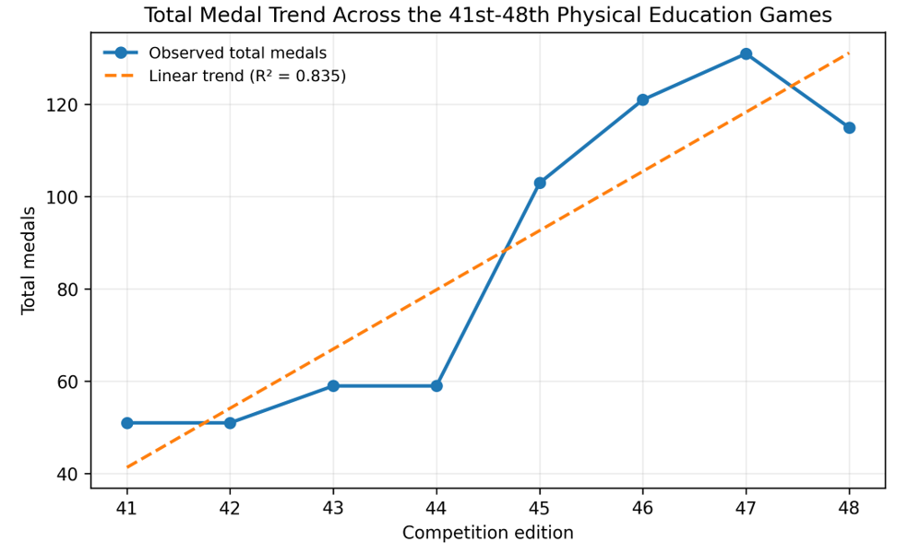

Figure 1. Total Medal Trend and Linear Regression Model Across the 41st–48th Physical
Education Games.
Figure 1. Evaluate the campus's athletic progression over time, the observed total medal counts from each competition edition were plotted chronologically and fitted with a linear regression model. Descriptive tracking reveals a clear, multi-phase growth trajectory. The Baseline Phase (41st–42nd Games). The Sisaket Campus maintained a steady baseline with a total of 51 medals won in both the 41st and 42nd editions. The Incremental Growth Phase (43rd–44th Games). Performance experienced a minor positive shift, stabilizing at 59 total medals during both the 43rd and 44th editions. The Expansion Phase (45th–47th Games). A major inflection point occurred between the 44th and 45th editions. Total medals grew rapidly from 59 (44th games) to 103 (45th games), followed by sustained increases to 121 medals (46th games) and peaking at 131 medals (47th games). The Stabilization Adjustment (48th Games). In the 48th edition, the total medal count saw a minor contraction to 115 medals, though it remained substantially higher than any total achieved during the first four editions under review. To determine the overall trajectory, a linear trendline was calculated. The regression analysis yielded a coefficient of determination of $R^{2}$ = 0.835. Statistically, this indicates that 83.5% of the variance in total medal counts is explained by the chronological progression of the tournament editions. This high value confirms a highly robust, statistically reliable upward trend in athletic performance over the eight-edition period.

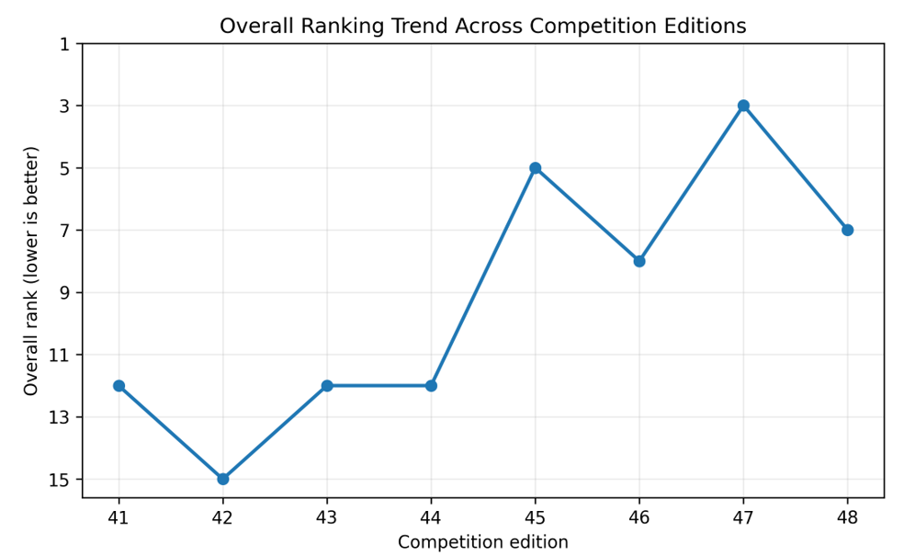

Figure 2. Overall Institutional Ranking Trajectory Across the 41st–48th Physical
Education Games.

The longitudinal tracking displays a clear distinction between the first four editions and the subsequent four editions, pointing to a major structural shift in competitive standing. The Low-Tier Stabilization Phase (41st–44th Games): During the early editions, the Sisaket Campus consistently finished outside the top ten. The campus launched its trajectory at 12th place in the 41st games before dropping to its lowest historical position of 15th place in the 42nd games. In the 43rd and 44th editions, the performance stabilized at a constant 12th place rank.
The High-Tier Breakthrough Phase (45th–48th Games): The 45th edition marked a major turning point, with the campus surging into the upper tier of the competition by claiming 5th place. Although the 46th games saw a minor setback to 8th place, the campus quickly rebounded in the 47th games to secure its highest historical rank at 3rd place overall. The final observed period (48th games) settled at 7th place, cementing the campus's position within the top tier.
The ranking data strongly validates the research hypothesis. The historical records reveal that the TNSU Sisaket Campus did not just experience temporary fluctuations; instead, it achieved a structural shift from a lower-tier standing (averaging ~13th place) to a consistent top-tier competitive presence (averaging ~6th place). This clear upward trajectory in overall rankings matches the rapid expansion observed in the total medal counts.

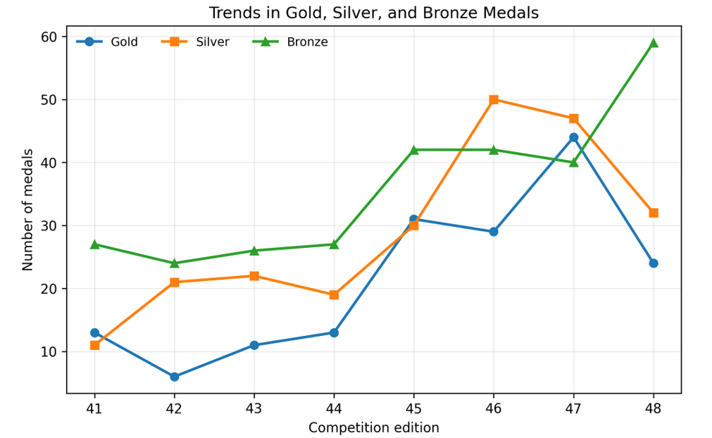

Figure 3. Individual Trajectories for Gold, Silver, and Bronze Medals Across the
41st–48th Physical Education Games.

The longitudinal tracking shows distinct performance patterns within each medal category. During the early era (41st–44th games), Gold medals remained low and variable, fluctuating between a minimum of 6 (42nd games) and a maximum of 13 (41st and 44th games). A major breakthrough occurred in the 45th games, with Gold medals climbing to 31, followed by a peak of 44 Golds in the 47th games. The 48th games saw a downward correction to 24 Gold medals.
Silver medals showed early stability, hovering around 11 to 22 medals during the 41st–44th games. In the recent era, Silver medal performance surged, reaching 30 in the 45th games and peaking at 50 in the 46th games. The count adjusted downward to 32 by the 48th games.

Bronze medals consistently formed the foundation of the campus's medal tallies. In the early block, Bronze counts remained remarkably steady, staying between 24 and 27 medals. In the recent block, Bronze counts experienced a step-like expansion, holding at 42 and 40 medals during the 45th–47th games before surging to an all time high of 59 medals in the 48th edition.
The data reveals a clear structural evolution in performance. In the early era, the campus relied heavily on a Bronze-dominated distribution (Bronze > 73 Silver > 43 Gold), indicating a baseline presence but a limited ability to win top-tier events. In contrast, the recent block shows a more balanced, high-performing distribution (183 Bronze : 159 Silver : 128 Gold), proving that the campus developed greater competitive depth across multiple disciplines. The unique pattern in the 48th games where Gold and Silver counts dipped while Bronze medals surged to a record high of 59 suggests a transition period. During this tournament, many elite athletes placed on the podium but finished third rather than securing first or second place. This indicates that while the campus maintained high overall competitiveness, it faced tougher opposition in championship finals.
Edition-to-Edition Percentage Change in Total Medal Count
Table 4. Percentage Change in Total Medal Count Between Consecutive Editions
Transition | Total Medals  (Previous → Current) | % Change
41st → 42nd | 51 → 51 | 0.00%
42nd → 43rd | 51 → 59 | +15.69%
43rd → 44th | 59 → 59 | 0.00%
44th → 45th | 59 → 103 | +74.58%
45th → 46th | 103 → 121 | +17.48%
46th → 47th | 121 → 131 | +8.26%
47th → 48th | 131 → 115 | −12.21%

The percentage-change analysis reveals a distinct structural shift between the 44th and 45th Games, where total medal count increased by 74.58% the single largest change observed across the eight editions. Following this shift, the campus sustained a substantially higher medal output through the 46th and 47th Games, with only one interim decline (−12.21%) recorded between the 47th and 48th Games. This pattern suggests that competitive gains achieved from the 45th Games onward were largely sustained rather than transient.
Trend Analysis
To rigorously test for the presence, direction, magnitude, and statistical significance of a trend across the eight competition editions, three complementary analytical techniques were applied: simple linear regression, the non-parametric Mann-Kendall trend test, and Sen's slope estimator.

Mann-Kendall Trend Test
Table 5 Mann-Kendall Non-Parametric Trend Test Results
Indicator | S | Var(S) | Z | p | Trend
Overall Ranking | −17 | 61.67 | −2.04 | .042 | Significant decreasing (improving)
Gold Medals | +15 | 64.33 | 1.75 | .081 | Increasing (not significant)
Silver Medals | +18 | 65.33 | 2.10 | .035 | Significant increasing
Bronze Medals | +18 | 63.33 | 2.14 | .033 | Significant increasing
Total Medals | +22 | 63.33 | 2.64 | .008 | Significant increasing

Because linear regression assumes a strictly linear relationship and is sensitive to outliers, the non-parametric Mann-Kendall test was applied as a robustness check that does not require this assumption (Kendall, 1975; Mann, 1945). The results converge closely with the regression findings: overall ranking showed a statistically significant improving (decreasing) trend (Z = −2.04, p = .042), and total medal count showed a statistically significant increasing trend (Z = 2.64, p = .008) — the strongest and most reliable trend among all indicators tested. Silver and bronze medals likewise showed statistically significant increasing trends (p = .035 and p = .033, respectively), while the increasing trend in gold medals, though directionally consistent with the other indicators, did not reach statistical significance under this more conservative test (Z = 1.75, p = .081).

Sen's Slope Estimator
Table 6. Sen's Slope Estimator for Rate of Change per Competition Edition
Indicator | Sen's Slope (per edition) | Interpretation
Overall Ranking | −1.33 | Ranking improves by ≈1.3 places per edition
Gold Medals | +4.00 | Gold medals increase by ≈4.0 per edition
Silver Medals | +4.38 | Silver medals increase by ≈4.4 per edition
Bronze Medals | +4.04 | Bronze medals increase by ≈4.0 per edition
Total Medals | +13.17 | Total medals increase by ≈13.2 per edition

Sen's slope estimator, a robust median-based measure less sensitive to outlier editions than ordinary least-squares regression (Sen, 1968), produced rate-of-change estimates closely consistent with the regression slopes reported in Table 4 (e.g., ranking: −1.33 vs. −1.36 total medals: +13.17 vs. +12.83). This agreement across two methodologically distinct estimation approaches one parametric and sensitive to all data points, one non-parametric and robust to outliers provides converging evidence that the estimated rates of improvement reflect a genuine underlying trend rather than an artifact of any single extreme edition.

Comparison Between the 41st–44th and 45th–48th Games
Table 7. Comparison of Mean Performance Between the Earlier Period (41st– 44th Games) and the Recent Period (45th–48th Games)
Indicator | M (41st–44th) | M (45th–48th) | Mean Difference | % Change | t(6) | p
Overall Ranking | 12.75 | 5.75 | −7.00 | −54.9% | 5.23 | .002
Gold Medals | 10.75 | 32.00 | +21.25 | +197.7% | −4.65 | .004
Silver Medals | 18.25 | 39.75 | +21.50 | +117.8% | −3.78 | .009
Bronze Medals | 26.00 | 45.75 | +19.75 | +76.0% | −4.39 | .005
Total Medals | 55.00 | 117.50 | +62.50 | +113.6% | −9.93 | <.001
Note. Independent-samples t-tests (equal variance assumed, df = 6). For Overall Ranking, a negative mean difference indicates improvement.

The period comparison provides the most direct test and confirms the pattern identified of all result. Average overall ranking improved from 12.75 in the 41st–44th Games to 5.75 in the 45th–48th Games, a statistically significant improvement of 7.0 places (t(6) = 5.23, p = .002). Total medal count more than doubled, rising from a mean of 55.0 to 117.5 medals (t(6) = −9.93, p < .001), a 113.6% increase. All three medal categories individually showed statistically significant increases between the two periods (all p < .01), with the largest relative gain observed in gold medals (+197.7%).

Discussion and Conclusion
Interpretation of Findings
This study set out to determine the level of competitive success achieved by TNSU Sisaket Campus in the Physical Education Games from the 41st to the 48th editions, to analyze the trend in overall ranking and medal counts across these editions, and to compare performance between the 41st–44th and 45th–48th Games, in order to test the hypothesis that the campus has shown an upward trend in its ranking. All data collected across these eight editions converge on a single, consistent conclusion.
Descriptively, the campus averaged a 9th-place overall ranking and 86.25 total medals per edition, but this average conceals a clear underlying structure: rankings in the 12th–15th range and medal totals no higher than 59 through the 41st–44th Games, followed by rankings in the 3rd–8th range and medal totals of 103–131 from the 45th Games onward. The percentage-change analysis located the turning point precisely between the 44th and 45th Games, where total medals rose by 74.58% by far the largest single-edition change observed. Linear regression confirmed that this shift produced a statistically significant overall trend across all five performance indicators (all p < .05), with competition sequence explaining 83.5% of the variance in total medal count. The non-parametric Mann-Kendall test corroborated this pattern for overall ranking, silver, bronze, and total medals (all p < .05), while the increasing trend in gold medals, though directionally consistent, fell short of conventional significance (p = .081) a nuance discussed further below. Sen's slope estimator produced rate-of-change estimates closely matching the regression coefficients, and the direct period comparison confirmed statistically significant improvement in every indicator between the 41st–44th and 45th–48th Games (all p < .01). Figure 1 further showed that this improvement, once achieved, was sustained rather than transient: results after the 45th Games consistently remained far above pre 45th Games levels, including at the minor dip recorded in the 48th Games.
Taken together, this evidence drawn from five methodologically distinct analytical approaches applied to the complete 41st–48th Games dataset supports the research hypothesis that TNSU Sisaket Campus has shown an upward trend in its ranking at the Physical Education Games. However, the pattern is better characterized as a sustained step change originating at the 45th Games than as a smooth, continuous, edition by edition improvement.
Discussion
The finding that competitive success improved as a coherent, multi-indicator shift rather than through the isolated growth of any single medal category is consistent with the conceptual framework proposed by (De Bosscher et al., 2006) and later refined in the SPLISS (Sports Policy factors Leading to International Sporting Success) model (De Bosscher et al., 2015), which holds that sustained sporting success rarely results from a single cause but instead emerges from the cumulative interaction of multiple, policy-controllable factors such as coaching provision, talent identification systems, training facilities, and structured competition pathways. The simultaneous, statistically significant improvement observed across overall ranking, silver medals, bronze medals, and total medals in the present study (Sections 5.4.1–5.4.2) is consistent with this "cumulative system" interpretation: it suggests that the gains achieved by TNSU Sisaket Campus from the 45th Games onward reflect broader improvements in institutional sporting capacity rather than the emergence of one or two exceptional individual athletes.
This interpretation is reinforced by the pattern observed across medal categories. Bronze and silver medals showed the strongest and most statistically robust trends, while gold medals, though also increasing, showed a comparatively weaker and non-significant trend under the more conservative Mann-Kendall test. Within the talent-development literature, this pattern is consistent with what would be expected from a broadening and deepening athlete pipeline: as more athletes reach a competitive standard, the number of near-podium and podium finishes (silver and bronze) tends to increase before the number of top-tier (gold-medal) performances catches up, since converting developing athletes into event winners typically requires a longer developmental horizon than producing competitive finishers (Leyhr et al., 2018; Nijenhuis et al., 2024), in a systematic review of talent identification and development research, similarly emphasized that longitudinal, multidimensional data are necessary to detect this kind of gradual, pipeline-driven improvement, which a single-edition or gold-medal-only analysis would likely have missed.
The magnitude and abruptness of the shift identified between the 44th and 45th Games is also consistent with the sport policy literature on the relationship between (Green & Houlihan, 2005) implementation continuity and performance outcomes, in their comparative analysis of elite sport development policy, argued that sport policies most often fail or succeed not because of the initial quality of policy design, but because of implementation continuity at the operational level over multiple years. Applied to the present findings, the fact that TNSU Sisaket Campus's improved performance from the 45th Games has been sustained across four consecutive editions, rather than reverting toward earlier levels, is more consistent with a durable change in institutional practice (e.g., coaching quality, athlete recruitment, or training infrastructure) than with a one-off, non repeatable event such as a single exceptional athlete or a favorable competition draw.
Finally, the use of overall ranking and total medal count as the primary outcome indicators in this study follows established precedent in the sport-performance literature. (Den Butter & Van Der Tak, 1995) demonstrated that medal counts, despite their simplicity, function as valid and practical indicators of collective sporting achievement, while (Emrich et al., 2012) showed that medal outcomes at major multi-sport competitions are statistically associated with underlying systemic investment rather than short-term random variation. This supports the methodological choice, described in Section 4, to treat sustained multi-edition changes in medal count rather than single edition fluctuations as the primary evidence for institutional-level competitive trends.
Conclusion
This study analyzed eight consecutive editions of the Physical Education Games (41st–48th) to examine the trend in competitive success achieved by Thailand National Sports University, Sisaket Campus. Using descriptive statistics, percentage-change analysis, linear regression, the Mann-Kendall trend test, Sen's slope estimator, and a two-period comparison, the study found consistent, statistically significant evidence of improvement across overall ranking and medal counts, concentrated in a sustained step-change beginning at the 45th Games (2022) and maintained through the 48th Games (2025). Average overall ranking improved from 12.75 (41st–44th Games) to 5.75 (45th–48th Games), and average total medal count more than doubled, from 55.0 to 117.5 medals, between the two periods. These findings support the research hypothesis that TNSU Sisaket Campus has shown an upward trend in its ranking at the Physical Education Games.
Beyond confirming the hypothesis, this study demonstrates the value of applying multiple, complementary longitudinal trend-analysis techniques rather than relying on single-edition comparisons to evaluate institutional sporting performance, extending an approach more commonly applied to individual athlete development to the institutional level within a Thai physical education context. Practically, the results provide TNSU Sisaket Campus administrators, coaches, and sport science staff with an evidence-based account of the campus's competitive trajectory that can inform future athlete-development planning and resource allocation, while the identification of a specific structural break at the 45th Games offers a concrete starting point for future research including qualitative or policy-record analysis into the institutional practices that may have driven this sustained improvement.

Reference

Bačík, V. (2021). Olympic medalists of the modern summer Olympic games 1896–2016. Journal of Maps, 17(1), 145-153.
De Bosscher, V., De Knop, P., Van Bottenburg, M., & Shibli, S. (2006). A conceptual framework for analysing sports policy factors leading to international sporting success. European sport management quarterly, 6(2), 185-215.
De Bosscher, V., Shibil, S., Westerbeek, H., & Van Bottenburg, M. (2015). Successful elite sport policies: An international comparison of the Sportspolicy Factors Leading to International Sporting Success (SPLISS 2.0) in 15 nations: Meyer & Meyer Verlag.
Den Butter, F. A., & Van Der Tak, C. M. (1995). Olympic medals as an indicator of social welfare. Social Indicators Research, 35(1), 27-37.
Emrich, E., Klein, M., Pitsch, W., & Pierdzioch, C. (2012). On the determinants of sporting success–A note on the Olympic Games. Economics Bulletin, 32(3), 1890-1901.
Ganse, B., Kleerekoper, A., Knobe, M., Hildebrand, F., & Degens, H. (2020). Longitudinal trends in master track and field performance throughout the aging process: 83,209 results from Sweden in 16 athletics disciplines. Geroscience, 42(6), 1609-1620.
Green, M., & Houlihan, B. (2005). Elite sport development: Policy learning and political priorities: Routledge.
Hughes, M. D., & Bartlett, R. M. (2002). The use of performance indicators in performance analysis. Journal of sports sciences, 20(10), 739-754.
Kendall, M. (1975). Rank Correlation Methods, Charles Griffin, London (1975). Google Sch.
Leyhr, D., Kelava, A., Raabe, J., & Höner, O. (2018). Longitudinal motor performance development in early adolescence and its relationship to adult success: An 8-year prospective study of highly talented soccer players. PloS one, 13(5), e0196324.
Mann, H. B. (1945). Nonparametric tests against trend. Econometrica: Journal of the econometric society, 245-259.
Nassif, N. (2018). World ranking of countries in elite sport: éditeur non identifié.
Nijenhuis, S. B., Koopmann, T., Mulder, J., Elferink-Gemser, M. T., & Faber, I. R. (2024). Multidimensional and longitudinal approaches in talent identification and development in racket sports: A systematic review. Sports Medicine-Open, 10(1), 4.
Ramchandani, G., & Wilson, D. (2013). Historical and contemporary trends in competitive balance in the Commonwealth Games.[Las tendencias históricas y contemporáneas en el equilibrio competitivo en los Juegos de la Commonwealth]. RICYDE. Revista Internacional de Ciencias del Deporte. doi: 10.5232/ricyde, 10(35), 75-88.
Sen, P. K. (1968). Estimates of the regression coefficient based on Kendall's tau. Journal of the American statistical association, 63(324), 1379-1389.
Zheng, J., Oh, T., Dickson, G., Hedlund, D. P., Zhong, T., & De Bosscher, V. (2024). Market Share Instability and Market Concentration: A Sport/Discipline-Specific Study of the Summer Olympic Games 1992–2020. SAGE Open, 14(2), 21582440241244972.

