PKC–MAPK Signaling Pathway and Exercise-Induced Physiological Cardiac Hypertrophy: Mechanisms and Recent Advances
Shuai Meng*
Pujiang College. Nanjing Tech University, China
Abstract:
Regular endurance exercise gradually reshapes the heart into a larger and more efficient organ, a benign adaptation known as exercise-induced physiological cardiac hypertrophy. Unlike the harmful growth that accompanies hypertension or heart failure, this form of remodelling strengthens cardiac performance without fibrosis or the loss of heart muscle cells. The protein kinase C–mitogen-activated protein kinase (PKC–MAPK) cascade has emerged as a central relay that translates the mechanical strain of exercise into cardiomyocyte growth, yet its exercise-specific behaviour remains only partly understood. This article synthesises seminal and recent evidence (2006–2025) on how the PKC–MAPK axis governs physiological cardiac hypertrophy and how this pathway diverges from pathological remodelling. Searches of PubMed, Web of Science, ScienceDirect, CNKI and Wanfang were screened against predefined eligibility criteria, appraised for quality, and synthesised around five themes: pathway architecture, mechanotransduction and Gq-independent activation, PKC and MAPK isoform specificity, crosstalk with neighbouring signalling networks, and epigenetic regulation. The evidence indicates that exercise-derived mechanical stretch can activate PKC–α and ERK1/2 independently of the classical Gαq route, steering the heart toward benign growth, whereas PKC-δ, p38 and JNK are tied to pathological injury. These mechanistic distinctions help explain why moderate endurance training protects the heart while excessive load can harm it, and they offer a physiological rationale for exercise prescription, training-load management and cardiac rehabilitation in sport and physical-education settings. Remaining gaps particularly the scarcity of human studies and isoform-specific therapeutics are discussed together with directions for future work.
Keywords: Exercise; Physiological cardiac hypertrophy; PKC–MAPK; Mechanotransduction; Cardiac remodelling

Corresponding Author: Shuai Meng, Pujiang College. Nanjing Tech University, China. Email: 61687768@qq.com
1. Introduction
The heart is a remarkably plastic organ. When it is repeatedly asked to pump more blood during months of endurance training, for instance it enlarges and remodels to meet the demand. Cardiac hypertrophy, defined as an increase in cardiomyocyte size and overall heart mass, is conventionally divided into pathological and physiological forms according to its cause, the tissue changes it produces and its effect on function (Nakamura & Sadoshima, 2018). Pathological hypertrophy arises from chronic stressors such as hypertension, myocardial infarction, cardiomyopathy and sustained neurohormonal activation. It is marked by interstitial fibrosis, widespread cardiomyocyte apoptosis and progressive dysfunction, and it is an independent risk factor for heart failure and adverse cardiovascular events.
Physiological hypertrophy is a very different story. Long-term aerobic training and habitual exercise lead the heart to grow in a controlled, reversible way that preserves or even improves its function. This is the “athlete’s heart” (Weeks & McMullen, 2011). Endurance work tends to enlarge the ventricular cavity (eccentric hypertrophy), whereas resistance work tends to thicken the walls (concentric hypertrophy). What the two share is a trigger: the mechanical stretch placed on cardiomyocytes with every loaded heartbeat. Membrane sensors convert that physical stretch into biochemical messages, which travel through multi-step signalling cascades to the nucleus and adjust gene transcription and protein synthesis. Among these cascades, the linked PKC–MAPK pathway sits at a hub that connects mechanical load to cell growth (Saucerman et al., 2019).
For decades the PKC–MAPK pathway was studied mainly in the context of disease. The textbook model holds that Gαq-coupled receptors activate PKC, which in turn switches on downstream MAPK kinases. Work appearing since 2023, however, suggests that the pathway behaves quite differently under exercise: distinct PKC isoforms can pull in opposite directions, mechanical stretch appears able to activate PKC without Gαq, and the MAPK subfamilies respond selectively to different stimuli (Heineke & Molkentin, 2006; Saucerman et al., 2019). Crosstalk with the PI3K–Akt, Hippo–YAP and calcium–calcineurin pathways, along with epigenetic inputs such as non-coding RNAs and RNA methylation, adds further layers of control (Nakamura & Sadoshima, 2018; Fernandes et al., 2015).
This distinction matters well beyond the laboratory. For physical educators, coaches and exercise physiologists, the molecular border between beneficial and harmful cardiac growth underlies several practical questions: how much endurance training is protective, where the threshold for overload lies, and how cardiac adaptation might be monitored in athletes and in rehabilitation. Yet focused syntheses of the PKC–MAPK axis in exercise cardiology are still scarce, and questions of upstream signal recognition, isoform-specific function and multi-pathway integration remain unresolved. The present review draws together recent evidence on the PKC–MAPK signalling axis, contrasts its behaviour in physiological and pathological hypertrophy, and considers the implications for exercise science and cardiovascular rehabilitation.
2. Research Objectives
This review pursues one overarching aim to clarify how the PKC–MAPK signalling axis mediates exercise-induced physiological cardiac hypertrophy through four specific objectives:
2.1 To describe the molecular composition and activation sequence of the PKC–MAPK pathway in cardiomyocytes.
2.2 To examine the core mechanisms of exercise-induced activation, namely mechanotransduction, PKC isoform differentiation and the selective response of MAPK subfamilies.
2.3 To map the crosstalk between PKC–MAPK and neighbouring cardiac signalling pathways and the epigenetic regulation that fine-tunes them.
2.4 To contrast the pathway’s activation and function in physiological versus pathological hypertrophy, and to draw out the implications for exercise prescription and cardiac rehabilitation.
3. Research Questions and Hypotheses
Because this is a review rather than an experimental study, the following statements are framed as guiding propositions that the synthesised literature is used to test:
3.1 Exercise-derived mechanical stretch is the primary activator of the cardiac PKC–MAPK pathway, and this activation can proceed independently of the classical Gαq-coupled receptor route.
3.2 PKC isoforms are functionally divided: PKC-α supports physiological growth, whereas PKC-δ is associated with pathological injury and fibrosis (Liu & Molkentin, 2011).
3.3 The MAPK subfamilies respond selectively, with ERK1/2 driving benign growth and p38/JNK responding chiefly to pathological stress (Rose et al., 2010).
3.4 Exercise type and intensity set the level of pathway activation and thereby help determine the morphological phenotype of hypertrophy (Bernardo et al., 2018).
4. Research Methods
This article is an integrative review of the literature on the PKC–MAPK signalling axis in exercise-induced physiological cardiac hypertrophy. Its purpose is to synthesise and interpret mechanistic evidence across studies rather than to perform a quantitative meta-analysis.
4.1 Eligibility Criteria
Studies were included if they (a) addressed PKC and/or MAPK signalling in cardiac tissue, (b) concerned exercise, mechanical load or physiological cardiac hypertrophy, and (c) were peer-reviewed original studies or authoritative reviews spanning seminal mechanistic studies and recent literature (2006–2025). Conference abstracts, duplicate reports and low-quality or non-retrievable papers were excluded.
4.2 Information Sources and Search Strategy
PubMed, Web of Science, ScienceDirect, CNKI and Wanfang were searched. Search terms combined the concepts “exercise”, “physiological cardiac hypertrophy”, “PKC”, “MAPK”, “ERK1/2”, “mechanotransduction”, “epigenetic regulation” and “cardiac remodelling” using Boolean operators, with priority given to high-quality original articles and reviews indexed in SCI journals.
4.3 Study Selection and Synthesis
Records were de-duplicated and screened by title and abstract, after which full texts were assessed against the eligibility criteria. The retained studies were grouped by theme pathway structure, mechanotransduction, isoform function, pathway crosstalk, epigenetic regulation and exercise intervention and their findings were integrated narratively. A horizontal comparison contrasted the pathway in physiological and pathological hypertrophy, while a longitudinal reading traced how the field has evolved over the past five years. Study quality was considered qualitatively, with greater weight given to mechanistic studies using genetic or pharmacological manipulation.
5. Research Results
5.1 Architecture and Activation of the PKC–MAPK Pathway
PKC and MAPK together form a conserved, multi-tier kinase cascade. PKC, a family of serine/threonine kinases, is grouped into conventional, novel and atypical subfamilies that populate the membrane and cytoplasm of cardiomyocytes. The MAPK family comprises three branches ERK1/2, p38 and JNK broadly responsible for growth, stress responses and apoptosis, respectively (Rose et al., 2010). In the canonical sequence, an extracellular stimulus activates PKC, which phosphorylates Raf-1; Raf-1 activates MEK1/2, which phosphorylates ERK1/2; and phosphorylated ERK1/2 then enters the nucleus to engage transcription factors that regulate target genes. This relay is how a cardiomyocyte senses an external cue and converts it into a change in shape and function. A schematic of the cascade is shown in Figure 1.
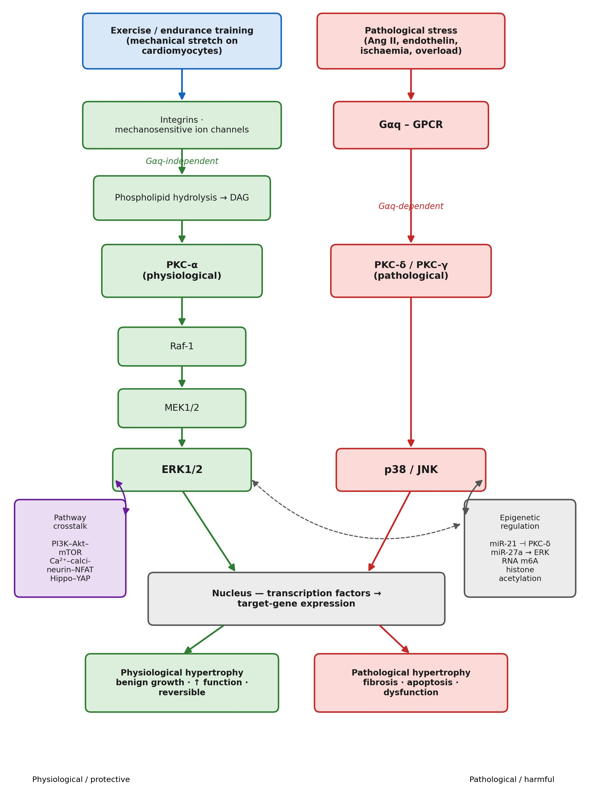

Figure 1 Schematic of the PKC–MAPK signalling cascade in exercise-induced cardiac adaptation.

5.2 How Exercise Activates the Pathway
5.2.1 Mechanotransduction and Gαq-independent activation. During sustained exercise, alternating volume and pressure loads place a continuous stretch on cardiomyocytes, and this stretch is the principal trigger for PKC–MAPK activation. Recent mechanobiology suggests that integrins and mechanosensitive ion channels in the cardiomyocyte membrane register the deformation and prompt hydrolysis of membrane phospholipids, generating diacylglycerol (DAG). DAG, acting as a second messenger, binds and activates cytoplasmic PKC directly. Notably, this route appears to bypass Gαq and its coupled receptors, which challenges the linear Gαq–PKC model inherited from disease research (Saucerman et al., 2019).
5.2.2 Functional specificity of PKC isoforms. Isoform-targeted work points to a clear division of labour among PKC variants (Liu & Molkentin, 2011):
- PKC-α appears to be preferentially activated by exercise, promoting protein synthesis and limiting apoptosis; its activity declines once training stops, consistent with the reversibility of the athlete’s heart.
- PKC-δ and PKC-γ are linked mainly to pathological conditions, where they are associated with interstitial fibrosis and cell death, and they remain largely quiet during regular exercise.
- Atypical PKC-ζ shows only slight upregulation and seems not to take part in the main signalling flow.
5.2.3 Selective response of the MAPK subfamilies. The three MAPK branches are not activated uniformly. ERK1/2 is steadily engaged by moderate endurance exercise and supports benign growth, whereas p38 and JNK are activated chiefly by ischaemia or excessive high-intensity loading and mediate inflammation and apoptosis; under ordinary exercise they change little (Rose et al., 2010).
5.3 Crosstalk with Neighbouring Signalling Pathways
Exercise-induced hypertrophy is not the work of a single pathway but of an interacting network (Nakamura & Sadoshima, 2018). Three interactions are particularly relevant. With the PI3K–Akt–mTOR pathway, activated ERK1/2 enhances Akt phosphorylation to support protein synthesis, while Akt in turn promotes PKC-α membrane translocation, amplifying the signal (Vega et al., 2017). With the Ca²⁺–calcineurin–NFAT pathway, ERK1/2 phosphorylates NFAT and limits its nuclear retention, restraining the pathological fetal-gene programme (Heineke & Molkentin, 2006). With the Hippo–YAP pathway, exercise suppresses Hippo kinase and activates YAP, which partners with ERK1/2 in the nucleus to upregulate growth-related genes (Wang et al., 2018).
5.4 Epigenetic Regulation
Epigenetic mechanisms fine-tune pathway activity and appear to encode a form of exercise “memory” that outlasts a single training block (Fernandes et al., 2015; Nakamura & Sadoshima, 2018). Among non-coding RNAs, miR-21 silences PKC-δ to dampen pathological signalling, while miR-27a prolongs ERK1/2 activation. RNA m6A methylation improves the translation of downstream genes and helps maintain cardiac adaptation after training ceases. At the chromatin level, activated ERK1/2 recruits acetyltransferases that raise the transcriptional efficiency of growth genes.
5.5 Influence of Exercise Type and Intensity
The type and intensity of exercise shape how strongly the pathway is engaged (Vega et al., 2017; Kehat et al., 2011). Endurance work such as swimming or running strongly activates the PKC-α–ERK1/2 arm and tends to produce eccentric hypertrophy. Resistance work engages the pathway more weakly and tends toward concentric hypertrophy. Excessive or unaccustomed loading, by contrast, can abnormally activate p38 and JNK and lead to myocardial damage an important caveat when prescribing high training volumes.
5.6 Physiological versus Pathological Hypertrophy
The contrasts that emerge across the literature are summarised in Table 1.
Table 1 Differences in the PKC–MAPK pathway between physiological and pathological cardiac hypertrophy.
Regulatory item | Exercise-induced physiological hypertrophy | Pathological cardiac hypertrophy
Upstream activating stimulus | Myocardial mechanical stretch | Neurohumoral factors (Ang II, endothelin)
Gαq involvement | Gαq-independent | Gαq-dependent
Dominant PKC isoform | PKC-α | PKC-δ, PKC-γ
Dominant MAPK subfamily | ERK1/2 | p38, JNK
Functional outcome | Benign cardiomyocyte growth; enhanced cardiac function | Fibrosis, apoptosis, cardiac dysfunction
Reversibility | Reversible after exercise cessation | Persistent, largely irreversible
Note. The dichotomy is a simplification; under some conditions the two phenotypes overlap. Compiled from Bernardo et al. (2010), Maillet et al. (2013), Nakamura & Sadoshima (2018) and Rose et al. (2010).
6. Conclusion and Discussion
6.1 Main Conclusions
Four conclusions follow from the synthesis. First, the PKC–MAPK cascade is a core axis linking the mechanical signal of exercise to physiological cardiac growth; mechanical stretch is the primary trigger and the process appears Gαq-independent, distinguishing it from pathological hypertrophy (Saucerman et al., 2019). Second, the PKC and MAPK isoforms respond selectively: PKC-α and ERK1/2 drive benign remodelling, whereas PKC-δ, p38 and JNK are tied to injury (Rose et al., 2010). Third, the pathway operates within a network interacting with PI3K–Akt, calcineurin–NFAT and Hippo–YAP signalling and tuned by epigenetic inputs that support longer-term adaptation (Fernandes et al., 2015). Fourth, moderate endurance exercise activates the pathway in a way that protects the heart, while overload can tip it toward damage (Bernardo et al., 2018).
6.2 Discussion
The most consequential shift in recent work is conceptual. The older view treated the Gαq–PKC–MAPK cascade as a single route common to all hypertrophy. The emerging picture separates the two: pathological stimuli appear to depend on Gαq to drive injury, whereas exercise-derived mechanical signals can activate PKC-α more directly. Layered onto this are the multi-pathway network and epigenetic controls that seem to keep exercise-induced growth within a benign range. Together these findings give a molecular footing to a long-standing clinical observation that habitual, moderate exercise protects the heart (Bernardo et al., 2018; Chen et al., 2022).
For physical education and sport science, the practical message is graded rather than absolute. Because different modes and intensities of exercise engage the pathway to different degrees, training can in principle be matched to the goal. Moderate endurance exercise is the safest default for general fitness and for cardiac rehabilitation, whereas highly trained athletes need their loads managed to avoid the maladaptive activation of p38 and JNK. Read this way, the molecular biology reinforces familiar principles of progression, recovery and individualisation that underpin sound exercise prescription.
6.3 Limitations of the Current Evidence
Several limitations temper these conclusions. Most mechanistic data come from rodent models, and human evidence is still thin (Cheng et al., 2025). The precise molecular link between cardiac mechanoreceptors and PKC-α is not yet defined. Long-term studies addressing ageing and sex differences are scarce. And isoform-specific drugs, though promising, have not reached clinical use. These gaps should be weighed when translating the findings to practice.
7. Suggestions
7.1 Basic Research
Future basic work should clarify the molecular steps of cardiac mechanotransduction, run controlled studies across ageing, sex and long-term training, and use gene-editing tools to test the causal role of individual kinase isoforms.
7.2 Applied and Translational Research
On the applied side, the priorities are to develop pathway-informed, standardised exercise prescriptions for general fitness and cardiac rehabilitation, to explore isoform-specific agents that might mimic the protective effects of exercise, and to screen miRNA and protein biomarkers for non-invasive monitoring of cardiac adaptation.
7.3 Interdisciplinary Expansion
Finally, combining multi-omics approaches to chart the full signalling network of the exercised heart would benefit from closer collaboration among exercise science, pharmacology and biomechanics.
8. Bibliography
Bernardo, B. C., Ooi, J. Y. Y., Weeks, K. L., Patterson, N. L., & McMullen, J. R. (2018).
Understanding key mechanisms of exercise-induced cardiac protection to mitigate disease: Current knowledge and emerging concepts. Physiological Reviews, 98(1), 419–475.
https://doi.org/10.1152/physrev.00043.2016
Bernardo, B. C., Weeks, K. L., Pretorius, L., & McMullen, J. R. (2010). Molecular distinction between physiological and pathological cardiac hypertrophy: Experimental findings and therapeutic strategies. Pharmacology & Therapeutics, 128(1), 191–227.
https://doi.org/10.1016/j.pharmthera.2010.04.005
Chen, H., Chen, C., Spanos, M., Li, G., Lu, R., Bei, Y., & Xiao, J. (2022). Exercise training maintains cardiovascular health: Signaling pathways involved and potential therapeutics. Signal Transduction and Targeted Therapy, 7(1), 306. https://doi.org/10.1038/s41392-022-01153-1
Cheng, P., Zhang, X., Si, Y., Yin, Q., Chen, L., Ru, Q., Chu, C., Xiang, H., Liao, L., Ran, H., Zhang, Z., & Wu, Y. (2025). Regulatory mechanisms of exercise-induced physiological cardiac hypertrophy: Progress and prospects. Frontiers in Cardiovascular Medicine, 12, 1657950. https://doi.org/10.3389/fcvm.2025.1657950
Fernandes, T., Baraúna, V. G., Negrão, C. E., Phillips, M. I., & Oliveira, E. M. (2015). Aerobic exercise training promotes physiological cardiac remodeling involving a set of microRNAs. American Journal of Physiology-Heart and Circulatory Physiology, 309(4), H543–H552. https://doi.org/10.1152/ajpheart.00899.2014
Heineke, J., & Molkentin, J. D. (2006). Regulation of cardiac hypertrophy by intracellular signalling pathways. Nature Reviews Molecular Cell Biology, 7(8), 589–600.
https://doi.org/10.1038/nrm1983
Kehat, I., Davis, J., Tiburcy, M., Accornero, F., Saba-El-Leil, M. K., Maillet, M., York, A. J., Lorenz, J. N., Zimmermann, W. H., Meloche, S., & Molkentin, J. D. (2011). Extracellular signal-regulated kinases 1 and 2 regulate the balance between eccentric and concentric cardiac growth. Circulation Research, 108(2), 176–183.
https://doi.org/10.1161/CIRCRESAHA.110.231514
Liu, Q., & Molkentin, J. D. (2011). Protein kinase Cα as a heart failure therapeutic target. Journal of Molecular and Cellular Cardiology, 51(4), 474–478.
https://doi.org/10.1016/j.yjmcc.2010.10.004
Maillet, M., van Berlo, J. H., & Molkentin, J. D. (2013). Molecular basis of physiological heart growth: Fundamental concepts and new players. Nature Reviews Molecular Cell Biology, 14(1), 38–48. https://doi.org/10.1038/nrm3495
Nakamura, M., & Sadoshima, J. (2018). Mechanisms of physiological and pathological cardiac hypertrophy. Nature Reviews Cardiology, 15(7), 387–407. https://doi.org/10.1038/s41569-018-0007-y
Rose, B. A., Force, T., & Wang, Y. (2010). Mitogen-activated protein kinase signaling in the heart: Angels versus demons in a heart-breaking tale. Physiological Reviews, 90(4), 1507–1546.
https://doi.org/10.1152/physrev.00054.2009
Saucerman, J. J., Tan, P. M., Buchholz, K. S., McCulloch, A. D., & Omens, J. H. (2019). Mechanical regulation of gene expression in cardiac myocytes and fibroblasts. Nature Reviews Cardiology, 16(6), 361–378. https://doi.org/10.1038/s41569-019-0155-8
Vega, R. B., Konhilas, J. P., Kelly, D. P., & Leinwand, L. A. (2017). Molecular mechanisms underlying cardiac adaptation to exercise. Cell Metabolism, 25(5), 1012–1026.
https://doi.org/10.1016/j.cmet.2017.04.025
Wang, J., Liu, S., Heallen, T., & Martin, J. F. (2018). The Hippo pathway in the heart: Pivotal roles in development, disease, and regeneration. Nature Reviews Cardiology, 15(11), 672–684. https://doi.org/10.1038/s41569-018-0063-3
Weeks, K. L., & McMullen, J. R. (2011). The athlete's heart vs. the failing heart: Can signaling explain the two distinct outcomes? Physiology, 26(2), 97–105.
https://doi.org/10.1152/physiol.00043.2010

