DIGITAL PLATFORMS AND CONSUMER ENGAGEMENT IN THE SPORTS INDUSTRY: AN EMPIRICAL STUDY

DR. VIJAY ARVIND SALUNKE
Assistant Professor
Department of Commerce
Chintamanrao College of Commerce, Sangli
Affiliated to Shivaji University, Kolhapur
Vijaysalunke2591@gmail.com
Abstract
This study examines the impact of digital platforms on consumer engagement in the sports industry, with particular emphasis on social media, live streaming services, and sports applications. The rapid adoption of digital technologies has transformed how sports organizations interact with their audiences, shifting from passive viewership to interactive and personalized experiences. The study aims to analyze the extent to which digital platforms influence fan engagement, participation, and consumption behavior.
A structured questionnaire was used to collect primary data from sports consumers, including students and general viewers. The study employs descriptive and inferential statistical tools to evaluate the relationship between digital platform usage and engagement levels. Key variables include frequency of platform usage, type of platform, and forms of engagement such as sharing, commenting, and participation in fantasy sports.
The findings reveal a significant positive relationship between digital platform usage and consumer engagement. The study also highlights how digital innovations contribute to enhanced fan experiences and influence spending behavior. The research provides valuable insights for sports marketers, managers, and policymakers in designing effective digital engagement strategies.
Keywords: Digital Platforms, Consumer Engagement, Sports Industry, Social Media, Fan Behavior
1. Introduction
The sports industry has undergone a profound transformation in recent years, driven by rapid advancements in digital technology. Traditionally, sports consumption was largely limited to physical attendance at events and passive viewership through television broadcasts. However, the emergence of digital platforms including social media, over-the-top (OTT) streaming services, mobile applications, and fantasy sports platforms has fundamentally reshaped how consumers interact with sports content. This shift has not only expanded the reach of sports organizations but has also redefined the nature of consumer engagement from passive observation to active participation.
Digital platforms enable real-time interaction, personalized content delivery, and global connectivity, thereby enhancing the overall fan experience. Social media allows fans to engage directly with teams, athletes, and communities through interactive features such as comments, shares, and live discussions. Similarly, streaming platforms provide flexible access to sports content, while fantasy sports applications promote active involvement and decision-making.
From a commerce and management perspective, digital transformation has introduced innovative business models and revenue streams, including digital advertising, subscriptions, sponsorships, and merchandise sales. Consumer engagement has emerged as a key factor influencing brand loyalty, revenue generation, and long-term sustainability.
In emerging economies like India, increased internet penetration and smartphone usage have accelerated the adoption of digital sports platforms. However, there is a need for empirical research to understand how these platforms influence consumer engagement. This study aims to address this gap by analyzing the relationship between digital platform usage and consumer engagement in the sports industry.
2. Literature Review
The evolution of digital technologies has significantly transformed sports consumption and fan engagement. Studies indicate that digital platforms have shifted sports consumption from passive viewing to interactive participation (Gashi, 2025). Social media platforms play a crucial role in enhancing fan interaction, brand loyalty, and engagement (Rai, 2025).
Research based on the Stimulus-Organism-Response (S-O-R) model suggests that digital platforms act as stimuli influencing emotional and behavioral responses, leading to increased engagement (Zhong et al., 2025). Similarly, digital marketing strategies, including personalized content and data analytics, have been found to significantly improve fan experience and consumption behavior.
Further studies highlight that digital platforms facilitate co-creation of content, allowing fans to actively participate and express their identity (Stegmann et al., 2026). In addition, digital transformation has introduced new revenue streams and marketing strategies, enhancing the commercial viability of sports organizations.
However, there remains a gap in empirical studies focusing on emerging markets like India. This study attempts to fill this gap by analyzing consumer engagement patterns in the digital sports ecosystem.
3. Objectives of the Study
- To analyze the role of digital platforms in the sports industry
- To examine consumer engagement levels across digital platforms
- To study the relationship between digital platform usage and engagement
- To identify key factors influencing consumer behavior
4. Hypotheses
H1: There is a significant relationship between digital platform usage and consumer engagement
5. Research Methodology
- Research Design: Descriptive and analytical
- Data Collection: Primary (questionnaire), Secondary (journals, reports)
- Sample Size: 120 respondents
- Sampling Method: Convenience sampling
- Tools Used: Percentage analysis, Chi-square test
6. Conceptual Framework
The study is based on the relationship between digital platforms and consumer engagement in the sports industry. Digital platforms act as stimuli influencing consumer behavior, which results in engagement and business outcomes.
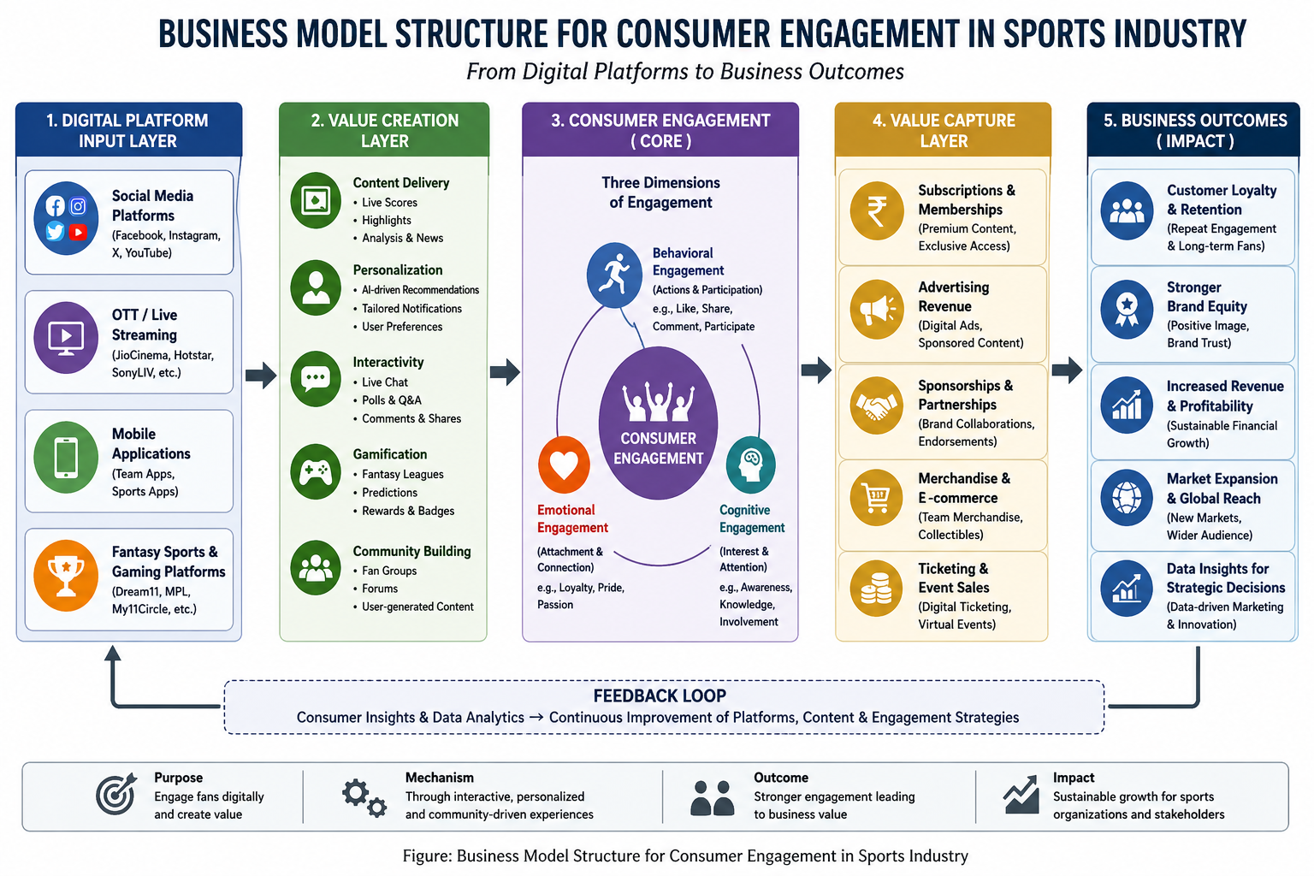
Figure 1: Business Model Structure for Consumer Engagement in Sports Industry
The above figure illustrates the business model structure for consumer engagement in the sports industry within a digital ecosystem. The model begins with the Digital Platform Input Layer, which includes social media platforms, OTT streaming services, mobile applications, and fantasy sports platforms that serve as primary touchpoints for consumers. These platforms enable wide accessibility and continuous interaction with sports content.
The next stage, the Value Creation Layer, highlights how sports organizations create value through content delivery, personalization, interactivity, gamification, and community building. These elements enhance user experience by offering real-time updates, tailored recommendations, and participatory opportunities, thereby increasing user involvement.
At the core of the model lies Consumer Engagement, which is categorized into three dimensions: behavioral engagement (such as likes, shares, and participation), emotional engagement (attachment, loyalty, and passion), and cognitive engagement (interest, awareness, and attention). This stage represents the central mechanism through which digital platforms influence consumer behavior.
The model then progresses to the Value Capture Layer, where engagement is monetized through various revenue streams including subscriptions, advertising, sponsorships, merchandise sales, and digital ticketing. This demonstrates the direct link between consumer engagement and financial performance.
The Business Outcomes Layer reflects the broader impact on sports organizations, including enhanced customer loyalty, stronger brand equity, increased revenue and profitability, market expansion, and data-driven strategic decision-making. The model also incorporates a feedback loop, indicating that consumer insights and analytics continuously inform and improve digital strategies and engagement practices.
The model emphasizes that digital platforms act as enablers of engagement, which in turn drives value creation and sustainable business growth in the sports industry.
Digital Platforms → Consumer Engagement → Behavioral Outcomes
- Independent Variable: Digital Platforms
- Dependent Variable: Consumer Engagement
- Outcome: Loyalty, Participation, Spending
7. Data Analysis and Interpretation
Key Results Summary
- 91.7% respondents use social media for sports
- 60% engage daily on digital platforms
- 85% report increased interest due to digital platforms
- 80% feel emotionally connected to teams
- 58.3% spending influenced by digital engagement
Hypothesis Testing
Chi-square test result shows p < 0.05, indicating a significant relationship between digital platform usage and consumer engagement.
8. Findings
- Digital platforms significantly enhance consumer engagement
- Social media is the most influential platform
- Engagement is both behavioral and emotional
- Digital interaction influences consumer preferences and spending
- Strong statistical relationship exists between usage and engagement
9. Suggestions
- Focus on social media-driven engagement strategies
- Use AI-based personalized content
- Develop interactive mobile applications
- Strengthen emotional branding
- Adopt data-driven marketing approaches
10. Conclusion
The present study highlights the transformative impact of digital platforms on consumer engagement in the sports industry. The findings clearly indicate that digital technologies have revolutionized the way consumers interact with sports, shifting from traditional passive consumption to dynamic and interactive engagement. Social media, live streaming services, and mobile applications have emerged as powerful tools for enhancing fan involvement, emotional connection, and participation.
The study establishes a significant relationship between digital platform usage and consumer engagement, confirming that increased exposure to digital platforms leads to higher levels of interaction, interest, and loyalty. Moreover, digital engagement has been found to influence consumer behavior not only in terms of participation but also in economic aspects such as spending on subscriptions and sports-related products.
From a commerce and management perspective, digital platforms have created new opportunities for revenue generation, marketing innovation, and customer relationship management. Organizations that effectively leverage digital tools can achieve competitive advantages by building strong and lasting connections with their audiences.
However, the study is limited to a specific sample size and demographic group, which may restrict the generalizability of the findings. Future research can expand the scope by including larger and more diverse samples, as well as exploring advanced analytical techniques and emerging technologies such as artificial intelligence and virtual reality in sports engagement.
In conclusion, digital platforms have become an integral component of the sports ecosystem, significantly influencing consumer engagement and shaping the future of the sports industry. Effective utilization of these platforms is essential for sustainable growth, enhanced fan experience, and long-term success in the digital era.
11. References
Gashi, A. (2025). Revolutionizing sports marketing through digital strategies.
Rai, J. S. (2025). Social media in sport: A systematic review. International Journal of Consumer Studies.
Zhong, Y. J., et al. (2025). Digital technology and sports consumption behavior. Frontiers in Psychology.
Stegmann, P., et al. (2026). Digital platform features and fan engagement. International Journal of Sports Marketing.
PwC. (2026). Digital fan engagement in sports report.
Deloitte. (2026). Sports industry outlook report.

