The Investigation of the Relationships among Island Tourism, Recreational Fisheries, Fireworks Festival and Behavior Intentions on the Penghu Bay

Chen, Jui-Pin¹, Chen, Chih-Jou², Yu, Jo-Hung³
¹Department of Marine Recreation, National Penghu University of Science and Technology
²Department of Marketing and Logistic Management, National Penghu University of Science and Technology
³Department of Marine Leisure Management, National Kaohsiung University of Science and Technology
Abstract
The Penghu Inner Bay consists of characterized by smaller waves and calm waters. These areas, often referred to as inner bay waters, serve as hubs for water sports, harbor settlements, and major tourist attractions. By utilizing data collected from tourist questionnaires, the research was aimed to analyze the research objective: determining whether these had a positive impact on tourists' willingness to visit Penghu. This study therefore was aimed to explore the relationships among island tourism, leisure fishery, firework festival and behavioral intention. A questionnaire survey was conducted using a snowball sampling approach, targeting tourists who had previously participated inner bay tourism. A total of 360 questionnaires were distributed, and 320 valid responses were obtained, yielding a response rate of 88.9%. The collected data was analyzed using SPSS 23.0 version and AMOS 24 version, employing confirmatory factor analysis (CFA) and structural equation modeling (SEM) to test the proposed hypotheses. The results indicated that island tourism had a significantly positive effect on both leisure fishery and firework festival, also, leisure fishery and firework festival positively influences behavioral intention. Furthermore, leisure fishery and firework festival played mediators roles in the relationship between island tourism and behavioral intention.
Keywords: Penghu bay, island tourism, leisure fishery, behavioral intention
Corresponding Author: Kao, Shao-Yuan, Department of Marine Recreation, National Penghu University of Science and Technology.
Email: shao@gms.npu.edu.tw, Taiwan.

INTRODUCTION
Penghu, an island county of Taiwan, is situated in the southeastern Taiwan Strait, located between mainland China and Taiwan. Comprising approximately 90 islands and featuring a coastline stretching over 320 kilometers, Penghu offers distinct seasonal charm and diverse landscapes, deeply enriched by its natural ecology and historical heritage. Penghu's tourism industry is a multi-objective, comprehensive sector that encompasses natural scenery, historical sites, transportation, hospitality, dining, local specialties, leisure, entertainment, and tourism promotion. This research focuses on tourism within the Penghu Inner Bay, using attractions such as sea ranches, the Heqing semi-submersible, Hujing Island, Tongpan Island, Dacang Island, the Rainbow Bridge, the Penghu Great Bridge, and the Mazu Statue as subjects for investigation.
To address this gap, the study examined the relationships among island tourism, leisure fishery, firework festival and behavioral intention in the context of yacht on the Penghu bay. Specifically, this study aimed to (1) examine the effects of island tourism, leisure fishery and firework festival upon behavioral intention, (3) analyze their causal relationships, and (4) test the mediating roles of leisure fishery and firework festival.
Literature Review
Penghu is a stunning island getaway beloved by travelers, and with its signature "Tiffany-blue" waters and countless surrounding islets, experiencing the sailing life on a heavy-keel yacht is a perfect, unmissable adventure. After meeting at the private floating pier and completing departure formalities, tourists would slowly ease out of the harbor and hoist the sails. Tourists were welcome to join the crew and capture the perfect photo while helping to hoist the sails! Conditions permitting, you can even take the helm and experience the thrill of being a captain yourself. Our captain will determine the route and the best bay for anchoring based on the day's wind and sea currents. You might sail past ocean lighthouses, catch views of the magnificent Daguoye columnar basalt, or cruise by secluded, uninhabited islands. Tourists may drop anchor at "Grandma's Penghu Bay," in front of the Guanyin Temple Rainbow Bridge, in our dedicated sailing training waters, or off the shore of a beautiful beach. Marine recreation was broadly defined as leisure activities associated with marine settings, extending beyond water-based activities to include all experiences shaped by ocean environments (Orams, 2002).
In addition to its marine environment, Penghu possessed distinctive cultural and ecological assets. Traditional stone fish traps, for instance, served as both cultural heritage and landscape features, reflecting historical fishing practices adapted to local environmental conditions (Yu et al., 2015). Furthermore, seasonal ecological phenomena—such as tern migrations—had been incorporated into tourism offerings, enhancing ecological awareness and supporting sustainable tourism development (PNSA, 2024). Tourism operators had also diversified recreational products, including island-hopping, intertidal exploration, and recreational fishing, which had gained global popularity. These developments demonstrated the integration of natural, cultural, and experiential elements in marine tourism.
Known as an "International Island and Pearl of the Sea," the Penghu archipelago is surrounded by the ocean and possesses inherent natural advantages, making it an excellent region for the development of eco-tourism. While island tourism serves as the primary economic driver for these islands, factors such as limited environmental carrying capacity, scarce water resources, and the high cost of external transportation have meant that Penghu’s active promotion of tourism has come at the expense of its high quality of life.
Leisure fishery was a novel form of the fishing industry that effectively leverages diverse fishery resources—including fishing villages, production assets, traditional gear and methods, aquatic products and their derivatives, marine life, and cultural heritage. By systematically reorganizing and allocating these resources, recreational fishery integrates traditional fishing activities with leisure and entertainment, sightseeing, ecological development, cultural preservation, scientific education, and culinary experiences. Ultimately, it provides a comprehensive suite of products and services that seamlessly fuse fishing with leisure (Fu & Wang, 2021; Yoon et al., 2010).
The Penghu International Fireworks Festival traces its origins back to May 2002, when it was launched to revitalize the local tourism industry following the severe slump caused by the China Airlines crash. It has been held annually since 2003, and has since become one of Taiwan's most iconic summer celebrations. The 2026 Penghu International Fireworks Festival will make a spectacular return from May to August at the Magong Guanyin Pavilion. This year, the night sky of the "Chrysanthemum Island" will be illuminated by a dazzling display of brilliant fireworks perfectly synchronized with high-tech drone light shows.
Behavioral intention, derived from attitude theory, was commonly used to predict future actions such as revisit intention and word-of-mouth recommendation (Oliver, 1980). In tourism studies, it reflected tourists’ willingness to re-engage with a destination or recommend it to others (Gan et al., 2023). Strong behavioral intention was often associated with higher satisfaction and perceived value, making it a critical indicator for tourism management (Baker & Crompton, 2000; Chen & Chen, 2010).

RESEARCH METHODOLOGY
Research hypothesis
H1: Island tourism, leisure fishery, firework festival had positively influenced behavioral intention on inner Penghu Bay.
H2: Island tourism, leisure fishery, firework festival and behavior intention had casual relationships.
H3: Leisure fishery and firework festival had mediated the relationships between island tourism and behavioral intention.
In summary, island tourism was an important driving force that encouraged individuals to engage in leisure fishery and firework, and significantly enhanced perceived leisure fishery and firework festival. Leisure fishery and firework festival, in turn, functions as a critical antecedent of behavioral intention and frequently served as a mediating mechanism linking island tourism factors to tourists’ future behavioral responses.
Sample Design and Data Collection
This study employed a questionnaire survey method to examine island tourism, leisure fishery, and behavioral intention among tourists participating in recreational activities in the East Sea area of Penghu. The research instrument consisted of four sections: island tourism, leisure fishery, behavioral intention, and respondents’ demographic information. All measurement items were designed using a five-point Likert scale, ranging from strongly disagree to strongly agree, and were presented as positively worded, closed-ended questions.
A snowball sampling technique was adopted to collect data. Initially, tourism operators providing recreational activities in the Penghu Bay were contacted to seek their cooperation. These operators subsequently invited tourists who had participated in related activities to complete the survey. The questionnaire was distributed online using Google Forms between December 1, 2025, and March 23, 2026. A total of 360 questionnaires were distributed, of which 320 valid responses were obtained, yielding a response rate of 88.9%. Data analysis tools used were IBM SPSS Statistics 23 and IBM SPSS Amos 23.
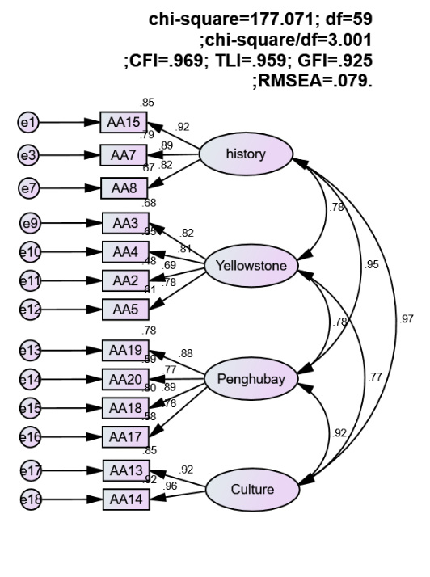
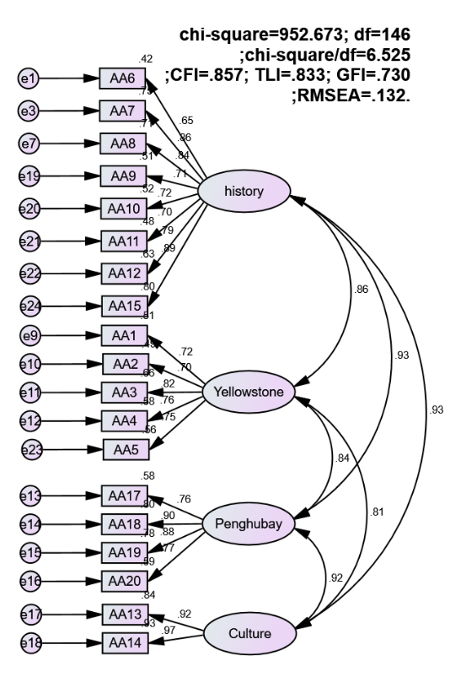
RESULTS
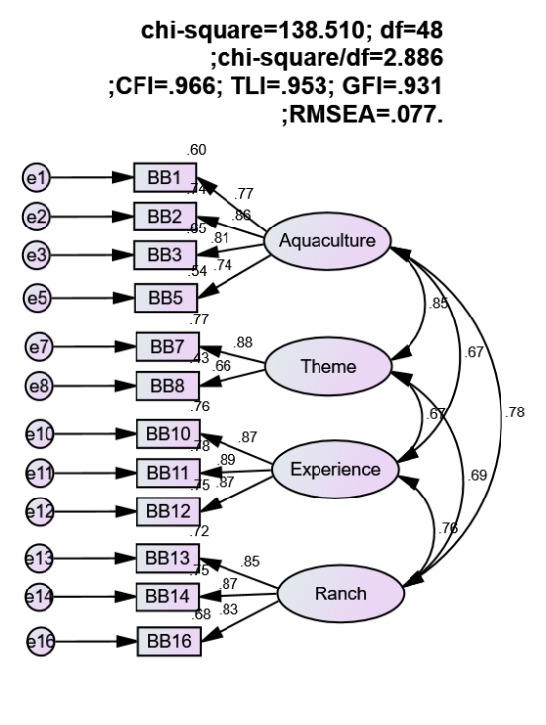
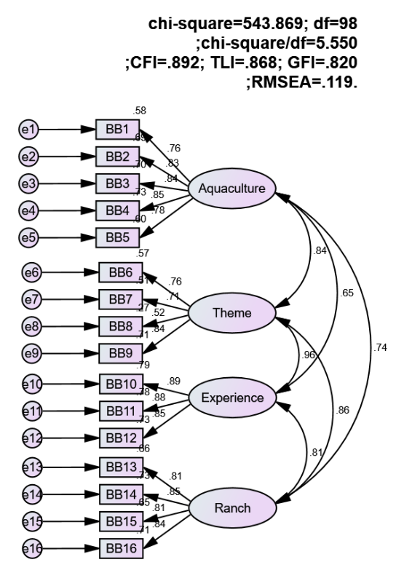
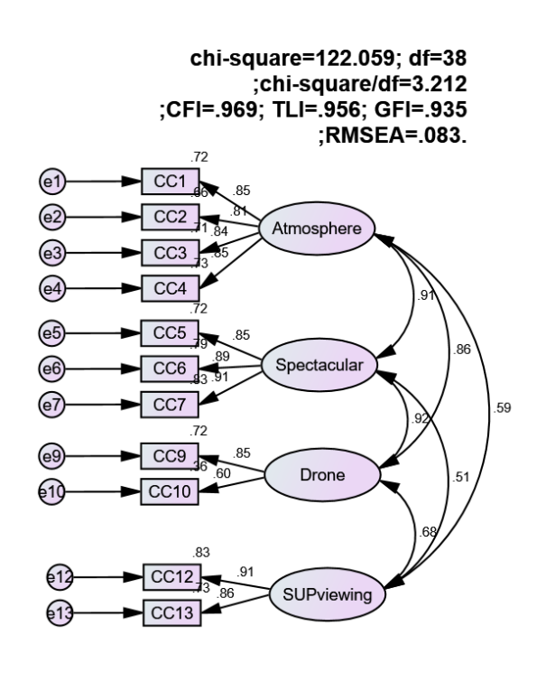
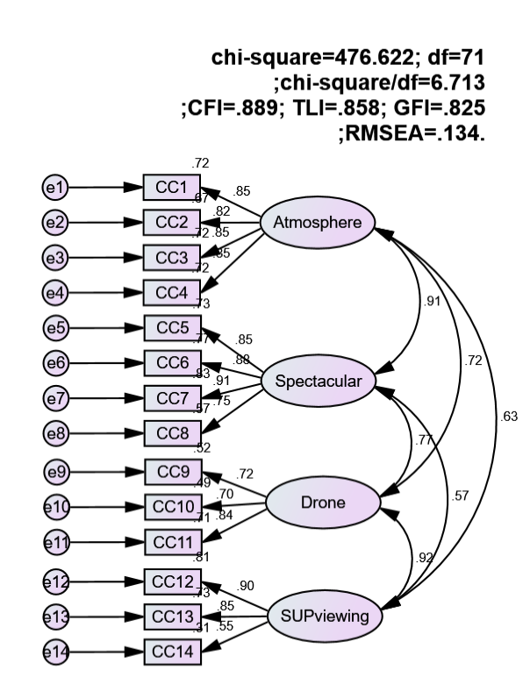
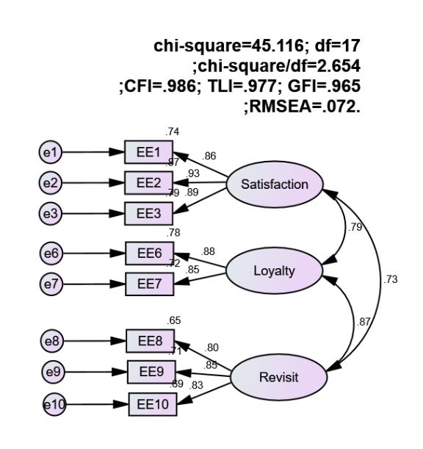
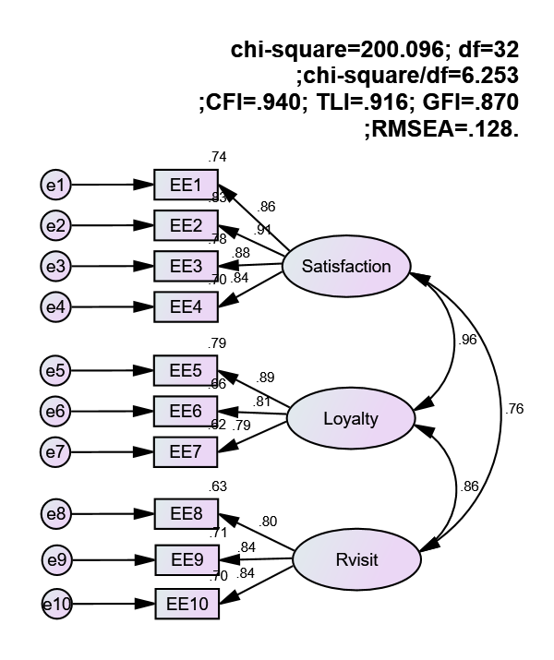
Fig 1-8. Structural Equation Modelling
Structural equation modeling
This study employed Structural Equation Modeling (SEM) via IBM SPSS AMOS 23.0 to examine the hypothesized relationships among island tourism, leisure fishery, and behavioral intention within the context of Penghu’s East Sea recreational activities. Preliminary diagnostics confirmed that the data distribution adhered to the assumptions of multivariate normality, justifying the use of Maximum Likelihood Estimation (MLE). The goodness-of-fit was evaluated using multiple indices (see Table 2). The absolute fit index yielded a χ2 value of 862.005. Although statistically significant, this elevation was frequently attributed to the index’s sensitivity to sample size and model complexity (Hair et al., 2019). While the Adjusted Goodness of Fit Index (AGFI = 0.765) fell slightly below the stringent 0.80 threshold, it remained within a marginal yet acceptable range for exploratory research. Regarding incremental fit indices, the TLI (0.847), CFI (0.862), and IFI (0.864) approached the conventional 0.90 benchmark, while the NFI (0.776) and RFI (0.751) exhibited consistent, albeit moderate, alignment. Despite these indices not reaching ideal levels, the holistic evaluation suggested the proposed model maintains a satisfactory degree of parsimony and fit, providing a robust foundation for subsequent hypothesis testing.
Table 2. Overall structural model compatibility and adaptation status
Model Fix Index |  | Acceptable value | Modified
Absolute fit indicators | χ2 | Small | 2363.366
Absolute fit indicators | χ2/df | <5 | 2.677
Absolute fit indicators | GFI | >0.8 is good | 0.747
Absolute fit indicators | AGFI | >0.8 is acceptable | 0.765
Absolute fit indicators | RMR | <0.05 | 0.037
Absolute fit indicators | RMSEA | <0.08 | 0.072
Incremental fit indicators | NFI | >.90 is great, >.80 is tolerable | 0.776
Incremental fit indicators | TLI | Same | 0.877
Incremental fit indicators | CFI | Same | 0.862
Incremental fit indicators | RFI | Same | 0.751
Incremental fit indicators | IFI | Same | 0.864
Overall structural causal model
The results of the structural path analysis indicated that all hypothesized relationships were statistically significant (see Table 3). Specifically, island tourism exerted a significant positive influence on leisure fishery (β = 0.727, T= 5.570, p < .001), providing strong support for H1. Regarding behavioral intention, both island tourism (β= 0.456, T = 2.592, p < .05) and leisure fishery (β = 0.739, T = 3.182, p < .01) exhibited positive and significant effects, thereby confirming H2 and H3, respectively. These findings suggested that higher levels of initial motivation and perceived value were critical antecedents to tourists' subsequent behavioral intentions within the context of the study (see Fig 9).
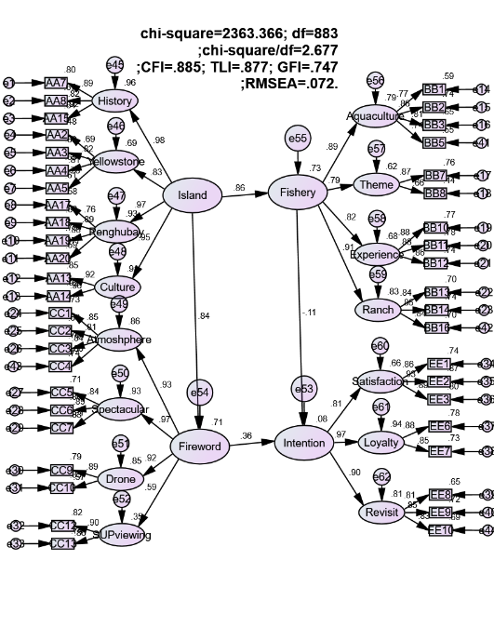

Fig 9. Structural Equation Modelling
Mediation Analysis
This study employed the bootstrap approach proposed by Efron (1979) to conduct statistical inference, utilizing confidence intervals to estimate indirect effects and examine mediation. The criteria for assessing mediation followed the guidelines of Preacher and Hayes (2004). Specifically, effects were considered non-significant when the confidence interval includes zero, whereas intervals excluding zero indicated statistical significance. An indirect effect was deemed non-existent if its confidence interval contained zero, and significant if it did not. Furthermore, full mediation was indicated when the direct effect was non-significant, whereas partial mediation was supported when both indirect and total effects were significant.
The empirical results demonstrated that the indirect effect of leisure fishery between island tourism and behavioral intention was 0.370. Both the bias-corrected (BC) and percentile (PC) 95% confidence intervals exclude zero, with a p-value below 0.05, indicating a significant mediator effect. The direct effect (0.403) was also significant, as its confidence interval did not include zero. Additionally, the total effect (0.742) was statistically significant. Based on the criteria proposed by Preacher and Hayes (2004), the simultaneous significance of both indirect and total effects confirmed the presence of partial mediation. Overall, leisure fishery serves as a significant partial mediator in the relationship between island tourism and behavioral intention.
Table 3. Summary of the Mediating Effect of Leisure fishery and firework festival
Island tourism (X)→Leisure fishery (M)→Behavioral Intention (Y)
 |  | Estimate | BC/PC 95% Confidence Interval |  |  | Result
 |  | Estimate | P value | BC | PC | Result
Indirect Effect | XMY | 0.370 | 0.000/0.006 | 0.300~1.232 | 0.144~0.707 | Confirmed
Direct Effect | XM | 0.735 | 0.000/0.001 | 0.568~0.875 | 0.548~0.866 | Partial Mediation
Direct Effect | XY | 0.403 | 0.029/0.025 | 0.064~0698 | 0.072~0.705 | Partial Mediation
Direct Effect | MY | 0.631 | 0.000/0.006 | 0.404~1.270 | 0.217~0.883 | Partial Mediation
Total Effect | XY | 0.742 | 0.000/0.001 | 0.064~0.698 | 0.686~0.928 | Confirmed

Island tourism (X)→Firework Festival (M)→Behavioral Intention (Y)
 |  | Estimate | BC/PC 95% Confidence Interval |  |  | Result
 |  | Estimate | P value | BC | PC | Result
Indirect Effect | XMY | 0.335 | 0.000/0.006 | 0.300~1.232 | 0.144~0.707 | Confirmed
Direct Effect | XM | 0.752 | 0.000/0.001 | 0.568~0.875 | 0.548~0.866 | Partial Mediation
Direct Effect | XY | 0.389 | 0.029/0.025 | 0.064~0698 | 0.072~0.705 | Partial Mediation
Direct Effect | MY | 0.653 | 0.000/0.006 | 0.404~1.270 | 0.217~0.883 | Partial Mediation
Total Effect | XY | 0.766 | 0.000/0.001 | 0.064~0.698 | 0.686~0.928 | Confirmed

DISCUSSION AND CONCLUSIONS
This study confirmed that island tourism, leisure fishery, firework festival and behavioral intention were significantly interrelated within the context of recreational activities in the Penghu Bay. The results demonstrated that island tourism positively influences both leisure fishery and firework festival, also, leisure fishery and firework festival further exerted a significantly positive effect on behavioral intention. These results were consistent with prior studies (Ding et al., 2021; Li et al., 2021; Zhu & Liu, 2024), reinforcing the critical roles of leisure fisher and firework festival in shaping tourist behavior intention. Moreover, leisure fishery was found to partially mediate the relationship between island tourism and behavioral intention, supporting the proposed theoretical framework.

References
Ajzen, I. (1991). The theory of planned behavior. Organizational Behavior and Human Decision Processes, 50(2), 179-211.
Archer, B. (1996). Sustainable tourism: An economist's view. In Sustainable Tourism: A European Perspective.
Baron, R. M., & Kenny, D. A. (1986). The moderator–mediator variable distinction in social psychological research: Conceptual, strategic, and statistical considerations. Journal of Personality and Social Psychology, 51(6), 1173-1182.
Blackwell, R. D., Miniard, P. W., & Engel, J. F. (2001). Consumer behavior. Harcourt College Publishers.
Briguglio, L. (1996). Sustainable tourism in small island states: The case of Malta. In Susta
Butler, R. W. (1993). Tourism development in small islands: Past influences and future prospects. In Island Tourism: Problems and Perspectives.
Butler, R. W. (1996). The concept of a tourist area cycle of evolution: Implications for management of resources. Canadian Geographer.
Chang, J. (2006). A case study of the festival tourism market in Taiwan. Journal of Vacation Marketing.
Chen, C. F., & Tsai, D. C. (2007). How destination image and evaluative factors affect behavioral intentions? Tourism Management, 28(4), 1115-1122.
Chi, C. G. Q., & Qu, H. (2008). Examining the structural relationships of destination image, customer satisfaction and destination loyalty. Journal of Hospitality & Tourism Research, 32(1), 62-81.
Cole, J. P. (1978). The geography of world affairs. Penguin Books.
Cronin Jr, J. J., Brady, M. K., & Hult, G. T. M. (2000). Assessing the effects of quality, value, and customer satisfaction on consumer behavioral intentions in service environments. Journal of Retailing, 76(2), 193-218.
Ditton, R. B., Holland, S. M., & Anderson, D. K. (2002). Recreational fishing as tourism. Fisheries, 27(3), 17-24.
Engel, J. F., Blackwell, R. D., & Miniard, P. W. (2005). Consumer behavior. Thomson South-Western.
Fortuny, M., Soler, A. M., Canovas, G., & Sanchez, A. (2008). Technical approach for a sustainable tourism development. Case study of the Balearic Islands. Journal of Cleaner Production, 16(7), 860-869.
García-Falcón, J. M., & Medina-Muñoz, D. (1999). Sustainable tourism development in islands: A case study of Gran Canaria. Business Strategy and the Environment.
Getz, D. (1991). Festivals, special events, and tourism. Van Nostrand Reinhold.
Getz, D. (2008). Event tourism: Definition, evolution, and research. Tourism Management, 29(3), 403-428.
Grappi, S., & Montanari, F. (2011). The role of social identification and hedonism in affecting tourist re-patronizing behaviours: The case of an Italian festival. Tourism Management.
Gregorich, S. P. (2006). Do self-report instruments allow meaningful comparisons across diverse population groups? Testing measurement invariance using the multigroup confirmatory factor analysis framework. Medical Care, 44(11), S78-S94.
Gursoy, D., Kim, K., & Uysal, M. (2004). Perceived impacts of festivals and special events by organizers: An extension and validation. Tourism Management.
Ha, J., & Jang, S. S. (2009). Perceived values, satisfaction, and behavioral intentions: The role of familiarity in Korean restaurants. International Journal of Hospitality Management, 28(1), 2-13.
Hair, J. F., Black, W. C., Babin, B. J., & Anderson, R. E. (2009). Multivariate data analysis. Pearson Education.
Hess, A. L. (1990). Overview: Sustainable development and environmental management of small islands. In Sustainable Development and Environmental Management of Small Islands.
Jackson, R. (1997). Developments in event management. In Festival and Special Event Management.
Jacobson, S. K., & Lopez, A. F. (1994). Biological impacts of ecotourism: Tourists and nesting turtles in Tortuguero National Park, Costa Rica. Wildlife Society Bulletin.
Kelly, T. L. (1939). The selection of upper and lower groups as the basis for determining item difficulty. Journal of Educational Psychology, 30(1), 17-24.
Kline, R. B. (2005). Principles and practice of structural equation modeling. Guilford Press.
Ladhari, R., Brun, I., & Morales, M. (2008). Determinants of dining satisfaction and post-dining behavioral intentions. International Journal of Hospitality Management, 27(4), 563-573
Lee, J. S. (2014). The relationship between festival satisfaction and destination loyalty: The case of the Kumgang Nature Art Biennale. International Journal of Tourism Research.
Nanos, P. (2017). Firework tourism: A new trend in the experience economy. Journal of Tourism and Hospitality.
Persson-Fischier, U., Lindström, K. N., Larsson, J., & Rönnbäck, P. (2022). Recreational fishing tourism: A case study of sustainable development. Sustainability.
Saleh, F., & Ryan, C. (1993). Jazz and souvenir sales: A survey of visitors to the 1991 Saskatoon Jazz Festival. Festival Management and Event Tourism.
Theobald, W. F. (1995). Global tourism: The next decade. Butterworth-Heinemann.
Vandenberg, R. J., & Lance, C. E. (2000). A review and synthesis of the measurement invariance literature: Suggestions, practices, and recommendations for organizational research. Organizational Research Methods, 3(1), 4-70.
Weber, K., & Ali-Knight, J. (2012). Events and festivals in Asia: A review. International Journal of Event and Festival Management.
Yang, J., Gu, Y., & Cen, J. (2011). Festival tourism and host community: Case of the Qingdao International Beer Festival. Journal of Sustainable Tourism.
Zeithaml, V. A., Berry, L. L., & Parasuraman, A. (1996). The behavioral consequences of service quality. Journal of Marketing, 60(2), 31-46.
Zumbo, B. D. (1999). A handbook on the theory and methods of differential item functioning (DIF). Directorate of Human Resources Research and Evaluation, Department of National Defence.

