Modeling Recreational Behavior in Island Diving: The Interplay of Responsible Water Activities, Involvement, Leisure Benefits, and Behavioral Intention at southern sea Penghu

Wu, Chien-HunG, Chang, Kai-Cheng, Yeh, Mei-Line
Department of Marine Recreation, National Penghu University of Science and Technology
Abstract
In recent years, recreational activities in the East Sea area of Penghu had attracted increasing attention from the tourism market; however, related academic research remains limited. This study therefore aims to examine the relationships among responsible water activities, involvement, and behavioral intention among tourists participating in recreational activities in this region and to construct a causal model explaining these relationships. A questionnaire survey was conducted using a snowball sampling approach, targeting tourists who had previously participated in recreational activities in the Southern sea of marine national park. A total of 500 questionnaires were distributed, and 431 valid responses were obtained, yielding a response rate of 86.2%. The collected data were analyzed using SPSS and AMOS, employing descriptive statistics and structural equation modeling (SEM) to test the proposed hypotheses.
The results indicate that responsible water activities had a significant positive effect on both involvement and behavioral intention, while involvement also positively influences behavioral intention. Furthermore, involvement plays a mediating role in the relationship between responsible water activities and behavioral intention.
Keywords: Marine national park, responsible water activities, involvement, behavioral intention

Corresponding Author: Kao, Shao-Yuan, Department of Tourism and Leisure, National Penghu University of Science and Technology.
Email: shao@gms.npu.edu.tw, Taiwan.

INTRODUCTION
Located in the center of the Taiwan Strait, Dongji Islet is a radiant pearl within the Penghu Archipelago. This picturesque island possesses a unique geographical advantage, surrounded by the sea and boasting stunning marine vistas. Dongji Islet is renowned for its pristine, fine white sandy beaches and crystal-clear azure waters; strolling along its coast feels akin to being in paradise.
Beyond its intoxicating natural scenery, Dongji Islet also offers a wealth of cultural landscapes. The historic Guanyin Temple on the island exudes a profound religious atmosphere, allowing visitors to immerse themselves in its long-standing cultural heritage. The traditional fishing village is another major highlight; the sight of fishing boats shuttling between the emerald sea and the blue sky, alongside the industrious figures of the fishermen, forms a moving tableau.
One of the defining features of Dongji Islet is its diverse marine ecology. The rich intertidal ecosystem, shaped by the ebb and flow of the tides, sustains a variety of corals, algae, and fish, attracting diving enthusiasts for exploration. The endemic species and rare creatures found on the island are also treasures for ecologists and nature lovers alike. In summary, with its exceptional geographical location, rich and diverse cultural landscape, and unique ecological environment, Dongji Islet offers visitors an unforgettable travel experience. Upon visiting this beautiful island, one can not only appreciate the wonders of nature but also deeply feel the profound historical culture and rich marine ecology, making the journey a true feast for both the soul and the senses.
Literature Review
This literature review examines the concepts of image and responsible water-based activities. Image is defined as an individual’s specific perception, shaped by subjective values and knowledge; it encompasses the sum of beliefs, thoughts, expectations, and feelings regarding a place. Within the tourism field, destination image is characterized as the aggregation of beliefs, attitudes, thoughts, and feelings concerning a tourist site.
Responsible water-based activities refer to adherence to responsible principles while participating in aquatic recreation. These activities serve as a critical indicator of tourists' attitudes toward local tourism development and their perceptions of the destination. The literature also addresses related constructs, such as 'destination image' and 'tourism image.'
Synthesizing these themes, the literature highlights that image serves as a pivotal indicator in tourism, influencing tourists' thoughts, feelings, memories, and interpretations, which subsequently fosters a sense of belonging known as 'place attachment.' For tourist destinations, comprehending the image held by visitors is essential for enhancing a destination's appeal and ensuring its sustainable development. Consequently, this study aims to analyze the image associated with responsible water-based activities. From the visitor's perspective, this research seeks to delve into the impacts of thoughts, feelings, and memories evoked by the destination, and further investigate the linkages between these images and tourists' place attachment."
Involvement was recognized as a pivotal construct in consumer behavior research, essential for explaining the psychological states of customers. Howard and Sheth (1969) posited that involvement reflects a consumer's perceived state of costs and rewards during the purchading decision process. Furthermore, Kotler (1997) defined involvement as the intensity of the psychological connection between a consumer’s pre-purchade expectations and their post-purchade evaluations regarding a product or service.
Within the context of tourism and recreation, involvement serves as a guiding indicator of a business's core competitiveness. Customer satisfaction is often defined as the cognitive gap between service expectations and actual experience. Research indicates that consumers with high levels of involvement tend to commit greater cognitive resources; when their actual experiences meet or exceed their expectations, they are more likely to generate positive emotional responses, which significantly enhances repurchade intention or behavioral intent. In conclusion, managing tourist involvement acts not only as a strategic tool for enhancing service satisfaction but also as a necessary pathway for establishing long-term customer relationships and promoting sustainable tourism.
Russell (1982) indicates that leisure activities are meaningful activities in which individuals participate with free will and during their free time. Lin (2002) expands the definition of leisure, stating that it is an activity performed according to one’s own volition during free time; regardless of its form, as long as it brings physical and psychological satisfaction to the individual and helps establish a good interpersonal network, it constitutes leisure. In other words, attitudes, feelings of freedom, or social activities—even more so than specific designated moments—can be referred to as "leisure." Kelly (1996) explains leisure through five dimensions: self-actualization, action, experience, activity, and time.
Leisure benefits were subjective rather than objective. One should be able to obtain six positive benefits from leisure activities: aesthetic, educational, relaxation, social, physical, and psychological (Bammel & Burrus-Bammel, 1992). Ajzen (1991) further defines leisure benefits as goal achievement following participation in an activity. The scope and significance of leisure benefits are broad and widely discussed, analyzed through various perspectives including psychology, economics, management, as well as personal needs and workplace demands. Although studies may differ in their viewpoints, there are many similarities in the literature, which are summarized below:
Kao (1995) pointed out that because individuals choose to participate in leisure activities based on free will and interest, the process can stimulate personal potential and open one's mind. Beyond discovering the "true, good, and beautiful" sides of oneself, individuals are more likely to accept and appreciate different aspects of the outside world and experience the surrounding living environment from a more objective perspective.
Lin and Jiang (2015) proposed that leisure benefits are the positive effects generated for oneself or society during the process of engaging in activities and experiencing them. They categorized these into: Physical benefits (maintaining health and training functions); Psychological benefits (leisure, relaxation, entertainment, and seeking novelty); and Social benefits (enhancing interpersonal relationships and environmental relationships).
Synthesizing the above research, the concept of leisure benefits can be broadly classified into two categories: "Self-benefits" (those that directly affect the individual) and "Social benefits" (a broader scope that transcends the individual and benefits the larger environment and direction). This study refers to the research of Kao (1995) and Lin (2002) and will adopt physical benefits, psychological benefits, and social benefits as the dimensions for analyzing the leisure benefits of visitors experiencing a one-day tour of Huxi.
Experience-based behavioral intention refers to a tourist's psychological tendency toward repurchading, revisiting, and recommending a destination (word-of-mouth) following their tourism experience. Rooted in behavioral intention theory, this concept emphadizes the influence of the quality of the tourism experience on subsequent behaviors. Kozak (2001) identifies key drivers of revisit intention, including destination accessibility, transportation convenience, service quality, and the tourist’s level of involvement in the itinerary.
Furthermore, Baker and Crompton (2000) define revisit behavioral intention as the likelihood of a tourist participating in an activity again, confirming that when a tourism experience exceeds psychological expectations, the tourist's willingness to recommend and propensity to revisit are significantly enhanced. As highlighted by researchers such as Xie (2003) and Lu (2005), experience-based behavioral intention not only reflects a tourist's preference for a destination but also serves as a core indicator of customer loyalty and repurchade behavior. In conclusion, positive evaluations of environmental facilities, activities, and service quality not only strengthen a tourist's attachment to the destination but also significantly promote their behavioral intentions to revisit and advocate for the location.
..
RESEARCH METHODOLOGY
3.1 Research hypothesis
Previous studies had consistently demonstrated that responsible water activities played a significant role in shaping individuals’ perceptions of involvement. Higher levels of motivation tend to enhance individuals’ engagement and involvement in activities, thereby strengthening perceived involvement (Ding et al., 2021; Li et al., 2021). When individuals possess strong motivations to participate in tourism or leisure activities, they are more likely to invest greater attention and emotional involvement in the experience, which subsequently leads to more meaningful and valuable experiential outcomes.
Involvement had also been widely recognized as a critical antecedent of behavioral intention in tourism research. It served as a key determinant influencing tourists’ future behavioral responses, such as revisit intention and word-of-mouth recommendations (Yoon et al., 2010; Ali et al., 2016). Empirical studies across different tourism contexts had confirmed the positive relationship between involvement and behavioral intention. For instance, more recent research by Zhu and Liu (2024) further supported this relationship, demonstrating that higher involvement significantly enhances tourists’ behavioral intentions.
In addition to its direct influence, involvement had also been identified as an important mediating variable linking responsible water activities and behavioral intention. Research in leisure and tourism contexts had shown that responsible water activities can influence behavioral intention both directly and indirectly through involvement (Chang, 2013; Lin et al., 2016). For example, Ding et al. (2021) found that stronger responsible water activities among exhibition visitors significantly increased perceived involvement, which in turn strengthened their behavioral intentions. Similarly, Zhu and Liu (2024) demonstrated that involvement mediates the relationship between responsible water activities and behavioral intention in family tourism contexts, indicating that motivated tourists are more likely to perceive higher involvement, which subsequently enhances their behavioral intentions.
H1: Responsible water activities positively influenced behavioral intention in recreational activities in the southern sea of marine national park.
H2: Involvement positively influences behavioral intention in recreational activities in the southern sea of marine national park.
H3: Involvement mediates the relationship between responsible water activities and behavioral intention.
Sample Design and Data Collection
3.2 Confirmatory Factor Analysis (CFA)
Confirmatory Factor Analysis (CFA) represents the measurement model portion of Structural Equation Modeling (SEM), used to verify whether the collected data aligns with the theoretical constructs. CFA was conducted for variables including responsible water-based activities, recreational behaviors, involvement, and experience-based behavioral intentions to confirm the effectiveness of the measurement indicators. Construct validity was assessed using factor loadings and standardized structural coefficients to evaluate the validity of the measurement indicators, alongside correlation coefficients to verify the relationships between latent constructs (Huang, 2010).
3.3 Structural Equation Modeling (SEM)
Structural Equation Modeling (SEM) was a multivariate statistical technique that combines path analysis and factor analysis to investigate quantitative relationships among multiple variables. SEM allows for the testing of causal hypotheses involving both manifest variables and latent variables. In this study, AMOS 23.0 software was used to perform SEM. This powerful and user-friendly approach explores linear relationships among variables and assesses the goodness-of-fit of the theoretical model based on the logical relationships between multiple variables. By integrating factor analysis, path analysis, and regression analysis, SEM enabled the simultaneous analysis of causal relationships among multiple variables and the testing of mediating effects between independent and dependent variables, thereby validating the proposed research model.
RESULTS
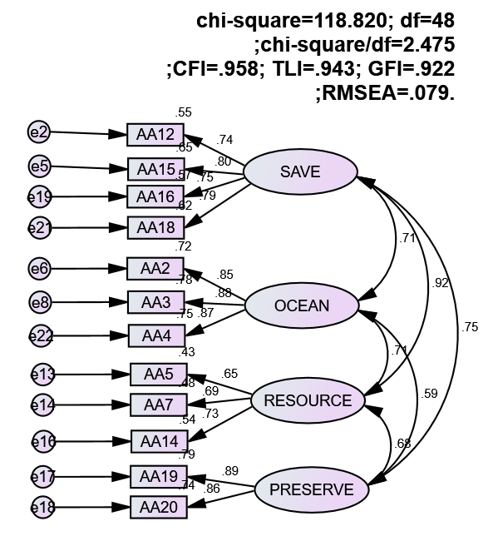
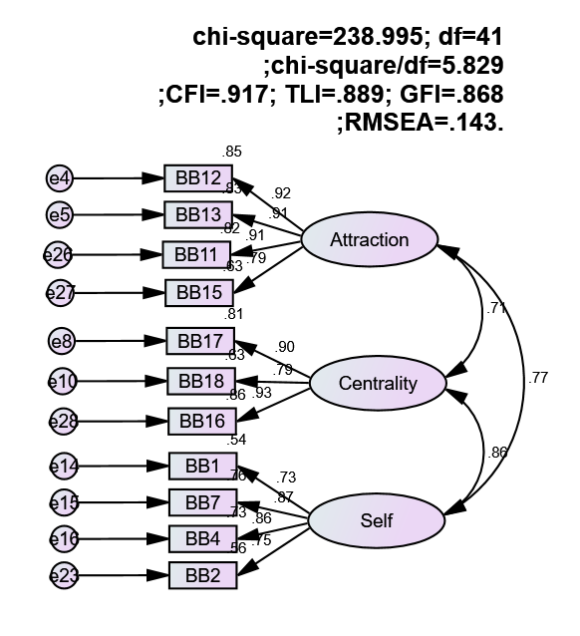
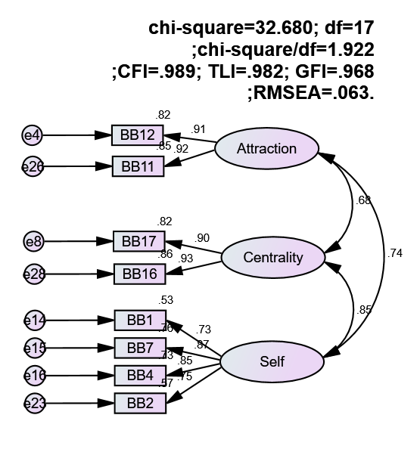
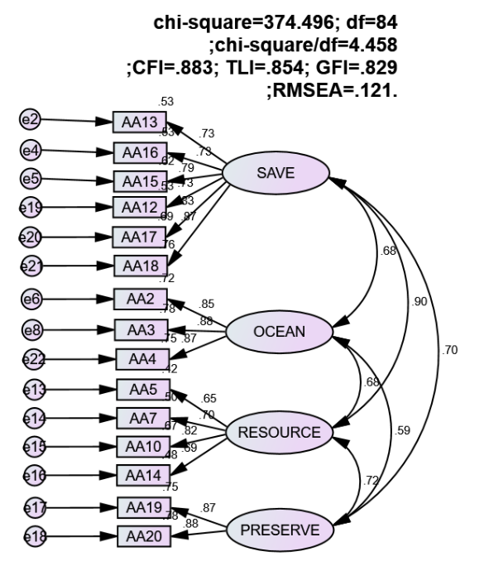
Structural equation modeling

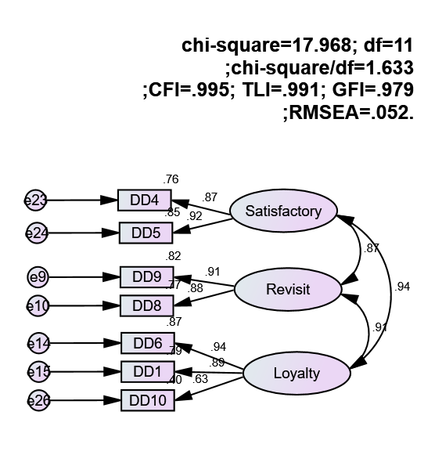
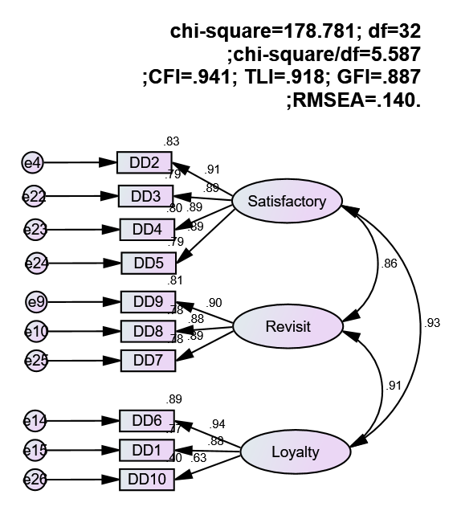
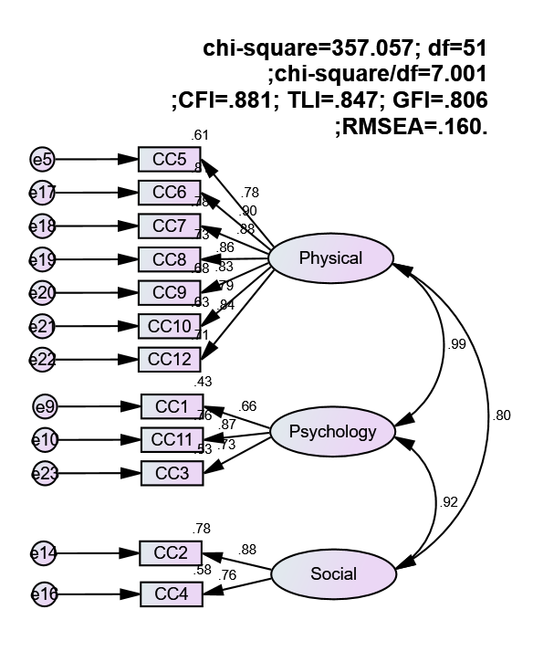
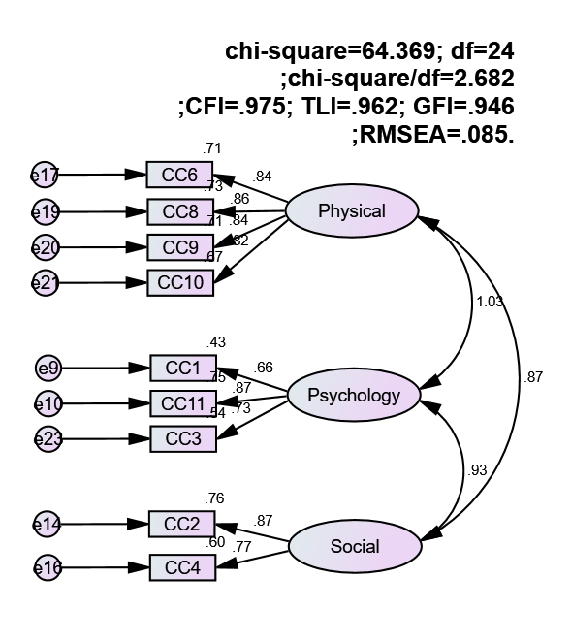

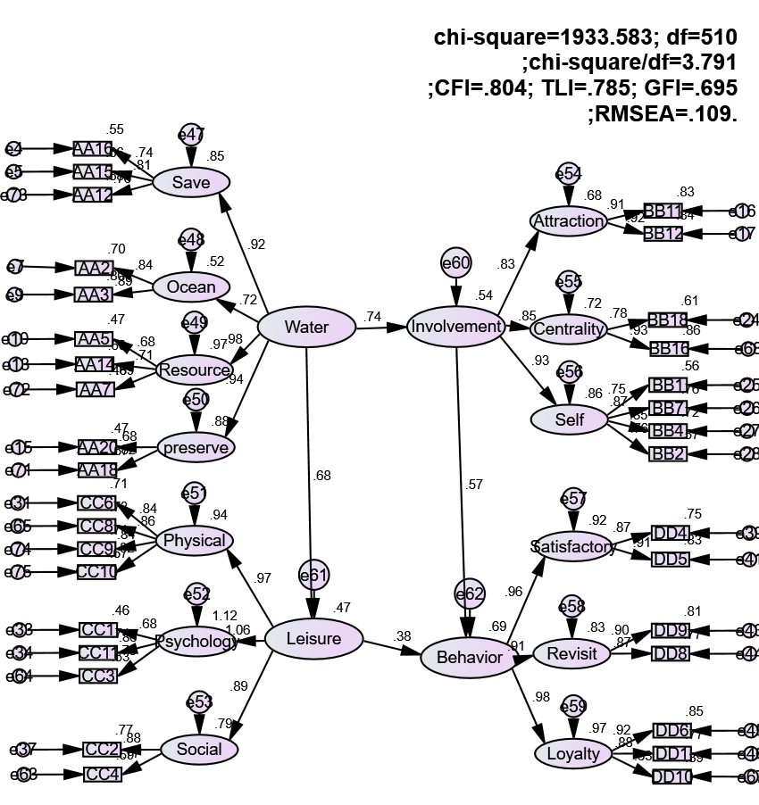
Fig 1. Structural Equation Modelling
Overall structural causal model
The results of the structural path analysis indicated that all hypothesized relationships were statistically significant (see Table 3). Specifically, responsible water activities exerted a significant positive influence on involvement (β = 0.737,T= 5.470, p < .001), providing strong support for H1. Regarding behavioral intention, both responsible water activities (β= 0.446, T = 2.492, p < .05) and involvement (β = 0.729, T = 3.182, p < .01) exhibited positive and significant effects, thereby confirming H2 and H3, respectively. These findings suggest that higher levels of initial motivation and perceived value are critical antecedents to tourists' subsequent behavioral intentions within the context of the study (see Fig 1).
Mediation Analysis
This study employed the bootstrap approach proposed by Efron (1979) to conduct statistical inference, utilizing confidence intervals to estimate indirect effects and examine mediation. The criteria for assessing mediation followed the guidelines of Preacher and Hayes (2004). Specifically, effects are considered non-significant when the confidence interval includes zero, whereas intervals excluding zero indicate statistical significance. An indirect effect is deemed non-existent if its confidence interval contains zero, and significant if it does not. Furthermore, full mediation is indicated when the direct effect is non-significant, whereas partial mediation is supported when both indirect and total effects are significant.
The empirical results demonstrate that the indirect effect of involvement between responsible water activities and behavioral intention is 0.464. Both the bias-corrected (BC) and percentile (PC) 95% confidence intervals exclude zero, with a p-value below 0.05, indicating a significant mediating effect. The direct effect (0.424) is also significant, as its confidence interval does not include zero. Additionally, the total effect (0.888) is statistically significant. Based on the criteria proposed by Preacher and Hayes (2004), the simultaneous significance of both indirect and total effects confirms the presence of partial mediation. Overall, involvement serves as a significant partial mediator in the relationship between responsible water activities and behavioral intention.
Table 3. Summary of the Mediating Effect of Involvement
Responsible water activities (X)→Involvement (M)→Behavioral Intention (Y)
 |  | Estimate | BC/PC 95% Confidence Interval |  |  | Result
 |  | Estimate | P value | BC | PC | Result
Indirect Effect | XMY | 0.464 | 0.000/0.006 | 0.300~1.232 | 0.144~0.707 | Confirmed
Direct Effect | XM | 0.735 | 0.000/0.001 | 0.568~0.875 | 0.548~0.866 | Partial Mediation
Direct Effect | XY | 0.424 | 0.029/0.025 | 0.064~0698 | 0.072~0.705 | Partial Mediation
Direct Effect | MY | 0.631 | 0.000/0.006 | 0.404~1.270 | 0.217~0.883 | Partial Mediation
Total Effect | XY | 0.888 | 0.000/0.001 | 0.064~0.698 | 0.686~0.928 | Confirmed

Table 4. Summary of the Mediating Effect of Leisure Benefits
Responsible water activities (X)→Involvement (M)→Behavioral Intention (Y)
 |  | Estimate | BC/PC 95% Confidence Interval |  |  | Result
 |  | Estimate | P value | BC | PC | Result
Indirect Effect | XMY | 0.464 | 0.000/0.006 | 0.300~1.232 | 0.144~0.707 | Confirmed
Direct Effect | XM | 0.735 | 0.000/0.001 | 0.568~0.875 | 0.548~0.866 | Partial Mediation
Direct Effect | XY | 0.424 | 0.029/0.025 | 0.064~0698 | 0.072~0.705 | Partial Mediation
Direct Effect | MY | 0.631 | 0.000/0.006 | 0.404~1.270 | 0.217~0.883 | Partial Mediation
Total Effect | XY | 0.888 | 0.000/0.001 | 0.064~0.698 | 0.686~0.928 | Confirmed
DISCUSSION AND CONCLUSIONS
This study confirmed that responsible water activities, involvement, and behavioral intention are significantly interrelated within the context of recreational activities in the Southern sea of marine national park. The findings indicate a relatively homogeneous visitor profile, predominantly composed of young, male, and well-educated individuals, with low expenditure patterns and a preference for individualized or small-group participation. Empirical results demonstrate that responsible water activities positively influences both involvement and behavioral intention, while involvement further exerts a significant positive effect on behavioral intention. These results are consistent with prior studies (Ding et al., 2021; Li et al., 2021; Zhu & Liu, 2024), reinforcing the critical role of motivation and experience in shaping tourist behavior. Moreover, involvement is found to partially mediate the relationship between responsible water activities and behavioral intention, supporting the proposed theoretical framework.
From a managerial perspective, tourism operators are advised to design market-oriented products targeting younger segments, incorporating experiential and flexible elements. Pricing strategies should consider low expenditure tendencies by offering tiered products and value-added services. Additionally, integrating traditional and digital media may enhance marketing effectiveness. For policymakers, strengthening promotional efforts and fostering sustainable tourism practices are essential to ensure long-term development, particularly given the ecological sensitivity of the East Sea region.
References
Abbott, L. (1955). Quality and competition. New York: Columbia University Press.
Bakker, A. B. (2009). Building engagement in the workplace. In R. J. Burke & C.L. Cooper (Eds.). The peak performing organization, (pp.50-72). Oxon, UK: Routledge.
Berger, B. C., & McInman, A. (1993). Exercise and the quality of life, In R. N. Singer, M.Murpuh, & Tennant, L. K.(Eds), Handbook of research on sport psychology (pp729-760). New York, NY: Macmillan.
Bryan, H. (1976). Leisure value systemsand recreational specialization:The case of trout fishermen. Journal of Leisure Research, 9(3), 174-187.
Bryan, H. (2000). Recreation specialization revisited. Journal of Leisure Research, 32 (1), 18-21.
Bultena, G. L., & Klessig, L. L. (1969). Satisfaction in camping: A conceptualization and guide to social research. Journal of Leisure Research, 1, 348-364.
Cardozo, R. N. (1965). An experimental study of customer effort, expectation, and satisfaction, Journal of Marketing Research, 24, 244-249.
Chen, H., Wigand, R. T., & Nilan, M. S. (1999). Optimal experience of web activities. Computers in Human Behavior, 15, 585-608.
Csikszentmihalyi, M. (1975). Beyond boredom and anxiety. San Francisco, CA:Jossy:-Bass.
Esgate, P. (2002). Pine and Gilmore stage a fourth think about experience. Strategy and Leadership, 30(3), 47.
Gautier, A. (2004). Why experiential marketing is the next big thing. New Zealand Marketing Magazine, 9, 8-14
Holbrook, M. B.( 2000 ). The millennial consumer in the texts of our times: experience and entertainment. Journal of Macromarketing, 20 (2) , 178-192.
Jackson, S. A. (1995). Factor influencing the occurrence of flow state in elite athletes. Journal of Applied Sport Psychology, 7 (2), 138-166.
Jackson, S. A., & Marsh, H. M. (1996). Development and validation of a scale to measure optimal experience: The Flow State Scale. Journal of Sport & Exercise Psychology, 18, 17-35.
Kotler, P. (2003). Marketing Management. 11th Edition. New Jersey: Prentice Hall
Kuentzel. W. F., & Heberlein. T. A. (1992). Does specialization affect behavioral choices and quality judgments among hunters? Leisure Sciences, 14(3). 211-226.
Lastovicka, J. L., & Kapferer, J. N. (1978). Low involvement versus high involvement cognitive structures. Advances in Consumer Research, 5(1), 87-92.
Little, B. R. (1976). Specialization and the varieties of environmental experience. Experiencing the environment, 81-116, Springer
Loomis, D., Warnick, R., Sylvester, C., & Caldwell, L. (1991). Recreation participation over time-outlook for the future: an examination of trends in selected activities. 1991 NRPA Leisure Research Symposium. Baltimore, Maryland.
Mannell, R. C. (1999). Leisure experience and satisfaction. In E. J. Jackson & T. L. Burton (Eds), Leisure studies: Prospects for the twenty-first century (pp. 235-251). State College, PA: Venture.
McIntyre, N., & Pigram, J. J. (1992). Recreation specialization reexamined: The case of vehicle -based campers. Leisure Science, 14, 3-15.
Novak, P. T., Hoffman, L. D., &Yung, Y. F. (1997). Modeling the structure of the flow experience among web users. Informs Marketing Science and the Internet Mini-Conference, MIT. Retrieved July 31, 2 002, from the World Wide Web: http://ecommerce.vanderbilt.edu/re seach/topics/flow/index.htm
Schmitt, B. H. (1999). Experientia: How to Get Customer to Sense, Feel, Think, Act, and Relate to Your Company and Brands, TheFreePrees, NewYork
Tinsley, H., & Tinsley, D. (1986). A theory of the attributes, benefits, and causes ofleisure experience. Leisure Sciences, 8(1), 1-45.
Tsaur, S. H., & Liang, Y. W.(2008). Serious leisure and recreation specialization. Leisure Sciences, 30(4), 325-341.
Voelkl, J. E., & Ellis, D. G. (1988). Measuring flow experiences in daily life: An examination of the items used to measure challenge and skill. Journal of Leisure Research, 30(3), 380-289.

