Impact of chloride salts on the efficacy
of cryotherapy agents in reducing
skin-surface temperature

Pattira Suktanarak^{1,2}, Benthiwa Surasartpisal² and Jaturong Hemara³
¹ Faculty of Sport and Health Sciences, Thailand National Sports University Chonburi Campus
² Faculty of Sport and Health Sciences, Thailand National Sports University Lampang Campus
³ Faculty of Education, Thailand National Sports University Lampang Campus

Abstract
Cryotherapy, typically involving the use of ice packs, is a common modality for treating injuries. However, the potential influence of chloride salts, characterized by their high abundance, low cost, ready availability, and low environmental impact, on ice packs has not been thoroughly explored. We hypothesized that incorporating chloride salts into wetted ice packs (WI) could reduce the pre-application temperature, leading to a significant decrease in localized skin-surface temperature. Accordingly, we examined the impact of adding sodium chloride (NaCl) to WI and evaluated its effectiveness in reducing skin-surface temperature. We observed that NaCl exhibited higher efficacy in reducing WI temperatures than that exhibited by WI alone. In addition to reducing the pre-application temperature, NaCl is a suitable salt for WI owing to its abundance, cost-effectiveness, and non-toxic nature. Combining NaCl with WI resulted in a significantly lower skin-surface temperature than that of WI alone (P < 0.001). These findings suggest that the addition of NaCl to WI helped achieve a substantial temperature reduction and facilitated a rapid decrease in skin-surface temperature. Our approach presents a potentially favorable option for treating injuries compared with that of the commonly used traditional ice packs. Moreover, cryotherapy employing chloride salt-supplemented WI benefits from the abundance, cost efficiency, and environmentally favorable characteristics of such salts in contrast to synthetic gel packs.

Keywords: Cryotherapy agents, Chloride salts, Wetted ice packs, Skin-surface temperature

Corresponding Author: Pattira Suktanarak, Faculty of Sport and Health Sciences,
Thailand National Sports University Chonburi Campus. Email: suktanarak.p@hotmail.com
Introduction
Cryotherapy has been extensively employed in the initial treatment of acute injuries, musculoskeletal trauma rehabilitation, and post-exercise recovery (Allan et al., 2022; Hawkins and Hawkins, 2016). In terms of physiological and clinical significance, cold therapy has the potential to reduce nerve conduction velocity (Chesterton et al., 2002; Halar et al., 1980; McMeeken et al., 1984), lower local blood flow (Cobbold & Lewis, 1956; Dolan et al., 1997; Taber et al., 1992; Weston et al., 1994), and suppress cellular metabolic rate (Curl et al., 1997; Enwemeka et al., 2002; Sapega et al., 1988), thereby positively impacting pain, edema during inflammation, and secondary hypoxic injury (Bugaj, 1975; Deal et al., 2002; Merrick et al., 1999; Ohkoshi et al., 1999).
Among various cryotherapeutic agents, such as gel packs, vapocoolant sprays, ice immersion, and ice packs, the use of ice packs stands out for reducing skin-surface temperature owing to its distinct features. These features include their effectiveness in cooling tissue, convenience in transportation and on-field settings, cost-effectiveness, and the use of eco-friendly materials. Researchers have attempted to enhance the effectiveness by comparing skin-surface temperature during cold application using different types of ice packs such as cubed, crushed, and wetted ice (Aimkosa, 2017; Dykstra et al., 2009; Hamid et al., 2013; Larsen et al., 2015; Matsumura et al., 2022; Merrick et al., 2003). Adjusting water content in wetted ice packs (WI) (de Estefani et al., 2020) and applying compression during ice application to the skin (Janwantanakul, 2006; Ostrowski et al., 2018; Tomchuk et al., 2010) were explored for effective localized temperature reduction.
Although an optimal temperature decrease for target tissues remains undefined, higher localized temperature decreases are likely to yield additional therapeutic benefits (Dykstra et al., 2009; Merrick et al., 2003; Sapega et al., 1988). Maintaining localized skin-surface temperatures at approximately 13.6, 12.5, and 10°C reportedly induces local analgesia, reducing nerve conduction velocity by approximately 10% (Bugaj, 1975; Chesterton et al., 2002; Jutte et al., 2001; Kennet et al., 2007) and minimizing cellular metabolic rate (Bugaj, 1975; Sapega et al., 1988). To enhance heat transfer, some research studies have concentrated on pre-application temperature reductions of cryotherapeutic agents using freezing point depression through the addition of common household chemicals (e.g. mixing alcohol with water and adding table salts to cubed and crushed ice packs). Nevertheless, despite the superiority of WI over various ice patterns (e.g., cubed, crushed, and salted crushed ice) in reducing skin-surface temperature, no study has investigated the effects of salts on WI (Aimkosa, 2017; Dykstra et al., 2009; Hunter et al., 2016).
Chloride salts are naturally occurring inorganic chemicals found in various foods, beverages, medicines, perspiration, and some deodorants (Lau and Fan, 2009) and possess distinctive attributes such as high abundance, low cost, ease of access, and low environmental impact. Among these, sodium chloride (NaCl) is of particular interest as it is a common household chemical found in table salt, making it highly accessible and non-toxic. Given that table salt typically contains approximately 97% NaCl (Bhattacharya, 2023), it represents a practical and safe source for this study. Consequently, we focused on incorporating NaCl into wetted ice packs (WI), hypothesizing that its addition would lower the pre-application temperature and thereby enhance cryotherapeutic effectiveness.
To validate this hypothesis, we examined the influence of NaCl on temperature decreases in WI. Subsequently, we compared the skin-surface temperature during WI application with and without NaCl. Collectively, we aimed to present an efficient approach to enhancing cryotherapeutic agent cooling, as well as provide an environmentally friendly option by using biodegradable plastic bags for ice pack preparation.

Research objectives
This study aimed to examine the effect of NaCl incorporation into WI on pre-application temperature and to compare the skin-surface temperature during WI application with and without NaCl.

Hypothesis
It was hypothesized that incorporating NaCl into WI would reduce the pre-application temperature and enhance the reduction in skin-surface temperature compared with WI without NaCl.

Research methods
Materials
The temperatures of the cryotherapeutic agents (both WI and WI containing NaCl) were recorded using a Diichi TH-207 (dual-input) digital temperature meter with a type-K thermocouple probe. To monitor the skin-surface temperature, a Diichi TH-205 (single-input) digital temperature meter with a type-K thermocouple probe was employed. According to the manufacturer, the Diichi TH-207 has a resolution of 1°C with an accuracy of ±0.3% at ±1°C, whereas the Diichi TH-205 has a resolution of 0.1°C with an accuracy of ±0.3% at ±1°C. Skinfold thickness was measured using a Lange skinfold caliper (Beta Technology Inc., Cambridge, Maryland). The body fat percentage was analyzed using a body composition monitor (Tanita Corp., Tokyo, Japan). To prepare the cryotherapeutic agents, a 13 cm × 20 cm biodegradable plastic ziplock bag (Advancebio, Thailand) was used to enclose the WI and WI with NaCl. Analytical reagent grade sodium chloride (NaCl) was purchased from KemAus (Australia) and used without further purification. Commercial bottled water was used to prepare the WI.

Procedure
For the typical procedure, WI was prepared by placing 300 g of cubed ice in a 13 cm × 20 cm environmentally degradable plastic bag, adding 100 mL of room-temperature water, and securing each bag with a zip lock. To prepare WI with NaCl, the solid powder of NaCl was mixed with the WI. To monitor the change in temperature of the cryotherapy agent, the plastic zip lock bag was marked with a sign to attach the thermocouple probe connected to a Diichi TH-207 by adhesive tape at two positions to report the average temperatures between two points. For the measurement points, two points were selected at the midpoint of the width and 7 cm from the top and bottom of the long side of the plastic zip lock bag. The changes in the surface temperature of each cryotherapy agent were measured in triplicate.
To investigate skin-surface temperature, all participants waited in the laboratory (temperature controlled at 25.0 ± 1.0°C) for 20 min to attain a stable baseline in their body temperature prior to the commencement of measurements. The participants were requested to remove their shoes and socks and lie supine in a comfortable posture on the treatment couch. Subsequently, the halfway point in the line of prominence of the anterior superior iliac spine and the midpoint of the superior border of the patella on each participant’s right thigh were marked and attached to a type-K thermocouple probe connected to a Diichi TH-205 Digital Temperature Meter using medical adhesive tape. To avoid superficial skin burns (Cuthill & Cuthill, 2006; O'Toole & Rayatt, 1999; Kanlayanaphotporn & Janwantanakul, 2005), the ice packs were wrapped in a microfiber bath towel soaked in water and wrung with water from a towel to prevent direct contact between the ice packs and skin, as described previously. The wrapped cryotherapy agent was centrally applied in the described position, and the skin-surface temperature was monitored at 1-minute intervals for 20 min during cold application and for 20 min during rewarming (after ice pack removal). A 20-minute application duration was selected for this study because of its common clinical usage (Mutlu & Yılmaz, 2020; Otte et al., 2002).

Participants
Ethical approval was obtained from the Research Ethics Committee of the Thailand National Sports University. Twenty healthy volunteers (13 men and 7 women) in the age range of 20–23 years (mean age = 21.8 ± 0.8 years, mean height = 169.2 ± 5.8 cm, mean body mass = 66.9 ± 9.9 kg, mean body mass index = 23.3 ± 2.4 kg/m², mean body fat = 19.6 ± 6.2 %, mean right anterior thigh skinfold = 15.3 ± 5.6 mm) participated in this study. The exclusion criteria were pain or open wounds in the area of the right anterior thigh, cardiovascular or peripheral vascular disease, known muscular or neurologic pathologic conditions, sensory deficits, and a history of allergy to cold or ice. All participants were screened for health status using a modified health history questionnaire, informed of the procedure and risks of the study, and provided written informed consent. None of the volunteers were excluded from the study.
We employed a repeated-measures counterbalanced design to compare skin-surface temperatures during the application of cryotherapy agents with and without NaCl. Each participant was administered separate treatments of WI or WI containing NaCl on two occasions with at least a 24-h interval between the treatment sessions. Prior to performing the procedure, all participants would be tested for cold and hot sensations and discriminatory ability by touching water in a test tube at 15–20°C for cold and 40–45°C for hot in the area of the right quadriceps femoris muscle, according to a previously published procedure (Hill & Petrucci, 2002; Kanlayanaphotporn & Janwantanakul, 2005).

Data analysis
Two-way repeated-measures ANOVA was used to determine the statistical difference in skin-surface temperature over time between WI with and without NaCl. The normal distribution of the data was verified using the Shapiro-Wilk test. In the case of a significant interaction, an independent t-test and one-way ANOVA were used to separately examine the main effects of cryotherapy modalities and time, respectively. All statistical data analyses were performed using SPSS Version 21.0, with the level of significance set at 5% (P < 0.05). A Tukey honest significant difference (HSD) test was performed as post hoc analysis for each main effect in the ANOVA test. In addition, an independent t-test was used to compare analytical reagent grade NaCl and table salt as the additive to WI to indicate the suitability of affordable table salt as a high-performance cryotherapy agent.

Results and discussion

Effect of NaCl on change in ice pack temperature at different times
The mean changes in surface temperature at different times for cryotherapeutic agents with and without NaCl are presented in Figure 1. The WI containing NaCl had lower temperatures than the WI without NaCl at all time points. The mean surface temperature during the 1–20 min period of WI + NaCl was approximately −1 ± 1.4°C, whereas WI without NaCl remained around 4 ± 1.2°C. The findings also revealed that the mean surface temperatures of WI + NaCl and WI without chloride salts at the end of the treatment time (20 min) were −3 ± 0.3°C and 3 ± 0.3°C, respectively.

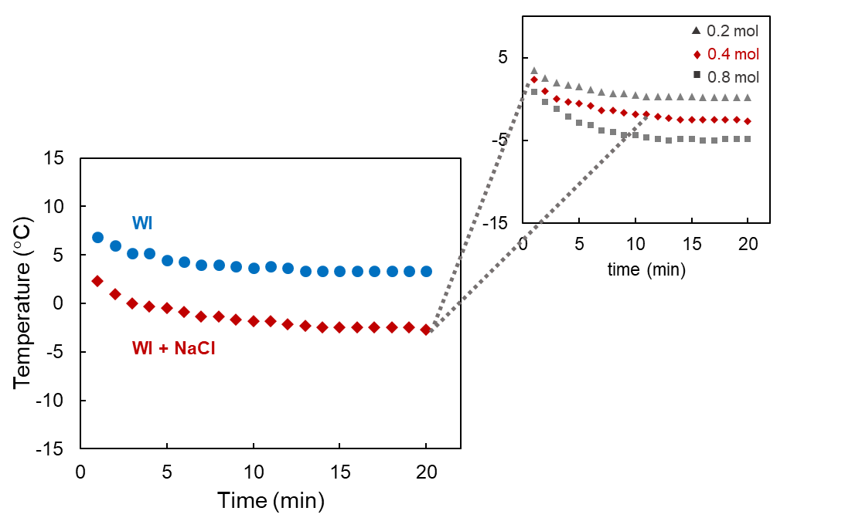
Figure 1. Changes in mean surface temperature of cryotherapeutic agents with (WI + NaCl ♦) and without NaCl (WI •) as a function of time (1–20 min). The inset shows the changes in mean surface temperature of WI with the addition of NaCl at different concentrations (0.2, 0.4 and 0.8 mol NaCl/100 mL water in WI).

The WI showed a gradual decrease in temperature over the 20-minute period, remaining above 0°C throughout, whereas the WI+NaCl exhibited a rapid decline in temperature during the initial phase and reached sub-zero levels within the first few minutes. Notably, among the NaCl-containing WI, increasing NaCl concentration (0.2-0.8 mol/100 mL) was associated with progressively lower temperature. The 0.8 mol formulation demonstrated the lowest temperatures, followed by 0.4 and 0.2 mol, respectively. Overall, all cryotherapeutic agents with NaCl exhibited a decreasing trend in temperature over time, with NaCl-containing formulations maintaining lower temperatures compared to WI alone.
The results suggest that the addition of NaCl helps decrease the pre-application temperature of WI and tends to enhance cryotherapy efficiency. This effect might be explained by 1) the colligative property of freezing point depression and 2) the enthalpy of the solution. Based on the chemistry of melting, the addition of salts to ice packs disrupts the crystal lattice structure of the ice, leading to melting of ice, depression of the freezing point, and a decrease in the temperature of the ice pack systems to below the typical freezing temperature [i.e., < 0°C] (Helmenstine, 2019; Hunter et al., 2016; Sehgal, 2017). Regarding the colligative properties, NaCl dissociated into Na⁺ and Cl⁻ ions, increasing the number of solute particles in the systems and enhancing the freezing point depression effect. Likewise, the enthalpy of the solution, which depends on the chemical characteristics of a particular salt, can indicate whether the reaction is exothermic or endothermic. The enthalpy of solution for NaCl showed a slightly endothermic value (ΔH ∼ +3.9 kJ/mol) [Pandelov et al., 2010], indicating heat absorption from the surroundings which contributes to a decrease temperature in the ice pack systems.
Although the presence of NaCl help reduce the surface temperature of cryotherapy agents, none of them produced a lower temperature than −10°C upon the addition of salts (0.2-0.8 mol). This temperature range (temp > −10°C) would not cause cell damage, in line with a report that suggested that cells would be destroyed when tissue temperature decreased below −10°C (Gage, 1979). These data imply that ice packs are relatively safe for application in cold therapy.

Influence of NaCl on cryotherapy agents
In this study, NaCl influenced the temperature reduction of cryotherapeutic agents upon the addition of NaCl on WI. An increased temperature decrease using cryotherapy agents also tends to contribute to positive therapeutic effects, such as local analgesia and cellular hypometabolism (Dykstra et al., 2009; Merrick et al., 2003; Sapega et al., 1988). When cold is applied to the skin, thermal energy is transferred from high-energy tissue to a low-energy ice pack. According to the laws of thermodynamics, heat transfer occurs unidirectionally from areas with high heat to those with low heat. Notably, a high temperature gradient between the cryotherapy agent and the skin can provide many opportunities for heat transfer (Kennet et al., 2007). The addition of NaCl not only enhanced temperature reduction in WI but was also readily commercially available, making it an easily accessible, inexpensive, and non-toxic option. NaCl is a well-known primary ingredient in ordinary table salts for daily consumption and is frequently referred to as common salt or kitchen salt. Given the high NaCl content in table salts, approximately 97% (Bhattacharya, 2023), replacing pure NaCl with commercial table salt is possible. A preliminary test comparing the effects of pure NaCl (analytical reagent grade) and commercial table salt on the change in pre-application temperature was performed and analyzed using an independent t-test. Statistical analyses revealed no significant difference between pure NaCl and commercial table salts, implying the viability of replacing pure NaCl with commercially available domestic table salt.

Comparison of skin-surface temperature during application of cryotherapy agents with and without NaCl
To investigate the impact of the combination of NaCl and WI on cryotherapy, alterations in skin-surface temperature during the application of WI + NaCl were monitored and compared with those of WI alone. Both cryotherapeutic agents were individually applied to the right quadriceps femoris muscle, and the skin-surface temperature was recorded every 1 min for 20 min during the treatment and recovery phases in a specific region. Before applying the ice packs, the baseline skin-surface temperature of each participant was recorded at 0 min. The WI and WI + NaCl exhibited skin-surface temperatures ranging from 29.7–33.6°C at 0 min. The changes in skin-surface temperature throughout the treatment and recovery periods are depicted in Figure 2. Both cryotherapy agents displayed a similar pattern of skin-surface temperature reduction, rapidly decreasing initially and stabilizing gradually thereafter. Mean skin-surface temperatures had decreased to 10.8 and 7.5°C for WI and WI + NaCl, respectively, after 20 min of cold treatment. These results suggest that the addition of NaCl to WI led to a greater reduction in skin-surface temperature than that of WI alone.
To elucidate the physiological impact of NaCl combined with WI, mean skin-surface temperatures during cold application were analyzed while considering temperature ranges indicative of therapeutic effectiveness: inducing local analgesia at 13.6°C, a 10% reduction in nerve conduction velocity at 12.5°C, and a 50% reduction in cellular metabolism around 10–11°C (Bugaj, 1975; Chesterton et al., 2002; Jutte et al., 2001; Kennet et al., 2007; Sapega et al., 1988). Our data revealed that the mean skin-surface temperature for WI + NaCl was below 13.6°C after 5 min of application and below 11°C after 8 min of application, whereas WI alone yielded a temperature below 13.6°C after 9 min of application and below 11°C after 19 min of application. This indicates that the combination of NaCl with WI influenced the magnitude of temperature reduction and the rate of skin-surface temperature reduction. WI containing NaCl is likely to induce analgesia and lower nerve conduction velocity and cellular metabolic rate quicker than WI alone will. Merrick et al. (2003) and Dykstra et al. (2009) observed that a greater change and faster reduction of the skin-surface temperature tends to result in better treatment outcomes.

Statistical analyses for skin-surface temperature using a two-way repeated-measures ANOVA demonstrated a significant interaction between cryotherapy modalities and time (F_{2.72,51.71} = 7.14, P < 0.05). Owing to the significant interaction, a dependent t-test and a one-way ANOVA were employed to examine the effect of cryotherapy modalities (WI vs. WI + NaCl) at each time points and the effect of time for each modality, respectively. The dependent t-test for skin-surface temperature at all time points except 0 min (1 – 20 min) during application of WI + NaCl was significantly lower than that of WI (P < 0.001). Post hoc one-way ANOVA for time effects exhibited a statistically significant difference in mean skin-surface temperatures during application time for both WI and WI + NaCl (P < 0.001). The post hoc Tukey HSD test revealed that both cryotherapeutic agents provided a statistically significant difference in mean skin-surface temperatures between 1–10 min (P < 0.05), whereas we observed no significance from 11–20 min (P > 0.05) in the 12.6–10.8°C temperature range for WI and 9.2–7.5°C for WI + NaCl. These data suggest that mean skin-surface temperatures were relatively stable after 10 min of cold application.
After ice pack removal, the mean skin-surface temperature rapidly increased at 1 min during rewarming and gradually increased at the next time point (Figure 2). Despite a gradual increase in mean skin-surface temperatures, they remained lower than the original pre-test levels: 26.4 ± 1.3°C for WI and 25.6 ± 1.1°C for WI + NaCl. These data align with those of previous studies (Bugaj, 1975; Enwemeka et al., 2002; Kanlayanaphotporn & Janwantanakul, 2005; McMeeken et al., 1984; Merrick et al., 2003). Nevertheless, blood flow and thus rewarming in deep tissue is likely persistently reduced after ice pack removal (Bugaj, 1975; Enwemeka et al., 2002; Jutte et al., 2001), which might explain the change in intramuscular temperature to enable accurate comparisons. No significant interaction of modality × time (F_{1.33,25.21} = 1.64, P > 0.05) was observed.
The present study had a few limitations. First, the method used for monitoring the skin-surface temperature involved non-invasive measurement with a thermocouple probe attached to the skin. This method cannot directly report the skin-surface temperature. Hence, the skin-surface temperature was obtained from the interface temperature of the skin surface and cryotherapy modality. Nonetheless, the approach demonstrated various advantages including simplicity, rapidity, and safety for participants. Second, skin-surface temperatures may be higher in people with injuries or medical cases than in normal people. Third, the environmental temperature for actual use may be different from that in the experiment owing to factors such as application of the cryotherapy agent outdoors. Moreover, high or low surrounding temperatures may affect the cryotherapy agent’s efficiency. Therefore, these factors may have possibly influenced skin-surface temperature reduction. Notably, the cooling efficacy of cryotherapy agents may be adjusted via modulation of chloride salt concentrations, according to colligative properties, which is dependent on the ratio of the total number of solutes (chloride salts) to the total number of solvent particles. Therefore, the tunability of proper temperature corresponding to injured condition or medical case is of interest for further study. Although high localized skin temperature reductions tend to induce a positive effect on therapeutic treatment, long-term cryotherapy agent administration, especially enhanced cooling agents, should be investigated further to ensure a comprehensive evaluation of their long-term safety and efficacy.
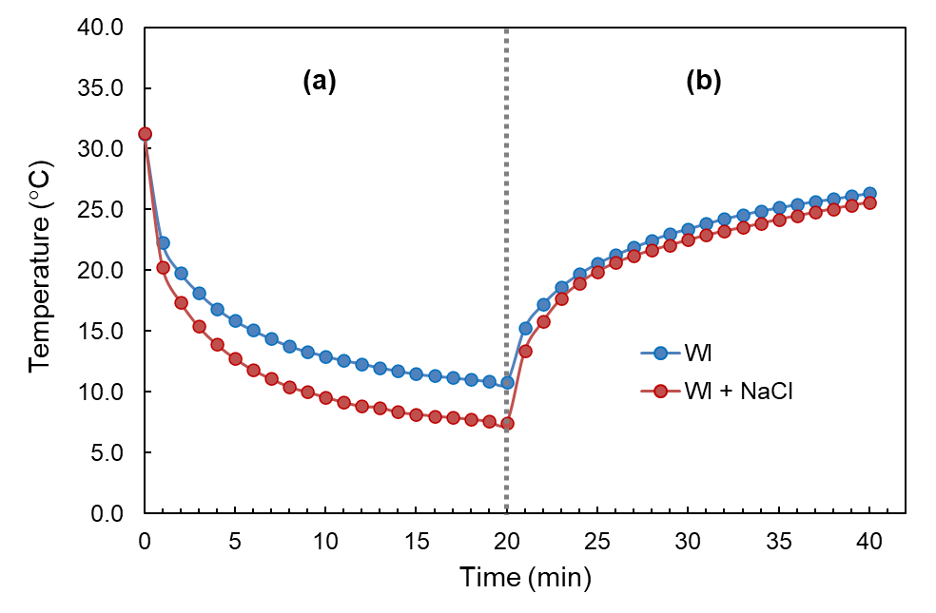

Figure 2. Changes over time for mean skin-surface temperature (a) during and (b) after application of the cryotherapy agents: WI vs. WI + NaCl.

Conclusions
Herein, we present a facile approach to enhance the cooling efficacy of traditional ice packs via the addition of NaCl to WI. The combination of NaCl in WI demonstrated great potential for temperature reduction in cryotherapy agents and a possible positive effect on cold therapy. Between the two modalities examined, WI + NaCl were superior to WI alone as temperature reduction agents. Compared with that of WI alone in terms of skin-surface temperature, WI + NaCl provided a greater and more rapid reduction in skin-surface temperatures. This approach will not only be useful for acute injury treatment, but also crucial for application in sports medicine, post-surgical recovery, and chronic pain management. The distinctive simplicity and rapidity of the cryotherapy agent preparation is also convenient for outdoor injuries and sports injuries.

References
Aimkosa, R., & Suksaard, C. (2017). Comparisons of cryotherapeutic agents' efficacy on skin-surface temperature changes. Journal of Charoenkrung Pracharak Hospital, 13(1), 46-58.
Allan, R., Malone, J., Alexander, J., Vorajee, S., Ihsan, M., Gregson, W., Kwiecien, S., & Mawhinney, C. (2022). Cold for centuries: a brief history of cryotherapies to improve health, injury and post-exercise recovery. European Journal of Applied Physiology, 122(5), 1153-1162. https://doi.org/10.1007/s00421-022-04915-5
Bhattacharya, S. (2023). Chapter 8. Different salts in snacks. In S. Bhattacharya (Ed.). Snack foods (pp. 193-210). Academic Press, Cambridge. http://dx.doi.org/10.1016/B978-0-12-819759-2.00001-X.
Bland, J. M., & Altman, D. G. (1986). Statistical methods for assessing agreement between two methods of clinical measurement. Lancet. 1(8476), 307-310.
Bland, J. M., & Altman, D. G. (1999). Measuring agreement in method comparison studies. Statistical Methods in Medical Research, 8(2), 135-160. https://doi.org/10.1177/096228029900800204
Bugaj, R. (1975). The cooling, analgesic, and rewarming effects of ice massage on localized skin. Physical Therapy, 55(1), 11-19. https://doi.org/10.1093/ptj/55.1.11
Chesterton, L. S., Foster, N. E., & Ross, L. (2002). Skin temperature response to cryotherapy. Archives of Physical Medicine and Rehabilitation, 83(4), 543-549. https://doi.org/10.1053/apmr.2002.30926
Chuang, L. L., Lin, K. C., Hsu, A. L., Wu, C. Y., Chang, K. C., Li, Y. C., & Chen, Y. L. (2015). Reliability and validity of a vertical numerical rating scale supplemented with a faces rating scale in measuring fatigue after stroke. Health and Quality of Life Outcomes, 13(91). https://doi.org/10.1186/s12955-015-0290-9
Cobbold, A. F., & Lewis, O. J. (1956). Blood flow to the knee joint of the dog; effect of heating, cooling and adrenaline. The Journal of Physiology, 132(2), 379-383. https://doi.org/10.1113/jphysiol.1956.sp005531
Curl, W. W., Smith, B. P., Marr, A., Rosencrance, E., Holden, M., & Smith, T. L. (1997). The effect of contusion and cryotherapy on skeletal muscle microcirculation. The Journal of Sports Medicine and Physical Fitness, 37(4), 279-286.
Cuthill, J. A., and Cuthill, G. S. (2006). Partial-thickness burn to the leg following application of a cold pack: case report and results of a questionnaire survey of Scottish physiotherapists in private practice. Physiotherapy, 92(1), 61-65. https://doi.org/10.1016/j.physio.2005.06.004
De Estéfani, D., Ruschel, C., Benincá, I. L., Dos Santos Haupenthal, D. P., De Avelar, N. C. P., & Haupenthal, A. (2020). Volume of water added to crushed ice affects the efficacy of cryotherapy: a randomised, single-blind, crossover trial. Physiotherapy, 107, 81-87. https://doi.org/10.1016/j.physio.2019.12.005
Deal, D. N., Tipton, J., Rosencrance, E., Curl, W. W., & Smith, T. L. (2002). Ice reduces edema. A study of microvascular permeability in rats. Journal of Bone and Joint Surgery. American volume, 84(9), 1573-1578.
Dolan, M. G., Thornton, R. M., Fish, D. R., & Mendel, F. C. (1997). Effects of cold water immersion on edema formation after blunt injury to the hind limbs of rats. Journal of Athletic Training, 32(3), 233-237.
Dykstra, J. H., Hill, H. M., Miller, M. G., Cheatham, C. C., Michael, T. J., & Baker, R. J. (2009). Comparisons of cubed ice, crushed ice, and wetted ice on intramuscular and surface temperature changes. Journal of Athletic Training, 44(2), 136-141. https://doi.org/10.4085/1062-6050-44.2.136
Enwemeka, C. S., Allen, C., Avila, P., Bina, J., Konrade, J., & Munns, S. (2002). Soft tissue thermodynamics before, during, and after cold pack therapy. Medicine and Science in Sports and Exercise, 34(1), 45-50. https://doi.org/10.1097/00005768-200201000-00008
Gage, A. A. (1979). What temperature is lethal for cells?. The Journal of Dermatologic Surgery and Oncology, 5(6), 459-464. https://doi.org/10.1111/j.1524-4725.1979.tb00695.x
Halar, E. M., DeLisa, J. A., & Brozovich, F. V. (1980). Nerve conduction velocity: relationship of skin, subcutaneous and intramuscular temperatures. Archives of Physical Medicine and Rehabilitation, 61(5), 199-203.
Hamid, N. A., Nawawi, M. F., Abdullah, N. M., & Latif, R. A. (2013). Efficacy of cubed-ice and wetted-ice as a cryotherapeutic agent in the Malaysian climate. Procedia – Social and Behavioral Sciences, 105, 211-219. https://doi.org/10.1016/j.sbspro.2013.11.022
Hawkins, S. W., & Hawkins, J. R. (2016). Clinical applications of cryotherapy among sports physical therapists. International Journal of Sports Physical Therapy, 11(1), 141-148.
Helmenstine, A. M. (2019). How cold does ice get with salt? Retrieved from https://www.thoughtco.com/how-cold-does-ice-get-with-salt-4017627.
Hill, J., & Petrucci, R. (2002). General Chemistry: an integrated approach. Prentice Hall, Upper Saddle River.
Hunter, E. J., Ostrowski, J., Donahue, M., Crowley, C., & Herzog, V. (2016). Effect of salted ice bags on surface and intramuscular tissue cooling and rewarming rates. Journal of Sport Rehabilitation, 25(1), 70-76. https://doi.org/10.1123/jsr.2014-0289
Janwantanakul, P. (2006). Cold pack/skin interface temperature during ice treatment with various levels of compression. Physiotherapy, 92(4), 254-259. https://doi.org/10.1016/j.physio.2006.05.006
Jutte, L. S., Merrick, M. A., Ingersoll, C. D., & Edwards, J. E. (2001). The relationship between intramuscular temperature, skin temperature, and adipose thickness during cryotherapy and rewarming. Archives of Physical Medicine and Rehabilitation, 82(6), 845-850. https://doi.org/10.1053/apmr.2001.23195
Kanlayanaphotporn, R., & Janwantanakul, P. (2005). Comparison of skin surface temperature during the application of various cryotherapy modalities. Archives of Physical Medicine and Rehabilitation, 86(7), 1411-1415. https://doi.org/10.1016/j.apmr.2004.11.034
Kennet, J., Hardaker, N., Hobbs, S., & Selfe, J. 2007. Cooling efficiency of 4 common cryotherapeutic agents. Journal of Athletic Training, 42(3), 343-348.
Larsen, C. C., Troiano, J. M., Ramirez, R. J., Miller, M. G., & Holcomb, W. R. (2015). Effects of crushed ice and wetted ice on hamstring flexibility. Journal of Strength and Conditioning Research, 29(2): 483-488. https://doi.org/10.1519/jsc.0000000000000340
Lau, L., and Fan, J. (2009). 13 - Laundry performance of fabrics and garments. In. J. Fan, L. Hunter, (Eds.). Engineering apparel fabrics and garments (p. 353). Woodhead Publishing, Sawston. https://doi.org/10.1533/9781845696443.339
Matsumura, N., Nagashima, S., Negoro, K., Motomura, Y., Shimoura, K., Tateuchi, H., Ichihashi, N., Aoyama, T., & Nagai-Tanima, M. (2022). The effect of Liquid ice after high-intensity exercise on muscle function compared to Block ice. Journal of Exercise Science and Fitness, 20(1), 23-26. https://doi.org/10.1016/j.jesf.2021.12.001
McMeeken, J., Lewis, M. M., & Cocks, S. (1984). Effects of cooling with simulated ice on skin temperature and nerve conduction velocity. Australian Journal of Physiotherapy, 30(4), 111-114. https://doi.org/10.1016/S0004-9514(14)60682-6
Merrick, M. A., Jutte, L. S., & Smith, M. E. (2003). Cold modalities with different thermodynamic properties produce different surface and intramuscular temperatures. Journal of Athletic Training, 38(1): 28-33.
Merrick, M. A., Rankin, J. M., Andres, F. A., & Hinman, C. L. (1999). A preliminary examination of cryotherapy and secondary injury in skeletal muscle. Medicine and Science in Sports and Exercise, 31(11), 1516-1521. https://doi.org/10.1097/00005768-199911000-00004
Mutlu, S., & Yilmaz, E. (2020). The effect of soft tissue injury cold application duration on symptoms, edema, joint mobility, and patient satisfaction: a randomized controlled trial. Journal of Emergency Nursing, 46(4), 449-459. https://doi.org/10.1016/j.jen.2020.02.017
O’Toole, G., & Rayatt, S. (1999). Frostbite at the gym: a case report of an ice pack burn. British Journal of Sports Medicine, 33(4), 278-279. https://doi.org/10.1136/bjsm.33.4.278
Ohkoshi, Y., Ohkoshi, M., Nagasaki, S., Ono, A., Hashimoto, T., & Yamane, S. (1999). The effect of cryotherapy on intraarticular temperature and postoperative care after anterior cruciate ligament reconstruction. The American Journal of Sports Medicine, 27(3), 357-362. https://doi.org/10.1177/03635465990270031601
Ostrowski, J., Purchio, A., Beck, M., Leisinger, J., Tucker, M., & Hurst, S. (2018). Examination of intramuscular and skin temperature decreases Produced by the PowerPlay Intermittent Compression Cryotherapy. Journal of Sport Rehabilitation, 27(3), 244-248. https://doi.org/10.1123/jsr.2016-0244
Otte, J. W., Merrick, M. A., Ingersoll, C. D., & Cordova, M. L. (2002). Subcutaneous adipose tissue thickness alters cooling time during cryotherapy. Archives of Physical Medicine and Rehabilitation, 83(11), 1501-1505. https://doi.org/10.1053/apmr.2002.34833
Pandelov, S., Werhahn, J. C., Pilles, B. M., Xantheas, S. S., & Iglev, H. (2010). An empirical correlation between the enthalpy of solution of aqueous salts and their ability to form hydrates. The Journal of Physical Chemistry. A, 114(38), 10454-10457. https://doi.org/10.1021/jp106050r
Sapega, A. A., Heppenstall, R. B., Sokolow, D. P., Graham, T. J., Maris, J. M., Ghosh, A. K., Chance, B., & Osterman, A. L. (1988). The bioenergetics of preservation of limbs before replantation. The rationale for intermediate hypothermia. Journal of Bone and Joint Surgery. American volume, 70(10), 1500-1513.
Sehgal, T., & Wright, C. (2017). Breaking the ice: a scientific take on the ice melting abilities of household salts. Journal of Emerging Investigators, 1-7. https://doi.org/10.59720/17-050
Taber, C., Contryman, K., Fahrenbruch, J., LaCount, K., & Cornwall, M. W. (1992). Measurement of reactive vasodilation during cold gel pack application to nontraumatized ankles. Physical Therapy, 72(4), 294-299. https://doi.org/10.1093/ptj/72.4.294
Tomchuk, D., Rubley, M. D., Holcomb, W. R., Guadagnoli, M., & Tarno, J. M. 2010. The magnitude of tissue cooling during cryotherapy with varied types of compression. Journal of Athletic Training, 45(3), 230-237. https://doi.org/10.4085/1062-6050-45.3.230
Weston, M., Taber, C., Casagranda, L., and Cornwall, M. (1994). Changes in local blood volume during cold gel pack application to traumatized ankles. Journal of Orthopaedic and Sports Physical Therapy, 19(4), 197-199. https://doi.org/10.2519/jospt.1994.19.4.197

