Effectiveness of Ultrasound Therapy and Laser Therapy in Pain and Shoulder Range of Motion in Adhesive Capsulitis – A Randomized Clinical Trial
Dr.Pratik Chettri
Associate Professor ,Sikkim Manipal College of Physiotherapy ,India

Abstract: The study aims to find the effectiveness of Ultrasound Therapy and Laser therapy in pain and shoulder ROM in adhesive capsulitis. Using a computer generated block random sampling 44 subjects with adhesive capsulitis was divided into two groups in department of physiotherapy central referral hospital ,Gangtok,india. The criteria for inclusion was subjects 35-65 years old subjects with Unilateral adhesive capsulitis. The outcome measures were Penn Shoulder Scale and range of motion by inclinometer.Treatment was given 3 times a week for 4 weeks.The results found that there was reduction in pain and increase in shoulder range of motions in both the group which indicates that both the interventions are effective .
But, neither of the intervention is found to be superior to the other except for increasing shoulder range of motion more in ultrasound group.
Conclusion: Both treatment modalities are effective in decreasing pain and increasing shoulder range of motion in adhesive capsulitis but Ultrasound therapy along with Maitland mobilization was more effective in increasing shoulder flexion range of motion in adhesive capsulitis as compared to laser therapy along with Maitland mobilization.

Keywords: adhesive capsulitis,LASER,ultrasound,penn score

Introduction
Adhesive capsulitis is defined as a condition where there is restriction of active and passive Range of Motion(ROM) in all directions. Adhesive capsulitis occurs 5% in general population. Females are 4 times more affected than male, while the non-dominant side is affected more than the dominant side. Ultrasound is a mechanical device emitting ultrasonic vibration. This vibratory energy is converted to heat energy and increases the temperature of tissue, which is one of the thermal effects caused by ultrasound therapy. Laser has been demonstrated to reduce muscle pain by reducing oxidative stress or by blocking axonal transport and facilitates collagen production and tendon healing which causes increase in ROM Mobilization is commonly used treatment strategy in physiotherapy department. Maitland’s mobilization involves the rhythmic and oscillatory movement pattern that trigger mechanoreceptors (type-2) and helps in inhibiting the nociceptive receptor (type-4) which eventually helps in relieving pain.
Penn Shoulder Scale is a condition specific self-questionnaire scale which consists of three sub scales that are pain, satisfaction, and function with total of 100 scoring points. This scale helps to know about patient pain ,satisfaction and disability level.Bubble inclinometer is a device used to measure the range of motion of joints. It uses liquid inside it which moves along with movement of limb which helps in measuring range of motion.
Research objective
To check the effectiveness of Ultrasound Therapy and Laser therapy in pain and shoulder ROM in adhesive capsulitis.
Research Hypothesis
To check significant difference between Ultrasound therapy and Laser therapy in pain and shoulder range of motion in adhesive capsulitis.
Research Methods
A Randomized clinical trial (RCT) was conducted in Physiotherapy OPD,Central Referral Hospital (CRH), Gangtok .Study population were subjects with adhesive capsulitis
Sample size calculation was done using g power software where, effect size =1.01, alpha error prob=0.05power=0.95, allocation ratio N2/N1=1 .Sample size was 22 in each group using a Computer generated blocked random sampling.Study duration was june 2022 to May 2023
Eligibilty criteria was participants with Unilateral adhesive capsulitis,capsular pattern of restriction in ROM and age group 35-65 years of age.
After the Ethical Committee of the Institute accepted the research proposal, a notice was circulated to the Department of Physiotherapy and to the other Departments of Central Referral Hospital. The notice provides information about the study and request to refer patients with diagnosed adhesive capsulitis. A detailed examination of the participants was done to those who meet the inclusion criteria and to those who voluntarily included as participants in this study. Randomization was done into two groups (ULTRASOUND and LASER) by using Computer generated blocked random sampling by the blinded assessor. Thereafter, the participants were explained about the study and informed consent forms were taken. Before the interventions, the participants were assessed, and all the required data was collected. Investigator 1 allocates the patients and the investigator 2 rate the patients’ outcomes (i.e., bubble inclinometer, Penn shoulder score) pre- and post-intervention. Investigator 1 gave intervention to the patients. Intervention was given 3 times a week for 4 weeks. On the first day, before starting treatment, baseline data of PENN scale and bubble inclinometer was taken for both groups by investigator 2. Data was again collected following the same procedure at the end of the treatment i.e., at last day of treatment of 2nd week and at the last day of treatment of 4th week and follow up was taken for Penn shoulder scale after 1 month by the investigator 2.
Research Instrument
Laser ultrasound bubble inclinometer and treatment couch was used for the study.
Data Analysis Method
Data was analyzed using SPSS software version 2020
Descriptive statistics summarized demographic data, age of the participants , dominant hand , affected hand, gender, duration of pain and occupation.
A Generalised Linear Measure repeated measures ANOVA 2 (time) × 2 (Group) with Group x Time effect was carried out showing the differences in the two-treatment groups.

Results

When Comparison at baseline was done.The outcome measures were not significantly different in the ultrasound group as compared to laser group at the beginning of trial. The only significant difference seen in shoulder extension at baseline.
The descriptive statistics and test statistics are given in the following table 1.

Table 1 – Baseline comparison of outcome measures in ultrasound and laser groups
 | Baseline
 | Ultrasound (22) | Laser (22) | pᶲ
Flexion | 106.36±28.418 | 93.86±22.143 | 0.111
Abduction | 89.23±39.537 | 71.82±21.852 | 0.078
Extension | 27.50±9.226 | 34.50±10.901 | 0.027
Internal rotation | 28.18±14.520 | 25.50±13.518 | 0.529
External rotation | 25.95±22.626 | 22.41±16.434 | 0.555
Pain | 11.32±6.136 | 9.45±5.189 | 0.283
Note – All values in mean and standard deviation unless stated otherwise

Within group analysis:
GLM repeated measures ANOVA was run on the outcome measures to determine the effect of two electrotherapy modalities (ultrasound therapy and Maitland mobilization compared with laser and Maitland mobilization) over four weeks on outcome measures in study participants. Interaction effects of different shoulder range of motion vs time points were computed for outcome measures. Standardized residuals for interventions and for the overall model were normally distributed. The results are summarized in table 2

Table 2 provides the information of within group analysis where there is improvement in both groups in pain and shoulder range of motion as the treatment goes on. The data were compared within group in different treatment time where there is increase in mean values of pain and shoulder range of motion as the treatment progresses. In both groups mean value lies within the confidence level which suggests that the value is significant.

Table 2 – Summary of group by time data for outcome measures which showed.
significant interaction effect
 | Group | Time | Mean ± SE | 95% Confidence Interval
Flexion | Ultrasound | Baseline | 7.500±1.953 | 3.559-11.441
Flexion | Ultrasound | At the end of 2nd week | 10.909±1.358 | 8.168-13.651
Flexion | Ultrasound | At the end of 4th week | 12.727±1.663 | 9.372-16.083
Flexion | Laser | Baseline | 11.727±1.953 | 7.786-15.668
Flexion | Laser | At the end of 2nd week | 10.818±1.358 | 8.077-13.560
Flexion | Laser | At the end of 4th week | 10.909±1.663 | 7.554-14.264
Abduction | Ultrasound | Baseline | 10.091±1.758 | 6.543-13.638
Abduction | Ultrasound | At the end of 2nd week | 11.591±1.858 | 7.841-15.341
Abduction | Ultrasound | At the end of 4th week | 9.318±1.860 | 5.564-13.072
Abduction | Laser | Baseline | 10.409±1.758 | 6.862-13.957
Abduction | Laser | At the end of 2nd week | 12.136±1.858 | 8.387-15.886
Abduction | Laser | At the end of 4th week | 11.000±1.860 | 7.246-14.754
Extension | Ultrasound | Baseline | 8.182±1.502 | 5.151-11.213
Extension | Ultrasound | At the end of 2nd week | 7.500±1.411 | 4.652-10.348
Extension | Ultrasound | At the end of 4th week | 7.500±1.411 | 4652-10.348
Extension | Laser | Baseline | 7.409±1.502 | 4.378-10.440
Extension | Laser | At the end of 2nd week | 8.864±1.411 | 6.016-11.712
Extension | Laser | At the end of 4th week | 8.864±1.411 | 6.016-11.712
Internal rotation | Control | Baseline | 4.545±0.671 | 3.190-5.900
Internal rotation | Control | At the end of 2nd week | 4.545±0.662 | 3.210-5.881
Internal rotation | Control | At the end of 4th week | 4.273±0.906 | 2.445-6.100
Internal rotation | Experimental | Baseline | 4.364±0.671 | 3.009-5.719
Internal rotation | Experimental | At the end of 2nd week | 4.818±0.662 | 3.483-6.154
Internal rotation | Experimental | At the end of 4th week | 2.818±0.906 | 0.991-4.646
External rotation | Ultrasound | Baseline | 4.273±0.906 | 2.445-6.100
External rotation | Ultrasound | At the end of 2nd week | 3.636±0.643 | 2.338-4.935
External rotation | Ultrasound | At the end of 4th week | 2.864±0.592 | 1.669-4.058
External rotation | Laser | Baseline | 2.818±0.906 | 0.991-4.646
External rotation | Laser | At the end of 2nd week | 4.409±0.643 | 3.111-5.707
External rotation | Laser | At the end of 4th week | 3.955±0.592 | 2.760-5.149
Pain | Ultrasound | Baseline | 11.318±1.212 | 8.873-13.763
Pain | Ultrasound | At the end of 2nd week | 16.273±1.043 | 14.168-18.377
Pain | Ultrasound | At the end of 4th week | 20.773±1.175 | 18.402-23.143
Pain | Ultrasound | After 1 month | 26.727±1.088 | 24.532-28.922
Pain | Laser | Baseline | 9.455±1.212 | 7.010-11.899
Pain | Laser | At the end of 2nd week | 13.8644±1.043 | 11.759-15.968
Pain | Laser | At the end of 4th week | 18.045±1.175 | 15.675-20.416
Pain | Laser | After 1 month | 23.955±1.088 | 21.759-26.150

Between group analysis:
Table 3 explains between group analysis which was done at end of the 4th week of treatment session in which there was significant improvement in flexion range of motion in both groups with mean and standard deviation of (12.727±1.663, 10.909±1.663) in ultrasound and laser therapy respectively. But more improvement can be seen in ultrasound group than in laser group with mean difference of approximately 2. The figure depicts Penn shoulder score between group where linear improvement could be observed in groups however, ultrasound group showed larger improvement.

Table 3– Summary table of effects in outcome measures

Measure | Last day of treatment at 4th week |  | Effect | F | p | η2
Measure | ultrasound  n=22 | Laser  n=22
Flexion | 12.727±1.663 | 10.909±1.663 | Group x time | 3.107 | 0.050 | 0.069
Abduction | 9.318±1.860 | 11.000±1.860 | Group x time | 0.190 | 0.827 | 0.005
Extension | 7.500±1.411 | 8.864±1.411 | Group x time | 0.887 | 0.416 | 0.021
Internal rotation | 4.273±0.906 | 2.818±0.906 | Group x time | 1.118 | 0.332 | 0.26
External rotation | 2.864±0.592 | 3.955±0.592 | Group x time | 2.487 | 0.089 | 0.056
Pain | 26.727±1.088 | 23.955±1.088 | Group x time | 0.178 | 0.911 | 0.004

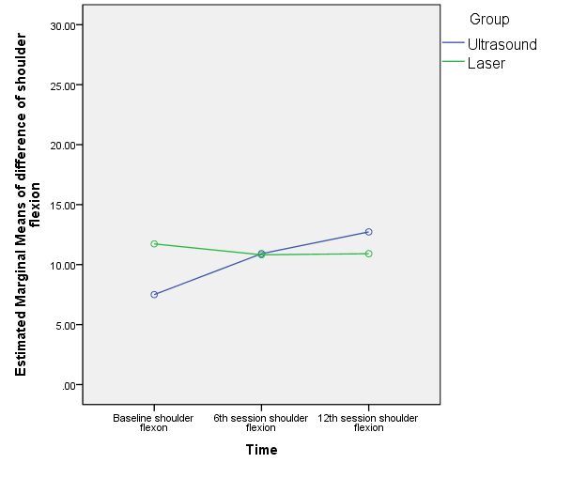
Figure 18: Time vs estimated marginal means of difference of shoulder scale shows improvement in shoulder flexion in ultrasound group than in laser group

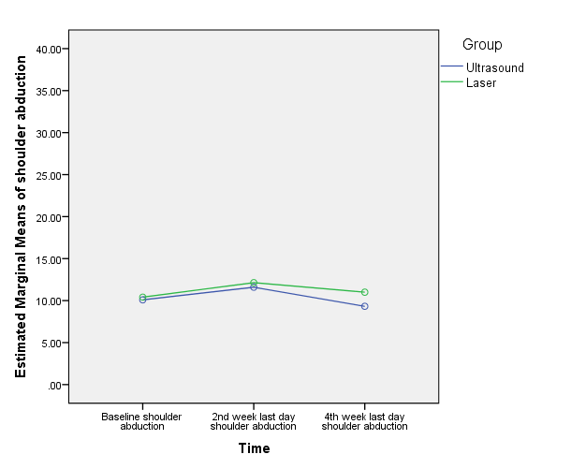

Figure 19: Time vs estimated marginal means of difference of shoulder abduction shows improvement of shoulder abduction in laser group than in ultrasound group
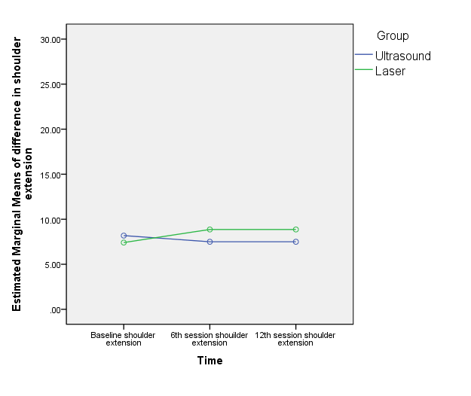
Figure 20: Time vs estimated marginal means of difference of shoulder extension shows improvement in both the groups, but more improvement can be in laser group

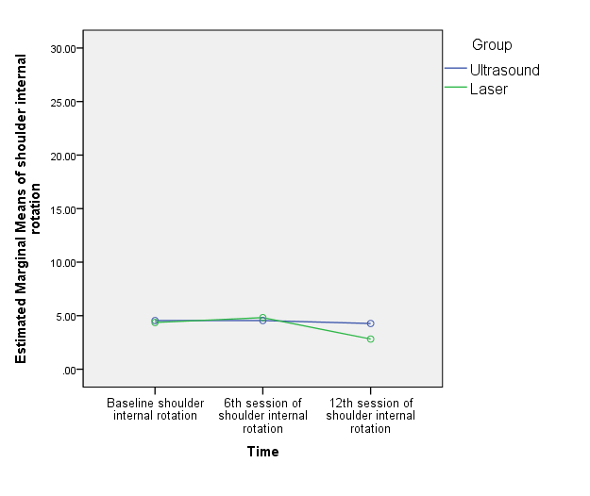

Figure 21: Time vs estimated marginal means of difference of shoulder internal rotation shows no improvement in shoulder internal rotation in both the treatment group.

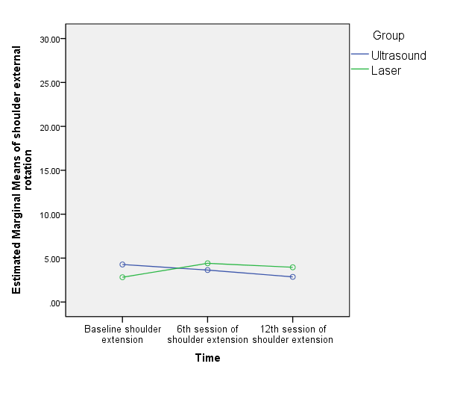
Figure 22: Time vs estimated marginal means of difference of shoulder external rotation shows no improvement in shoulder external rotation in both the treatment groups.

The mean gain in pre-post shoulder range (abduction, external rotation, and extension) in Laser group is linearly increased till 6th session and is decreased progressively in 12th session and follow up as depicted in figure 3, 4 and 6, however in figure 1, shoulder flexion had linear improvement till the end of session in both the groups. The mean gain in pre-post shoulder range (flexion, extension, and external rotation) in ultrasound group is reduced with each session as depicted in figure 1,3 and 6. The shoulder extension ROM in both groups showed a plateau in ROM after 6th session. The was no change in external rotation in the ultrasound group.

Discussion
The aim of the study was to find the effectiveness of ultrasound therapy and laser therapy in pain and shoulder range of motion in patients with adhesive capsulitis.
In this study baseline comparison between the group was done, where statistically significant data can be seen in the extension as there is no involvement of extension range of motion in the adhesive capsulitis.
In this study baseline comparison between the groups was done where statistically significant improvement can be seen in the extension as there is no involvement of extension range of motion in the adhesive capsulitis. This study found out the significant improvement in shoulder flexion, shoulder abduction, extension, internal rotation, external rotation within the group analysis. Pain in the groups when analyzed, also revealed statistically significant improvement. When both the treatment groups were compared, there was a significant improvement in flexion in the groups, but more significant improvement can be seen in ultrasound group. It may be because in adhesive capsulitis there is no involvement of flexion pattern.
Dogru et.al reported that the ultrasound therapy group showed greater gain in flexion, internal rotation, and external rotation than ultrasound therapy group but there was no improvement in pain in between the group’s comparison. Ultrasound uses molecular vibration as non-thermal effects in the form of cavitation and microstreaming which increases the cell membrane permeability and soft tissue healing. Molecular vibration is change in to heat energy which increases the extensibility of collagen and tendon which increases the viscosity of the collagen and resolve fibrosis, leading to pain reduction and increase shoulder movement in patients with adhesive capsulitis.¹⁶
The present study revealed that there is significant improvement in shoulder flexion with 4 weeks of laser therapy. The recorded improvement is comparable with the study done by the Stergioulas who reported the treatment with laser therapy for 8 weeks in participants with adhesive capsulitis shows more improvement in pain intensity, disability score and shoulder range at the end of 4 and 8 weeks of treatment¹⁰. Studies stated that laser helps in decreasing pain and inflammation by changing prostaglandin E2 concentrations. It also helps in reducing the pain by increasing the blood circulation and removal of wastage substances from the body. Laser therapy reduces muscle pain by decreasing concentration of free oxidative radicals or by stopping axoplasmic transport ^{17,18}. A study by Reddy et.al, found out that the laser therapy helps in tendon healing and collagen formation. The collagen present in the ligaments and the synovia loses it function in adhesive capsulitis. This in return results in restriction of glenohumeral joint range. Once the collagen around the ligament of glenohumeral joint and the synovia loosens then it may help in increasing the shoulder range of motion¹⁹. Further, study done by Madani et.al states that any treatment modalities that relieve pain and promote healing can facilitate tendon excursion and increase the active range of motion.²⁰
Use of ultrasound also decreased the pain in four weeks of treatment session in this study, which was in tandem with a study done by Robertson VJ et.al. reported the use of ultrasound therapy in treating patients with adhesive capsulitis. The reason behind it may be because of the thermal and non-thermal effects of ultrasound therapy. This is useful in decreasing pain and inflammation that promotes tissue elasticity. The non-thermal effects of ultrasound therapy help in decreasing the symptoms and the prevention of its relapse. The use of ultrasound has also shown a decrease in the rehabilitation time.²¹
Another study done by Anderson et. al. suggested that ultrasound is beneficial by increasing blood circulation as well as decreasing the adhesion in the lymphocytes along with that there is increase in the mast cell which helps in removal of waste material as well as increase in the level of the T-cells helps in maintaining the immunological memory and self-tolerance. It helps in dissolution of the adhesions that were restricting the joint function. It helps in lengthening the shorten tendon and further improving the range of glenohumeral joint.²²
In the present study, laser also helps in decreasing the pain in the adhesive capsulitis which was similar to the study done by the Bjordal 2010, and Peplow 2010 which suggest that laser therapy is effective in pain relief with decrease in pro-inflammatory cytokines levels and increases cytokines level of anti-inflammatory growth factor. Laser therapy has an effect of photochemical reactions in cells which is known as photobioactivation which produces its physiological and therapeutic effects by producing energy to disturb orbits of local electron. It starts the exchange of chemicals and produces free radicals at the cell membrane. This helps in decreasing inflammation healing of the tissue and later causes decrease in pain tolerance level (Robertson et al 2006, Watson 2000). The effects of laser therapy are dependent upon dosage, wavelength, site as well as duration of treatment²³
Another study done by Hawkins et. al, found that the target cells from mitochondria and cell membranes absorbed the photon from a laser probe. Photon emitted by laser changes into chemical energy within the cell, in the form of Adenosine triphosphate (ATP), which helps in regulation of cell function which increases the healing of the tissue and cause pain relief. ²⁴
The present study also included the Maitland mobilization in both the groups which was given in AP, PA, and inferior glide for 2-3 glides for 30 seconds and 5 rest in between for 5 repetition which may have improvement in shoulder range and pain intensity. The study done by Kumar et.al, in which Maitland mobilization technique with the addition of exercises has helped in decreasing pain and improving R.O.M. and shoulder function. It may be because when gliding force is given during mobilization to particular parts of capsule of glenohumeral joints which may create stress to that part leading to breaking up of adhesions and realignment of collagen. Furthermore, mobilization techniques help in exchange of nutrients in the capsule as well as maintain the joint integrity and increases the blood flow which may help in reducing the pain as well as removal of waste substances. Maitland’s mobilization involves the rhythmic and oscillatory movement pattern that trigger mechanoreceptors(type-2) and helps in inhibiting the nociceptive receptors(type-4) which eventually helps in relieving pain. ¹²
A study conducted in year 2012 by Kumar et.al, to assess the effect of Maitland mobilization technique in treating primary adhesive capsulitis where he found that when mobilization is combined with shoulder exercises then it may help in decreasing the pain intensity and improving the shoulder motion which later increases the shoulder function. When the mobilization is given, it increases the pressure gradients which causes exchange of fluids in the vessels of nerve fibers that supply the avascular cartilage and bringing the nutrient to that area which later causes decreases in ischemia, edema, and inflammation at that joint causing decrease in joint effusion. This helps in pain modulation by decreasing the pressure over nerve endings.^{15,26}

Conclusion
Both treatment modalities are effective in decreasing pain and increasing shoulder range of motion in adhesive capsulitis but Ultrasound therapy along with Maitland mobilization was more effective in increasing shoulder flexion range of motion in adhesive capsulitis as compared to laser therapy along with Maitland mobilization.

References
- Levangie PK, Norkin CC. Joint Structure and Function. Philadelphia, PA: F.A. Davis Company; 2005.
- Neumann DA. Kinesiology of the musculoskeletal system: Foundations for rehabilitation. 3rd ed. St. Louis, MO: Mosby; 2016.
- Tasto JP. James P et al 2007,’ Adhesive Capsulitis. Sports Medicine and Arthroscopy Review. 2007;15(4):216–21.
- Brent Brotzman S, Manske C. Clinical Orthopedic rehabilitation: an evidence-based approach. Philadelphia: Elsevier Mosby; 2011.
- Mezian K, Coffey R, Chang K-V. Frozen Shoulder. StatPearls Publishing; 2022
- Whelton C.’ Review of diabetic frozen shoulder. Eur J Orthop Surg Traumatol. 2017.
- Mahendran J. Efficacy of ultrasound with Maitland mobilization over short wave diathermy with Maitland mobilization in improving the functional performance of patients with periarthritis patients. International Journal of Physiotherapy and Research. 2014;2(4):621–5
- Morishita K, Karasuno H, Yokoi Y, Morozumi K, Ogihara H, Ito T, et al. Effects of therapeutic ultrasound on range of motion and stretch pain. J Phys Ther Sci [Internet]. 2014;26(5):711–5. Available from: http://dx.doi.org/10.1589/jpts.26.711
- Soliman S. Therapeutic effects of Low-level laser and reflexology on adhesive capsulitis in elderly type 2 diabetics patients. 2014; 7:317–21.
- Stergious A. Low-Power Laser Treatment in Patients with Frozen Shoulder: Preliminary Results. Photomedicine and Laser Surgery. 2008;26(2):1–7.
- Elhafez HM. Axillary ultrasound and laser combined with post isometric facilitation in treatment of adhesive capsulitis: A randomized clinical trial. Journal of Manipulative and Physiological Therapeutics. 2014;39(2):331–88.
- Ansari S. Effect of ultrasound therapy with end range mobilization over cryotherapy with capsular stretching on pain in frozen shoulder- A comparative study. Int J Cur Res Rev. 2012; 04:68–72.
- Leggin BG, Michener LA, Shaffer MA, Brenneman SK, Iannotti JP, Williams GR Jr. The Penn shoulder score: reliability and validity. J Orthop Sports Phys Ther [Internet]. 2006;36(3):138–51. Available from: http://dx.doi.org/10.2519/jospt.2006.36.3.138
- Lin J-J.’ Reliability and validity of shoulder tightness measurement in patients with stiff shoulders. Manual Therapy. 2006; 11:146–52.
- Sheri A. Efficacy of Maitland mobilization in frozen shoulder. European Journal of Biomedical and Pharmaceutical Sciences. 2018; 12:22–7.
- Effectiveness of therapeutic ultrasound in adhesive capsulitis* Hacer Dogru, Sibel Basaran*, Tunay Sarpel
- Bjordal JM, Lopes-Martins RA, Iversen VV. A randomized, placebo-controlled trial of low-level laser therapy for activated Achilles tendinitis with micro dialysis measurement of peritendinous prostaglandin E2 concentrations. Br J Sports Med 2006;40(1):76-80
- Albertini R, Villaverde AB, Aimbire F, Salgado MA, Bjordal JM, Alves LP, et al. Anti-inflammatory effects of low-level laser therapy (LLLT) with two different red wavelengths (660 nm and 684 nm) in carrageenan-induced rat paw edema. J Photochem Photobiol B 2007;89(1):50-5.
- Reddy GK, Stehno-Bittel L, Enwemeka CS. Laser photostimulation of collagen production in healing rabbit Achilles tendons. Lasers Surg Med 1998;22(5):281-7
- Madani AS, Ahrari F, Nasiri F, Abtahi M, Tunér J. Low-level laser therapy for management of TMJ osteoarthritis. Cranio [Internet]. 2014;32(1):38–44. Available from: http://dx.doi.org/10.1179/0886963413Z.0000000004
- Robertson VJ, Baker KG. A review of therapeutic ultrasound: Effectiveness studies. Phys Ther 2001; 81:1339e50.
- Anderson DW, Barrett JT. Depression of phagocytosis by ultrasound. Ultrasound Med Biol. 1981;7(3):267-73
- Thompson. Tidys Physiotherapy Bie 12 Edition: An International Edition. 12th ed. Oxford, England: Butterworth-Heinemann; 1991
- Hawkins D, Houreld N, Abrahamse H. Low level laser therapy (LLLT) as an effective therapeutic modality for delayed wound healing. Ann N Y Acad Sci [Internet]. 2005;1056(1):486–93. Available from: http://dx.doi.org/10.1196/annals.1352.040
- Kumar A, Kumar S, Aggarwal A, Kumar R, Das PG. Effectiveness of Maitland techniques in idiopathic shoulder adhesive capsulitis. ISRN Rehabil [Internet]. 2012; 2012:1–8. Available from: http://dx.doi.org/10.5402/2012/710235

