RISK FACTORS FOR LOWER EXTREMITY INJURIES IN INJURED AND NON-INJURED FOOTBALL PLAYERS OF SIKKIM
Bishal Bista*
*Associate Professor, Sikkim Manipal College of Physiotherapy, Sikkim Manipal University, 5th Mile, Tadong, Gangtok, Sikkim, India, bshlbst@gmail.com
Sharad Gurung
²Post Graduate, Sikkim Manipal College of Physiotherapy, Sikkim Manipal University, 5th Mile, Tadong, Gangtok, Sikkim, India

Abstract:
This study aims to find out the percentage association of risk factors for lower extremities injuries in injured and non-injured football players and to compare the risk factors among injured and non-injured football players in Sikkim. A cross sectional study using purposive sampling was done among all football players in Sikkim. Logistic regression was performed to ascertain the effects of name, age, weight, gender, BMI, flexibility, ROM on the likelihood that participants will have an injury. Significant correlation between players with decreased flexibility of the hamstring muscles (less than 90°), quadriceps muscles, ROM of ankle joint and the occurrence of an injury was found. The logistic regression analysis identified decreased flexibility of the hamstring muscles, quadriceps muscle and ROM of ankle joint as an intrinsic risk factor for the development of a muscle injury with statistically significant. So, according to equation, flexibility of Hamstring muscle of right leg has odds ratio of .286, flexibility of Hamstring muscle of left leg has odds ratio of 3.736, flexibility of Quadriceps muscle of right leg has odds ratio of 1.375, flexibility of Hamstring muscle of left leg has odds ratio of .760 and Range of motion of Ankle Eversion right joint has odds ratio of .567 to cause injury. In conclusion football players with hamstring muscle flexibility of less than 90° have a significantly higher risk for injuries and should be advised to perform a thorough stretching program to decrease their injury risk.
Keywords: LE injury, football, injured and non-injured

Introduction
Football is considered to be the most popular sports in the world & is played by at least 200million license players. Physiologically, football is characterised as a high intensity, intermittent, non-continuous exercise. Overall the incidence of injury is estimated to be approximately 10 to 15 injuries, per 1000 playing hours. About one-fourth of injuries are musculoskeletal lesions mainly located in the thigh (17%). Football injuries has been found to be 68% to 88% mainly in lower extremities.¹
Muscle strength has been suggested as potential predictors for new lower extremity injuries. Low concentric hamstring- to–quadriceps ratio (H: Q) has been found to increase risk of acute lower extremity injuries. A lack of muscle flexibility is a commonly intrinsic risk factor for occurrence of muscle strain injuries. Flexibility is measured by the range of motion available of a joint.^{3,4}
Injuries to four major muscle groups of the lower extremity - adductors, hamstrings, quadriceps, and calf - comprise more than 90% of all muscle injuries in professional soccer.⁵
Many injury risk factors, both extrinsic (those outside of the body) and intrinsic (those from within the body), have been suggested. Extrinsic risk factors include level of competition, skill level, shoe type, use of ankle tape or brace, and playing surface. Intrinsic risk factors include age, sex, previous injury and inadequate rehabilitation, aerobic ﬁtness, body size, limb dominance, ﬂexibility, limb girth, muscle strength, imbalance and reaction time, postural stability, anatomical alignment, and foot morphology.⁹
The use of artificial football pitches has been put forward as a solution to these problems. A comparison between first generation artificial turf and natural grass pitches revealed that the utility of artificial pitches was 12 times greater than grass pitches and the maintenance costs only 15%. However, playing football on first- and second-generation artificial turf has the disadvantage of a distorted bounce and roll of the ball and there was concern that the risk of injury was greater.¹⁰
But it is not known which risk factor contributes the maximum percentage for lower extremity injuries in football players.
Objectives
To find out the level of association of risk factors for lower extremity injuries in injured and non-injured football players and to compare the risk factors among injured and non-injured football players in Sikkim.
Hypothesis
There are various risk factors leading to muscle injuries in football players. However, there is a dearth of literature on level of association of major risk factor causing lower limb muscle injury in football players in Sikkim.
Materials and Methods
The study is a cross-sectional study that was done in Sikkim. Prior Approval was taken from the Institutional Research and Ethical Committees. All football players of every club were approved by respective football clubs of Sikkim which were included in the study. Players aged 15-25 years was invited to join the study and was assessed and examined according to the eligibility criteria.
Written Informed consent was taken prior to the commencement of the study and the screening was done to according to the eligible criteria, where non-eligible were excluded and the eligible one was divided into two groups i.e. injured and non-injured group, where both the group underwent screening where the data comparison for injured and non-injured was done and further data was collected and analysed.
Demographic data including the name, age, sex, height, weight seen and documented. Physical examination including ROM, flexibility measurement of lower extremity with goniometer and height measurement, weight measurement was taken.
Flexibility Measurements:
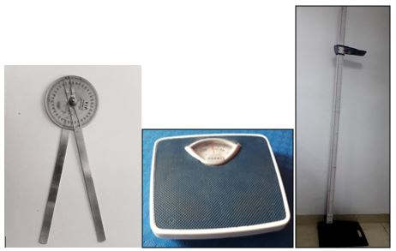
Fig: 1. Material Required (1) Goniometer, (2) Weighing Machine, (3) Stadiometer

Flexibility of the hamstring and quadriceps muscles was measured goniometrically on both sides. The dominant leg was defined as the preferred kicking leg. All measurements were made by the physical therapists. Previous research has indicated that the performed measurements in this study are reliable.
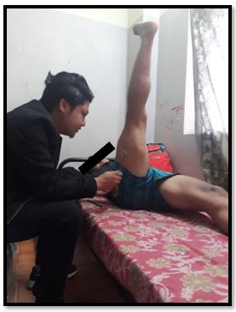
Fig: 2. Method of goniometric measurement of flexibility in the hamstring muscles.
The flexibility of the hamstring muscles was tested with the subject in a supine position, straightened limbs and measured the angle at the hip. A standard goniometer was used for this measurement. During this measurement the axis of the standard goniometer was placed at the greater trochanter of the femur. The stationary arm of the goniometer was placed horizontally, parallel to the bed, and the moving arm was placed pointing to the lateral epicondyle of the femur.

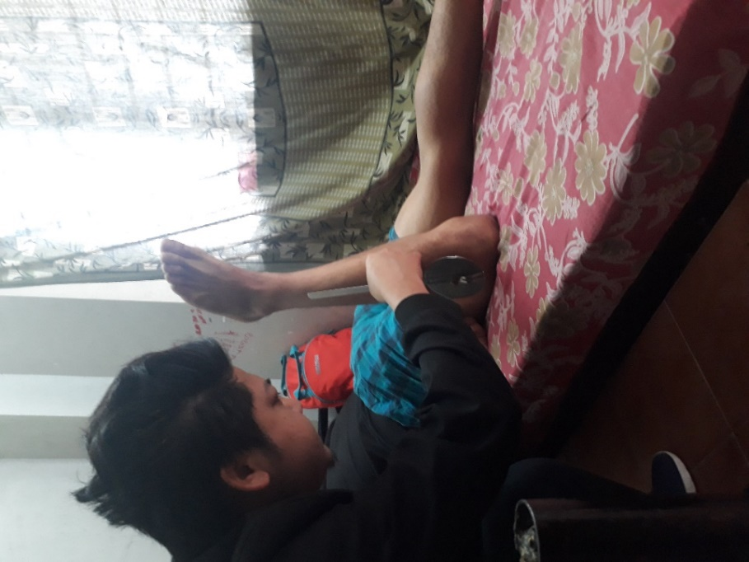
Fig: 3. Method of goniometric measurement of flexibility in the quadricep muscles.
The quadriceps muscle was tested with the subject in the prone position. The knee was maximally flexed. With the subject in this position, the angle of the knee was measured. A standard goniometer was used for this measurement. During this measurement the axis of the standard goniometer was placed at the lateral epicondyle of the femur. The stationary arm of the goniometer was placed pointing toward the greater trochanter of the femur, and the moving arm was placed pointing to the lateral malleolus of the tibia.
Statistical Analysis
Descriptive statistics for baseline matching and demographic data were used. Logistic linear equation to find out percentage association of risk factors for lower extremity injuries.

RESULTS
Logistic regression was performed to ascertain the effects of name, age, weight, gender, BMI, flexibility, ROM on the likelihood that participants will have an injury. The logistic regression model was statistically significant, χ2(4) = 12.698, p < .026 and is valid from 34.5-46.7%.

Table 1: Logistic Regression Model Summary
Model Summary
Step | -2 Log likelihood |  | Cox & Snell R Square |  | Nagelkerke R Square
1 | 27.683ª |  | .345 |  | .467
a. Estimation terminated at iteration number 8 because parameter estimates changed by less than .001.
Classification Table a
 | Observed |  | Predicted
 |  |  | No. of Injury |  | Percentage Correct
 |  |  | No injury | Injury | Percentage Correct
Step 1 | No. of Injury | No injury | 15 | 3 | 83.3
Step 1 | No. of Injury | Injury | 5 | 7 | 58.3
Step 1 | Overall Percentage |  |  |  | 73.3
a. The cut value is .500

Among all of the measured and described variables in this study, the stepwise logistic regression identified only the flexibility of the hamstring muscles, quadriceps and ROM of ankle joint as an intrinsic risk factor for musculoskeletal injuries in this study. With the use of this technique, we found a significant correlation between players with decreased flexibility of the hamstring muscles (less than 90°), quadriceps muscles, ROM of ankle joint and the occurrence of an injury is 73.3%. The logistic regression analysis identified decreased flexibility of the hamstring muscles, quadriceps muscle and ROM of ankle joint as an intrinsic risk factor for the development of a muscle injury with statistically significant, χ2(4) = 12.698 (P< .026).
Table 2: Binary logistic regression analysis for strength of association of risk factors
Variables in the Equation
 |  | B | S.E. | Wald | df | Sig. | Exp(B) | 95% C.I. for EXP(B)
 |  |  |  |  |  |  |  | Lower | Upper
 | Flexibility of Hamstring muscle right leg | -1.250 | .955 | 1.713 | 1 | .191 | .286 | .044 | 1.863
 | Flexibility of Hamstring muscle lt. leg | 1.318 | .982 | 1.801 | 1 | .180 | 3.736 | .545 | 25.612
 | Flexibility of Quadriceps muscle rt. leg | .318 | .199 | 2.564 | 1 | .109 | 1.375 | .931 | 2.030
 | Flexibility of Hamstring muscle lt. leg | -.275 | .198 | 1.931 | 1 | .165 | .760 | .515 | 1.119
 | Range of motion of Ankle Eversion rt. joint | -.567 | .433 | 1.719 | 1 | .190 | .567 | .243 | 1.324
 | Constant | 3.005 | 12.208 | .061 | 1 | .806 | 20.180
a. Variable(s) entered on step 1: Flexibility of Hamstring muscle right leg, Flexibility of Hamstring muscle left leg, Flexibility of Quadriceps muscle right leg, Flexibility of Hamstring muscle left leg, Range of motion of Ankle Eversion right joint.

So, according to equation, flexibility of Hamstring muscle of right leg has odds ratio of .286, flexibility of Hamstring muscle of left leg has odds ratio of 3.736, flexibility of Quadriceps muscle of right leg has odds ratio of 1.375, flexibility of Hamstring muscle of left leg has odds ratio of .760 and Range of motion of Ankle Eversion right joint has odds ratio of .567 to cause injury.
Discussion
The main finding of the present study was that reduced flexibility and decreased ROM was consistently identified as the most important risk factor for injury. The results also showed that players with reduced flexibility of Hamstring and Quadriceps bilaterally were at increased risk of injury for lower extremity.
Erik Witvrouw et al indicated that soccer players with an increased tightness of the hamstring or quadriceps muscles have a statistically higher risk for a subsequent musculoskeletal lesion.¹
In 2007 Paul S. Bradley et al stated that most significantly, soccer players with preseason decreased ROM in the hip flexors and knee flexors had a statistically higher risk for a muscle strain injury to a muscle group during a competitive season.⁴
Ekstrand and Gillquist also found that players with less ROM in hip abduction were at higher risk of adductor muscle ruptures or tendinopathy. Other studies have not found significant differences in ROM between players who incurred muscle strains and those who did not.⁷
In the present study it indicates ROM of ankle joint according to variable equation with odd ratio of .567 has a higher risk factor to cause injury, as mentioned above on the results.
Players with a greater range of movement may have a “flexibility reserve” with respect to such activities, which reduces the muscular tension and thus helps them to avoid injury
Demographic variables and injury risk
Among the intrinsic factors associated with lower extremity injury, Flexibility was the strongest factor, increasing the injury risk by 73.3% of variables according to classification tables.
Quadriceps injuries are more common in the kicking leg, most probably due to a greater volume of shooting and passing/crossing actions with the dominant leg resulting in injury, that is, a greater exposure to high risk actions. However, it is also seen that specific limb preference in soccer players may result in enduring muscle imbalances that could lead to an increased propensity for injury, and altered strength characteristics between the dominant and non-dominant leg has been found in soccer players.
Thus, correction of muscle imbalances at preseason has been found to decrease hamstring injury rates in soccer players, but its preventive effects needs to be verified also for other muscle injuries.
On the basis of the results of this study, emphasis should be placed on the importance of a preseason flexibility screening of the hamstring and quadriceps muscles to identify players at risk of hamstring or quadriceps muscle injuries. Logically, stretching should be stressed as an important part of a prevention program for muscle injuries.
The results of our study suggest that hamstring muscle flexibility of less than 90° could be considered as “tight” because these players had a significantly higher risk for an injury. Hence, on the basis of our results, players with hamstring muscle flexibility of less than 90° should be encouraged to stretch intensively to decrease their risk for a muscle injury. The reason could be improper stretching techniques applied or the lack of compliance by the players for stretching. Further evaluation could reveal the reason for this decrease in flexibility.
Arni Arnason et al stated that previous injury was consistently identified as the most important risk factor for injury. Players with former injuries had a four- to sevenfold increased risk for the four most frequent injury types—knee sprains, ankle sprains, groin strains, and hamstring strains.⁷ The role of previous injury could not be assessed as there were very few subjects who had been injured previously in the present study.
In 2013 Martin Hägglund et al has also stated that one of the most cited risk factors for lower extremity muscle injury in which soccer is a previous identical injury.⁵
Nilstad et al stated that using a series of comprehensive screening tests and subsequent injury registration through text messaging to assess potential intrinsic risk factors for lower extremity injuries in soccer players they found that greater BMI was identified as a risk factor for a new lower extremity injury, increasing the injury risk by 51% per one SD increase.³ The role of BMI could not be assessed due to the small sample size recruited in the present study, though it was assessed for all the players.
Several studies have shown that older players (Age related) are more susceptible to muscle injury, particularly to the hamstrings. The reason why older players may be at risk for muscle injury is unclear, but it has been suggested that age-related changes in older athletes, such as increased body weight and a loss of flexibility, may partially explain the risk increase.⁵ The present study recruited players between 15-25 years, which counts as the golden playing years, where fitness is usually the maximum, hence the role of age could not be assessed, though recruitment of subjects were done in the wide range of 9 years.
J Ekstrand et al did a study to compare injury risk in elite football played on artificial turf compared with natural grass, were they found that only significant difference in injury pattern in the study was a higher risk of ankle sprain during matches on artificial turf and a lower risk of lower extremity muscle injuries.¹² The present study recruited only players who played in artificial turf, hence the role of natural grass in causing injury or having a protective effect could not be assessed; though many studies have documented its role in causing lower extremity injuries in soccer players.
Ekstrand et al. found that players with an average training incurred the highest injury rate and lower rates for those who trained less or more. That players who trained and played football for fewer hours were less exposed, and therefore incurred fewer injuries, is not surprising. Why players with the highest exposure suffer fewer injuries is less clear. While it has been suggested that they are in better physical condition.¹²
In the present study the influence of body mass, previous injury, age related, playing surface and duration of training on injury rates could not be estimated due to a smaller number of sample due to which these factors were rejected by the logistic regression model equation. However, knowledge of such factors may still be of value to identify subgroups of players at increased risk of injury, as well as to recognize parts of a season and types of exposures where injury is more likely to occur, in order to implement proper preventive measures.
Conclusion
The study indicates that flexibility of the hamstring, quadriceps muscles and ROM can be considered as an important risk factor for the development of muscle injuries in injured and non-injured football players of Sikkim. These findings suggest that preseason testing of the flexibility of these muscles can identify football players at risk of developing muscle injuries. In concrete terms, it can be concluded that football players with hamstring muscle flexibility of less than 90° have a significantly higher risk for injuries and should be advised to perform a thorough stretching program to decrease their injury risk. Future research is needed to identify other risk factors for the development of soccer injuries.
References
- Erik Witvrouw, Lieven Danneels, et al. Muscle Flexibility as a Risk Factor for Developing Muscle Injuries in Male Professional Soccer Players. Am. J. Spo. Med. 2003; 31(1).
- P Wong, Y Hong, Soccer injury in the lower extremities. Br J Sports Med 2005; 39:473–482.
- Agnethe Nilstad, et al. Risk factors for lower extremity injuries in elite female soccer players. Am. J. Spo. Med. 2014; 42: 940-948.
- Paul S. Bradle et al. The Relationship Between Preseason Range of Motion and Muscle Strain Injury in Elite Soccer Players. J. Streng.&. Condi.Res. 2007; 21(4):1155-1159.
- Martin Hägglund, et al. Risk Factors for Lower Extremity Muscle Injury in Professional Soccer: The UEFA Injury Study. Am. J. Spo. Med, 2013; 41(2): 327-335.
- Rogério Ferreira Liporaci, Marcelo Camargo Saad, et al. Preseason intrinsic risk factors— associated odds estimate the exposure to proximal lower limb injury throughout the season among professional football players. BMJ Open Sport Exerc Med 2018;4.
- Arni Arnason, Stefan B. Sigurdsson et al Risk Factors for Injuries in Football. Am. J. Sports Med 2004;32(5).
- Engebresten, A. H., et al. Intrinsic risk factors for groin injuries among male soccer players. Am. J. Spo. Med. 2010; 38:2051-2057.
- Jesper Petersen, et al. Preventive Effect of Eccentric Training on Acute Hamstring Injuries in Men’s Soccer. Am. J. Sports Med 2011:39(11).
- D F Murphy et al. Risk factors for lower extremity injury. Br J Sports Med 2003; 37:13–29.
- Sean D. Turbeville, et al. Risk Factors for Injury in High School Football Players. Am. J. Sports Med.2003;31(6).
- Jan Ekstrand, et al. Epidemiology of muscle injuries in professional football. Am. J. Sports Med.2011.
- Richard D Hawkins, et al. A prospective epidemiological study of injuries in four English professional football clubs. Br J Sports Med 1999; 33:196–203196.

