ABSTRACT
Objective
The aim of the study is to find out the effectiveness of ultrasound therapy and laser therapy in pain and shoulder range of motion in adhesive capsulitis.
Methodology
This study is a randomized clinical trial study carried out in physiotherapy Out-Patient Department (OPD) of Central Referral Hospital (CRH) including patients with adhesive capsulitis. Total of 44 patients were included in the study where after randomization each group was divided with 22 participants. Group A received ultrasound therapy for 10 minutes in anterior and lateral acromion border for 3 times a week for 4 weeks and Group B received laser therapy for 30 sec for per each point . The pain was assessed by using Penn Shoulder scale which ICC was 0.93 and the range of motion is assessed by bubble inclinometer with ICC 0.84.
Result
Statistical analysis of 44 participants was done using SPSS version 20.0. Descriptive statistics were analyzed for mean and standard deviation. Two-way ANOVA was carried out to check within the group and between the group analysis. There was a significant improvement in shoulder flexion range of motion in both groups, but more improvement was seen in ultrasound group.
Conclusion
Both treatment modalities are effective in decreasing pain and increasing shoulder range of motion but Ultrasound therapy along with Maitland mobilization was more effective in increasing shoulder flexion range of motion in adhesive capsulitis as compared to laser therapy along with Maitland mobilization
Keywords: Ultrasound, Laser, Adhesive Capsulitis
CTRI/2022/10/046729

Introduction
Shoulder joint consists of four joints i.e., glenohumeral joint, sternoclavicular joint, scapulothoracic joints and acromioclavicular joints. Out of these joints glenohumeral joint is the most affected joint which is ball and socket synovial joint with three transitional and rotational degrees of freedom. It is surrounded by capsules, ligaments, and bursae. The articulation is formed by humerus and glenoid fossa.[1] There are various pathologies in shoulder joints. They are subacromial pain syndrome, bursitis, rotator cuff tendinopathy or tear, biceps long head tendinopathy or tear, and adhesive capsulitis.[2]
Adhesive Capsulitis (AC) is a glenohumeral condition where capsular pattern is normally seen. Codman first described frozen shoulder in 1936 and later in 1945, Naviser termed adhesive capsulitis as there is synovial changes in glenohumeral joint. Lundberg latter categorized frozen shoulder in two categories which are primary or idiopathic and secondary adhesive capsulitis. The pathophysiology of primary adhesive capsulitis is unclear, but Harryman and Neviser suggested that there may be chances of having the primary adhesive capsulitis if there is change in endrocrine, immunological as well as inflammatory and biomechanical systems.[3]
Categories of Adhesive Capsulitis
- Primary adhesive capsulitis:
It occurs without any reason by fibrosis of joint capsule.
- Secondary adhesive capsulitis:
It can occur with a known cause, have a pre-disposing factor, or surgically centred, may be evident in post stroke individuals and even after injuries. An injury in shoulder girdle can alter the movement pattern of shoulder causing reduction in shoulder motor movement which later reduces ROM causing gradual stiffness of joint capsule.

- Secondary adhesive capsulitis can be divided into three subgroups, that is.
- Systemic: It includes diabetes mellitus and other metabolic conditions.
- Extrinsic: It includes CVA, fracture of humerus, parkinsonism, cardiopulmonary diseases.
- Intrinsic: It includes the destruction of ligament, muscles, and arthritis of joint within the shoulder complex.[3]

There are three stages of adhesive capsulitis. They are.
Freezing stage: In this stage, pain is the chief complaint of patient with slight decrease in shoulder Rom. The pain occurs at night and worsen when sleeping on the affected side. In arthroscopic studies, there is presence of synovial hyperplasia which is followed by increase in fibroblastic cell division in the glenohumeral capsular tissue. There is an increase in the level of cytokines which promotes proliferation of fibroblastic cells and synthesis of collagen fibers. Capsular fibrosis is present due to the initial inflammatory process.[4]
Frozen stage: In this stage, there is stiffness of joint capsule along with the decrease in shoulder movement and patients mainly complain about loss of movement. Synovial pathological process starts with adhesion of the capsular tissue. This will decrease the intra-articular volume and capsular function.[4]
Thawing stage: In this phase, there is improvement in glenohumeral motion and shoulder function. The main characteristic of this phase is absence of pain and progressive improvement of glenohumeral range of motion.[4]
Adhesive capsulitis occurs in 5% in general population. The prevalence is almost four times more in females as compared to the male population. The non-dominant hand is more affected.[5] The lifetime chance in prevalence of adhesive capsulitis is 40% and overall, 11% of Type 2 diabetics have adhesive capsulitis. 16% of people have a chance to develop adhesive capsulitis in both shoulders. There is greater incidence of adhesive capsulitis in patients with hypothyroidism. It is common in the age group between 50-60 years.[6]
The pathology of adhesive capsulitis is not clearly mentioned. It is said that chronic inflammation is due to proliferative fibrosis. Microscopic findings suggest increase in capsular wall thickness along with the obstruction of the capsule with the inflammation in the structure of glenohumeral joint such as the rotator interval and ligaments. Microscopic has shown that there is increased number of t cells, mast cells, macrophages, and fibroblast in patients suffering from adhesive capsulitis. In case of diabetes mellitus, there is increase in glucose level resulting in glycosylation process; this results in increased rates of adhesive capsulitis and other soft tissue disorders such and Duptyren’s diseases. Diabetic patients who develop frozen shoulder seem to have a higher HBA1C. Arthroscopic procedure of synovium in diabetics illustrates greater endothelial growth factors compared with those without diabetes. Further in progressive stages there is reduction of inflammatory responses which causes the prolongation and increases the severity of diseases.[6]
Treatment can be both operative and non-operative. The non- operative treatment choices are physiotherapy, steroidal injections in the glenohumeral joint and pharmacological medications. Physiotherapy treatment includes use of wide variety of electrical modalities like interferential therapy, ultrasound therapy as well as use of cryotherapy and heat therapy. The evidence is supportive in advising home base exercise therapy including stretching of tightened structures and strengthening of supportive musculature of glenohumeral joint.[6]
Ultrasound is a mechanical device emitting ultrasonic vibration. This vibratory energy is converted to heat energy and produces the increase in temperature of tissue, which is one of the thermal effects caused by ultrasound therapy. On the other hand, it also has non-thermal effects which lead to modulation in pain, improvement in the collagen fiber function and increases in enzymatic activity at the cellular level. Along with it, there is improvement observed in the nerve conduction and contractile function of the skeletal muscle.[7] The contractile tissue elasticity and viscosity is being targeted by the ultrasonic energy. This helps in reduction in formation of scar tissue and fibrinolysis. This further brings improvement in shoulder motion and improvement in pain threshold.[8]
Laser therapy is a non-invasive method for inducing non-thermal effects which causes the reduction in the inflammatory process and helps in pain modulation. The change in the prostaglandin (E2) level and the removal of angiogenic substances is the pathognomic mechanism helping in the positive responses. Laser therapy reduces muscle pain by decreasing concentration of free oxidative radicals or by stopping axoplasmic transport.[9]
Mobilization is commonly used treatment strategy in physiotherapy department. Normally grade 1 and 2 mobilizations are given for pain relief purpose whereas grades 3 and 4 are given for range of motion purposes. It helps in exchange of nutrients in the capsule as well as maintain the joint integrity and increases the blood flow which may help in reducing the pain as well as removal of waste substances. Maitland’s mobilization involves the rhythmic and oscillatory movement pattern that trigger mechanoreceptors (type-2) and helps in inhibiting the nociceptive receptor (type-4) which eventually helps in relieving pain.[7]
The pain-relieving medication such as acetaminophen and short acting prednisolone are helpful in the modulation of the pain threshold thereby improving the pain intensity in patients with the adhesive capsulitis. The use of steroids injections in the joint for relieving pain and improving the extensibility the soft tissue is gaining popularity in the present era. Patients are even benefited with the use of the steroidal injections.[6]
The surgical option in treating the adhesive capsulitis includes the anesthesia assisted manipulation of the joint. Another surgical option may be release of the capsule using the less invasive video assisted procedure named arthroscopy. This surgical option is a second line choice when 6 months of non-operative conservative treatment fails. Even though there are benefits of anesthesia assisted manipulation in improving shoulder motion and reducing the pain intensity, there are some deliberating side effects of it. One of the common risks is having humeral fracture.[6]

Statement of problem
- To find out the best treatment approach among ultrasound and laser therapy for adhesive capsulitis
- To decrease multimodal treatment approaches for adhesive capsulitis to regain the normal ROM & reduce pain.
- There is dearth of literature on effectiveness between ultrasound and laser therapy in adhesive capsulitis.

Objective of the study
- To check the effectiveness of Ultrasound Therapy and Laser therapy in pain and shoulder ROM in adhesive capsulitis

Null Hypothesis:
There will be no significant difference between Ultrasound therapy and Laser therapy in pain and shoulder range of motion in adhesive capsulitis.

Alternate Hypothesis:
There will be significant difference between Ultrasound therapy and Laser therapy in pain and shoulder range of motion in adhesive capsulitis.

OPERATIONAL DEFINITION

- Adhesive capsulitis:
It is a condition in which there is pain and limitation in shoulder range of motion.

- Low level laser therapy:
It is an instrument which utilizes a pencil like beam of electromagnetic single frequency waves with defined wavelength which promotes tissue healing and pain relief in a soft tissue injury and diseases.

- Ultrasound:
Ultrasound is a mechanical device which convert sound energy into vibration energy which helps in tissue healing causing reduction in pain.

- Maitland mobilization:
It is the joint mobilization techniques which helps in pain relief and increasing range of motion.

Literature review

Laser
In 2008, Apostolos Stergioulas, conducted a study to determine the efficacy of low-level laser therapy (LLLT) in patients with adhesive capsulitis in which 63 patients were included in the study. Out of which 31 patients received laser therapy in 8 points for 2 session for 4 weeks and 1 session for remaining 4 weeks. The total session for the treatment was 12 sessions. At the end of treatment session, the study shows there was decrease of pain and in disability of patients.[10]

In 2016, El Hafez and El Hafez, conducted a study to determine the effectiveness of ultrasound, laser, and post isometric facilitation technique with standard care in the management of shoulder adhesive capsulitis. In this study total 59 patients were selected who received Ultrasound and Laser together at anterior and lateral border of acromion for 3 times a week for 4 weeks which shows Axillary ultrasound and laser therapy had greater effect in decreasing pain and increasing range of motion.[11]

In 2014, Ayman’s Soliman et al conducted a study to determine the efficacies of low-level laser therapy (LLLT) for improving range of motion (ROM) in patients with adhesive capsulitis. In this study, 40 volunteer patients were included in the study out of which 20 patients received LLLT for 15 minutes for 3 times a week for 8 weeks. The study shows LLLT has significant improvement in shoulder range of motion and decreased in pain severity in patients with adhesive capsulitis.[9]

Ultrasound
In 2014, Mahendran, M.PT (Ortho) et.al, conducted a study to investigate the effectiveness of ultrasound therapy in improving the functional performance of patients with adhesive capsulitis. In this study total of 30 patients were included out of which 15 patients were treated with ultrasound therapy for 10 minutes for 5 session a week for two successive weeks in anterior, superior, and posterior regions of the affected joint in slow, circular and overlapping fashion. The study concludes that ultrasound therapy is more effective and beneficial in adhesive capsulitis.[7]

In 2014, Shahbaz Nawaz Ansari et al, conducted a study to check the effectiveness of ultrasound therapy in patient with adhesive capsulitis. In this study they included 40 patients out of which they have treated 20 patients with ultrasound therapy for 6 days a week for 4 weeks. The study concluded that ultrasound therapy was more effective in decreasing pain and increasing range of motion in patients with adhesive capsulitis. [12]

In 2018, a study was conducted to check the effectiveness of ultrasound therapy in treatment of adhesive capsulitis.. In this study, 20 participants were included in the study where 10 participants were included in the ultrasound therapy group. The participants received ultrasound in continuous mode with 3 MHz frequency and 1.0W/cm2 intensity for 5 minutes in glenohumeral joint. The study concluded that the patients receiving ultrasound therapy has more effects on decreasing pain and increasing range of motion.[13]

Penn Shoulder Score
In 2006, Brian Legging, et al, conducted a study to examine psychometric properties of reliability and validity of the Penn shoulder score. The study included 40 patients with shoulder disorders who were taking the physiotherapy treatment. The scale was taken on the first day of visit and within hours of visit to assess test-retest reliability. The Penn shoulder scale was compared with ASES and constant shoulder scale for the construct validity which showed 0.93 as test-retest value. This indicates Penn shoulder scale as reliable and valid questionnaire for measuring pain and function of shoulder disability.[14]

Bubble Inclinometer
In 2006, Lin and Yang et al, conducted a study to check anterior and posterior tightness of shoulder muscles by using baseline bubble inclinometer. They included 16 patients with stiff shoulder. The assessment was taken for posterior and anterior shoulder tightness in which horizontal flexion ROM (cross-chest adduction) and horizontal extension ROM (below-chest abduction) were measured, respectively, in the supine position. The study found ICC as 0.86. It means baseline bubble inclinometer is reliable and valid tool for measuring shoulder range of motion in patients with adhesive capsulitis.[15]

Maitland mobilization
In 2018, Shamsi et.al, conducted a study to find the effectiveness of Maitland Mobilization in adhesive capsulitis. The study included 40 patients out of which 20 patients received Maitland mobilization in glenohumeral joint for thrice a week for four weeks. The mobilization was given in glenohumeral joint at 30-degree abduction where glenohumeral caudal glide mobilization was given at the rate of 2-3 glides per second for 30 seconds for each glide for 5 sets. After the four weeks of treatment session, study concludes that Maitland mobilization is effective in decreasing pain and increasing shoulder range of motion in patients with adhesive capsulitis.[16]

Methodology

- Study Design: Interventional study
- Study Type: Randomized clinical trial (RCT)
- Study Setting: Physiotherapy Department, Central Referral Hospital (CRH), Gangtok
- Study Population: Patients visiting Central Referral Hospital with adhesive capsulitis.
- Sampling Method: Probability sampling
- Study Duration: 1 year (June 2022 – May 2023)
- Randomization: Computer generated blocked random sampling
- Sample size: 22 in each group
- Sample size calculation: g power software, where effect size is 1.01,
effect size formula=pretest mean-posttest mean/pre-SD-post SD
- Eligibility Criteria
Inclusion criteria | Exclusion criteria
- Unilateral adhesive capsulitis  - Patient with capsular pattern involvement  - Patients age of 35-65 years  - All genders  - Adhesive capsulitis Stage1 and 2 | - Patients with skin disorders over glenohumeral joint  - Recent history of any major trauma or surgery around glenohumeral joint  - Recurrent dislocation of glenohumeral joint  - Neurological disorders (loss of sensation around the glenohumeral joint)  - Unwilling to participate in the study

- Blinding: Single blinding(accessors)
- Investigator 1: Screening and treatment
- Investigator 2: Penn scale and range of motion (MPT student)
Outcome Measures
1. Penn Shoulder Scale
Penn Shoulder Scale is a condition specific self-questionnaire scale which consists of three sub scales that is pain, satisfaction, and function with total of 100 scoring points. Out of which pain carries 30 points; satisfaction carries 10 points and function carries 60 points. The pain and satisfaction are rated with numeric pain scale which is 10 points scale in which 0 is no pain and 10 is worst possible pain whereas in satisfaction 0 is not satisfied and 10 is very satisfied. The pain consists of 3 questions: pain at rest, pain at normal activities and pain at strenuous activities. If patients are not able to perform movement, then 0 scoring will be provided. The function part consists of 20 questions with 4 points Likert scale that is 0 (can’t do at all), 1 (much difficulty), 2 (with some difficulty), and 3 (no difficulty). 60 points is given to the patient if he can perform all activities without difficulty and there are some items in this subscale which may not be applicable to all patients, so there is the response option that is ‘‘did not do before injury’. If participants have chosen, the option of did not before then we will be subtracting the total value by 3. The score obtain in this scale is calculated in percentage. The interpretation of this scale is more the points less pain, more satisfaction and less functional disability. The reliability of pain scale is 0.94 (95% CI, 0.89-0.97) and Internal consistency analysis; Cronbach alpha is 0.93. The minimal detectable change (MDC) is ± 12.1 scale points (based on a 90% CI). The minimal clinically important difference (MCID) for improvement is 11.4 points. [12]

2. Inclinometer
Inclinometer is a device used to measure the range of motion of the joints. Bubble inclinometers consist of liquid inside which helps in measuring the range of motion. It ranges from 0 to 360 degrees. While measuring ROM the liquid inside inclinometer must be kept at zero so that no false result is obtained. The inclinometer needs to be placed at a stable place and it should not move during the procedure. The area of inclinometer placement for measuring shoulder flexion and abduction are by placing inclinometer at lateral epicondyle of humerus. Extension is measured by placing inclinometer at medial epicondyle of humerus in standing position. Similarly, for internal and external ROM participants is in supine lying position with elbow and shoulder at 90 degrees with inclinometer placed at medical epicondyle of humerus. The ICC of inclinometer is 0.84.[13]

Instruments
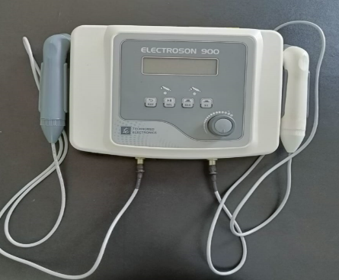 | 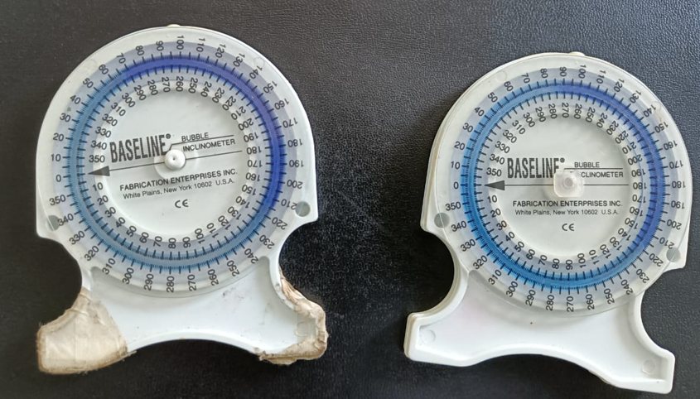
Figure 1: Ultrasound (Electroson 900, Technomed electronics | Figure 2: Bubble Inclinometer (Fabrication Enterprises INC. white plains, New York 10602 U.S. A
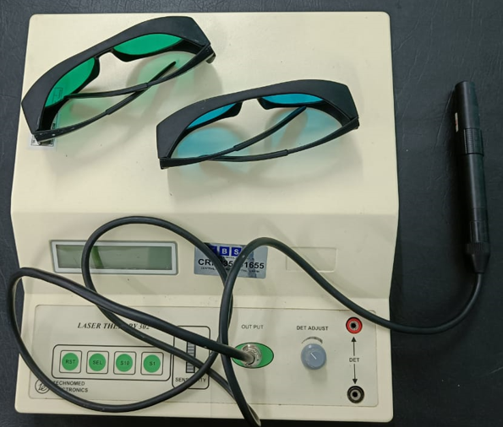 | 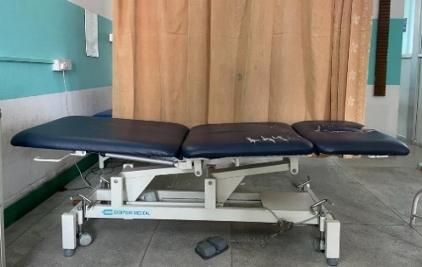
Figure 3: Laser (Laser therapy 302, Technomed electronics) | Figure 4: Mobilization Couch
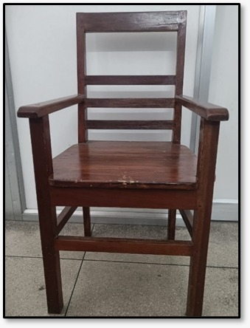
Figure 5: Chair
Procedure
Approval was obtained from Institutional Research Committee and Institutional Ethics Committee, SMIMS

Adhesive capsulitis referred from other Departments.

After obtaining informed consent, screening of participants was done as per eligibility criteria

Computer generated block randomization was done

Baseline data (Penn and Inclinometer) assessment was taken on the 1st day of treatment
Group-B laser therapy
Laser was given in lateral and anterior border of acromion for per point 30 sec with wavelength of 810 nm, in continuous mode, with 60 mW of power, 0.5 cm2 of spot size, duty cycle of 50%, energy density of 3.6 J/cm2. The dose per point was 1.8 J.
Maitland mobilization Grade II-III was given Anterior- posterior glide, Inferior glide, and Posterior-anterior glide for 2-3 glides per second for 30 seconds for each glide, given for 5 sets.

Group-A ultrasound
Ultrasound therapy was given in lateral and anterior border of acromion for 10 minutes at 1.5 watts in pulse mode with 3 MHz in (1:1) ratio for 3 times/week for 4 weeks.
Maitland mobilization Grade II-III was given. Anterior-Posterior glide, Inferior glide, and Posterior -Anterior glide for 2-3 glides per second for 30 seconds for each glide, given for 5 sets.

Post intervention test (Inclinometer) was taken on the last day of treatment of 2nd and 4th week and follow up was done for Penn shoulder scale after 1 month

Data was assessed by a blinded assessor
Statistical analysis was done

Figure 6: Methodology for dissertation
After the Ethical Committee of the Institute accepted the research proposal, a notice was circulated to the Department of Physiotherapy and to the other Departments of Central Referral Hospital. The notice provides information about the study and request to refer patients with diagnosed adhesive capsulitis. Thus, the source of participants was from physiotherapy and other Departments of Central Referral Hospital who were volunteer to take part in this study. A detailed examination of the participants was done to those who meet the inclusion criteria and to those who voluntarily included as participants in this study. Randomization was done into two groups (ULTRASOUND and LASER) by using Computer generated blocked random sampling by the blinded assessor. Thereafter, the participants were explained about the study and informed consent forms were taken. Before the interventions, the participants were assessed, and all the required data was collected. Investigator 1 allocates the patients and the investigator 2 rate the patients’ outcomes (i.e., bubble inclinometer, Penn shoulder score) pre- and post-intervention. Investigator 1 gave intervention to the patients. Intervention was given 3 times a week for 4 weeks. On the first day, before starting treatment, baseline data of PENN scale and bubble inclinometer was taken for both groups by investigator 2. Data was again collected following the same procedure at the end of the treatment i.e., at last day of treatment of 2nd week and at the last day of treatment of 4th week and follow up was taken for Penn shoulder scale after 1 month by the investigator 2. (annex:VIII)

Group-A (Ultrasound therapy):
Ultrasound therapy was given in lateral and anterior border of acromion for 10 minutes at 1.5 watts in pulse mode with 3 MHz in (1:1) ratio. Maitland mobilization Grade II-III was given in A-P glide, Inferior glide, and P-A glide in glenohumeral joint. The patient was in supine lying with hip and knee in neutral position for Anterior – Posterior and inferior glide but for P-A glide the participants were in prone lying position. The dosages for Maitland mobilization were 2-3 glides per second for 30 seconds for each glide which was given for 5 sets.

Group-B (Laser therapy):
The treating area was cleaned and kept, the participants was in chair sitting position where laser therapy was administered 3times/week for 4 weeks with wavelength of 810 nm, in continuous mode, with 60 mW of power, 0.5 cm2 of spot size, 50 % of duty cycle, and energy density of 3.6 J/cm2. The duration of treatment per point was 30 sec. The dose per point was 1.8 J and the total dose per session was 14.4 J in anterior and lateral border of acromion in each session. Maitland mobilization Grade II-III was given A-P glide, Inferior glide, and P-A glide in glenohumeral joint. The patient was in supine lying with hip and knee in neutral position for A-P and Inferior glide but for P-A glide the participants were in prone lying position. The dosages for Maitland mobilization were 2-3 glides per second for 30 seconds for each glide which was given for 5 sets.

Statistical analysis

Data was recorded in SPSS software version 20.0 which is a computerized software for data analysis. Descriptive data were expressed in frequency and percentage. Mean and standard deviation were used to express continuous variables. A Generalised Linear Measure repeated measures ANOVA 2 (time) × 2 (Group) with Group x Time effect was carried out showing the effect size of difference in the two-treatment groups.

Results

The consort diagram on Figure 1 shows the flow of the participants in this study where Forty-four individuals with adhesive capsulitis satisfied the inclusion criteria for this trial. The mean age (SD) of participants in both ultrasound group and Laser group were 56.41 ±7.320 years and 53.78 ± 11.667 years respectively. The demographic data of the participants enrolled in the treatment program is demonstrated in table 1.

Table 1 – Distribution of participants in the study
Characteristics |  | Ultrasound (n=22) | Laser (n=22) | p
Age | Mean ± SD | 56.41±7.320 | 53.86±11.667 | 0.391
Gender | M /F (%) | 68.2/31.8 | 59.1/40.9
Affected Side | Rt / Lt | 81.8/18.2 | 59.1/40.9
Duration of pain | months | 3.68±2.679 | 3.82/3.960 | 0.894

The number of treatment sessions allocated for this study was 3 sessions a week for a 4 week. There was no home exercise included in the treatment regime in this study. After the completion of treatment session, the participants were taught with the home exercises. There was no difference in the number of sessions completed by ultrasound group and laser group.

Participants identified (n= 60)

Informed consent taken (n=44)

Screening according to inclusion/exclusion criteria (n= 44)

Excluded (n=16) (without capsular pattern involvement)
- Supraspinatus tendinitis 6
- Shoulder impingement 4
- Biceps tendinitis 6

Computer generated Block Randomization into two groups

Baseline data recorded

Group B: Laser n=22
Group A: Ultrasound n=22

Pulse mode 3 MHZ 10 minutes 1:1 ratio 3 time per week for 4 weeks

per point 30 sec with wavelength of 810 nm, in continuous mode, with 60 mW of power, spot size of 0.5 cm2, duty cycle of 50%, energy density 3.6 of J/cm2. The dose per point was 1.8 J and the total dose per session was 14.4 J

Pre and Post shoulder range of motion was taken at 1st day, 2nd week and 4th week treatment session

Penn shoulder scale was taken at begin of each (1st day, 2nd week and 4th week) treatment session

Follow up after 1 Month

Penn shoulder scale was assessed

Analysis of N= 44; Group A- 22 & Group B- 22

Figure 7: Participants enrollment flow chart

Comparison at baseline
The outcome measures were not significantly different in the ultrasound group as compared to laser group at the beginning of trial. The only significant difference seen in shoulder extension at baseline. The descriptive statistics and test statistics are given in the following table 2.

Table 2 – Baseline comparison of outcome measures in ultrasound and laser groups
 | Baseline
 | Ultrasound (22) | Laser (22) | pᶲ
Flexion | 106.36±28.418 | 93.86±22.143 | 0.111
Abduction | 89.23±39.537 | 71.82±21.852 | 0.078
Extension | 27.50±9.226 | 34.50±10.901 | 0.027
Internal rotation | 28.18±14.520 | 25.50±13.518 | 0.529
External rotation | 25.95±22.626 | 22.41±16.434 | 0.555
Pain | 11.32±6.136 | 9.45±5.189 | 0.283
Note – All values in mean and standard deviation unless stated otherwise

Within group analysis:
GLM repeated measures ANOVA was run on the outcome measures to determine the effect of two electrotherapy modalities (ultrasound therapy and Maitland mobilization compared with laser and Maitland mobilization) over four weeks on outcome measures in study participants. Interaction effects of different shoulder range of motion vs time points were computed for outcome measures. Standardized residuals for interventions and for the overall model were normally distributed. The results are summarized in table 3

Table 3 provides the information of within group analysis where there is improvement in both groups in pain and shoulder range of motion as the treatment goes on. The data were compared within group in different treatment time where there is increase in mean values of pain and shoulder range of motion as the treatment progresses. In both groups mean value lies within the confidence level which suggests that the value is significant.

Table 3 – Summary of group by time data for outcome measures which showed.
significant interaction effect
 | Group | Time | Mean ± SE | 95% Confidence Interval
Flexion | Ultrasound | Baseline | 7.500±1.953 | 3.559-11.441
Flexion | Ultrasound | At the end of 2nd week | 10.909±1.358 | 8.168-13.651
Flexion | Ultrasound | At the end of 4th week | 12.727±1.663 | 9.372-16.083
Flexion | Laser | Baseline | 11.727±1.953 | 7.786-15.668
Flexion | Laser | At the end of 2nd week | 10.818±1.358 | 8.077-13.560
Flexion | Laser | At the end of 4th week | 10.909±1.663 | 7.554-14.264
Abduction | Ultrasound | Baseline | 10.091±1.758 | 6.543-13.638
Abduction | Ultrasound | At the end of 2nd week | 11.591±1.858 | 7.841-15.341
Abduction | Ultrasound | At the end of 4th week | 9.318±1.860 | 5.564-13.072
Abduction | Laser | Baseline | 10.409±1.758 | 6.862-13.957
Abduction | Laser | At the end of 2nd week | 12.136±1.858 | 8.387-15.886
Abduction | Laser | At the end of 4th week | 11.000±1.860 | 7.246-14.754
Extension | Ultrasound | Baseline | 8.182±1.502 | 5.151-11.213
Extension | Ultrasound | At the end of 2nd week | 7.500±1.411 | 4.652-10.348
Extension | Ultrasound | At the end of 4th week | 7.500±1.411 | 4652-10.348
Extension | Laser | Baseline | 7.409±1.502 | 4.378-10.440
Extension | Laser | At the end of 2nd week | 8.864±1.411 | 6.016-11.712
Extension | Laser | At the end of 4th week | 8.864±1.411 | 6.016-11.712
Internal rotation | Control | Baseline | 4.545±0.671 | 3.190-5.900
Internal rotation | Control | At the end of 2nd week | 4.545±0.662 | 3.210-5.881
Internal rotation | Control | At the end of 4th week | 4.273±0.906 | 2.445-6.100
Internal rotation | Experimental | Baseline | 4.364±0.671 | 3.009-5.719
Internal rotation | Experimental | At the end of 2nd week | 4.818±0.662 | 3.483-6.154
Internal rotation | Experimental | At the end of 4th week | 2.818±0.906 | 0.991-4.646
External rotation | Ultrasound | Baseline | 4.273±0.906 | 2.445-6.100
External rotation | Ultrasound | At the end of 2nd week | 3.636±0.643 | 2.338-4.935
External rotation | Ultrasound | At the end of 4th week | 2.864±0.592 | 1.669-4.058
External rotation | Laser | Baseline | 2.818±0.906 | 0.991-4.646
External rotation | Laser | At the end of 2nd week | 4.409±0.643 | 3.111-5.707
External rotation | Laser | At the end of 4th week | 3.955±0.592 | 2.760-5.149
Pain | Ultrasound | Baseline | 11.318±1.212 | 8.873-13.763
Pain | Ultrasound | At the end of 2nd week | 16.273±1.043 | 14.168-18.377
Pain | Ultrasound | At the end of 4th week | 20.773±1.175 | 18.402-23.143
Pain | Ultrasound | After 1 month | 26.727±1.088 | 24.532-28.922
Pain | Laser | Baseline | 9.455±1.212 | 7.010-11.899
Pain | Laser | At the end of 2nd week | 13.8644±1.043 | 11.759-15.968
Pain | Laser | At the end of 4th week | 18.045±1.175 | 15.675-20.416
Pain | Laser | After 1 month | 23.955±1.088 | 21.759-26.150

Between group analysis:
Table 4 explains between group analysis which was done at end of the 4th week of treatment session in which there was significant improvement in flexion range of motion in both groups with mean and standard deviation of (12.727±1.663, 10.909±1.663) in ultrasound and laser therapy respectively. But more improvement can be seen in ultrasound group than in laser group with mean difference of approximately 2. The figure depicts Penn shoulder score between group where linear improvement could be observed in groups however, ultrasound group showed larger improvement.

Table 4– Summary table of effects in outcome measures

Measure | Last day of treatment at 4th week |  | Effect | F | p | η2
Measure | ultrasound  n=22 | Laser  n=22
Flexion | 12.727±1.663 | 10.909±1.663 | Group x time | 3.107 | 0.050 | 0.069
Abduction | 9.318±1.860 | 11.000±1.860 | Group x time | 0.190 | 0.827 | 0.005
Extension | 7.500±1.411 | 8.864±1.411 | Group x time | 0.887 | 0.416 | 0.021
Internal rotation | 4.273±0.906 | 2.818±0.906 | Group x time | 1.118 | 0.332 | 0.26
External rotation | 2.864±0.592 | 3.955±0.592 | Group x time | 2.487 | 0.089 | 0.056
Pain | 26.727±1.088 | 23.955±1.088 | Group x time | 0.178 | 0.911 | 0.004

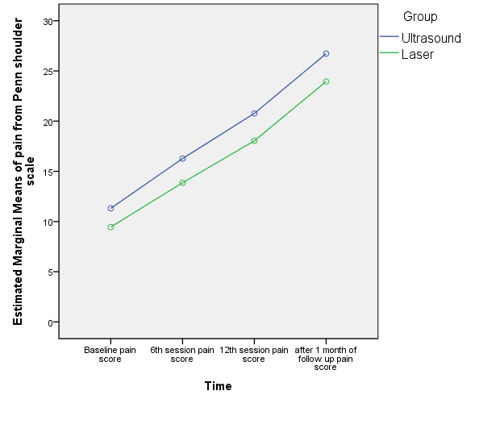
Figure 8: Time vs estimated marginal means of pain from Penn Shoulder Scale shows improvement in pain in both the groups, but more improvement can be seen in the ultrasound group

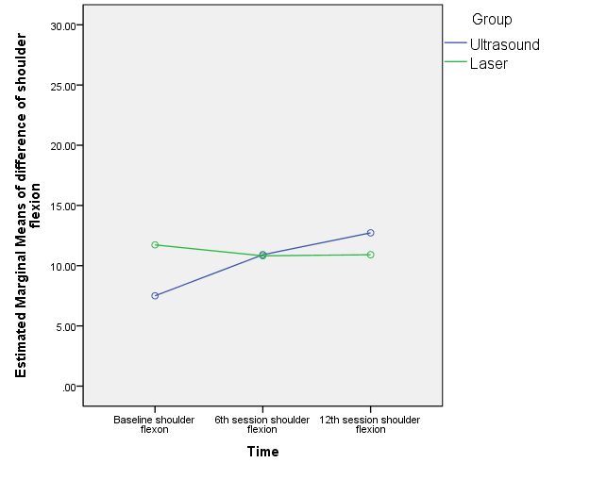
Figure 9: Time vs estimated marginal means of difference of shoulder scale shows improvement in shoulder flexion in ultrasound group than in laser group

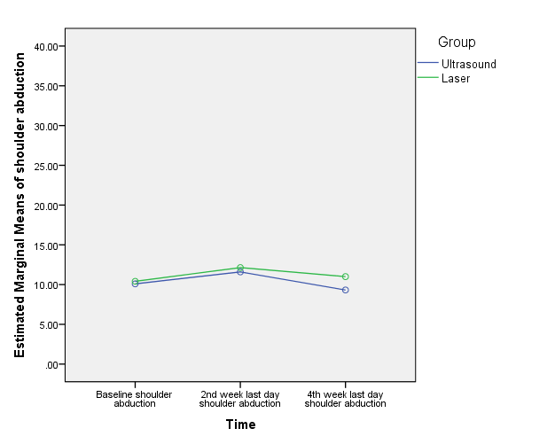

Figure 10: Time vs estimated marginal means of difference of shoulder abduction shows improvement of shoulder abduction in laser group than in ultrasound group

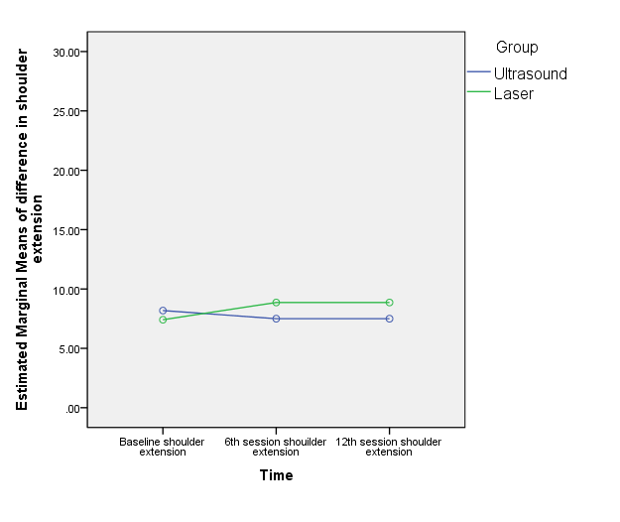
Figure 11: Time vs estimated marginal means of difference of shoulder extension shows improvement in both the groups, but more improvement can be in laser group

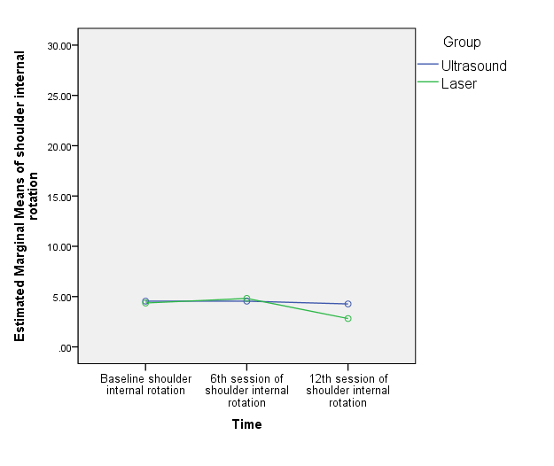
Figure 12: Time vs estimated marginal means of difference of shoulder internal rotation shows no improvement in shoulder internal rotation in both the treatment group.

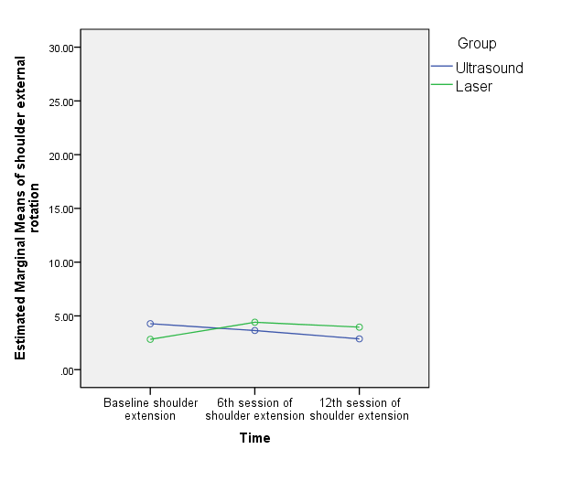
Figure 13: Time vs estimated marginal means of difference of shoulder external rotation shows no improvement in shoulder external rotation in both the treatment groups.

The mean gain in pre-post shoulder range (abduction, external rotation, and extension) in Laser group is linearly increased till 6th session and is decreased progressively in 12th session and follow up as depicted in figure 3, 4 and 6, however in figure 1, shoulder flexion had linear improvement till the end of session in both the groups. The mean gain in pre-post shoulder range (flexion, extension, and external rotation) in ultrasound group is reduced with each session as depicted in figure 1,3 and 6. The shoulder extension ROM in both groups showed a plateau in ROM after 6th session. The was no change in external rotation in the ultrasound group.

Discussion

The aim of the study was to find the effectiveness of ultrasound therapy and laser therapy in pain and shoulder range of motion in patients with adhesive capsulitis.
Present study consists of two groups: ultrasound therapy and laser therapy in which the mean age (SD) of participants in both ultrasound group and Laser group were 56.41±7.320 years and 53.78±11.667 years respectively where female population is affected more than the male population in both the group with percentage of 68.2/31.8 and 59.1/40.9 respectively. Most of the participants were right hand dominant with right hand affected more than left hand. The duration of pain in both the groups was 3.68 ±2.69 and 3.82 ±3.96 respectively. In this study baseline comparison between the group was done, where statistically significant data can be seen in the extension as there is no involvement of extension range of motion in the adhesive capsulitis.
In this study baseline comparison between the groups was done where statistically significant improvement can be seen in the extension as there is no involvement of extension range of motion in the adhesive capsulitis. This study found out the significant improvement in shoulder flexion, shoulder abduction, extension, internal rotation, external rotation within the group analysis. Pain in the groups when analyzed, also revealed statistically significant improvement. When both the treatment groups were compared, there was a significant improvement in flexion in the groups, but more significant improvement can be seen in ultrasound group. It may be because in adhesive capsulitis there is no involvement of flexion pattern.
Dogru et.al reported that the ultrasound therapy group showed greater gain in flexion, internal rotation, and external rotation than ultrasound therapy group but there was no improvement in pain in between the group’s comparison. Ultrasound uses molecular vibration as non-thermal effects in the form of cavitation and microstreaming which increases the cell membrane permeability and soft tissue healing. Molecular vibration is change in to heat energy which increases the extensibility of collagen and tendon which increases the viscosity of the collagen and resolve fibrosis, leading to pain reduction and increase shoulder movement in patients with adhesive capsulitis.[16]
The present study revealed that there is significant improvement in shoulder flexion with 4 weeks of laser therapy. The recorded improvement is comparable with the study done by the Stergioulas who reported the treatment with laser therapy for 8 weeks in participants with adhesive capsulitis shows more improvement in pain intensity, disability score and shoulder range at the end of 4 and 8 weeks of treatment.[10] Studies stated that laser helps in decreasing pain and inflammation by changing prostaglandin E2 concentrations. It also helps in reducing the pain by increasing the blood circulation and removal of wastage substances from the body. Laser therapy reduces muscle pain by decreasing concentration of free oxidative radicals or by stopping axoplasmic transport.[17][18] A study by Reddy et.al, found out that the laser therapy helps in tendon healing and collagen formation. The collagen present in the ligaments and the synovia loses it function in adhesive capsulitis. This in return results in restriction of glenohumeral joint range. Once the collagen around the ligament of glenohumeral joint and the synovia loosens then it may help in increasing the shoulder range of motion.[19] Further, study done by Madani et.al states that any treatment modalities that relieve pain and promote healing can facilitate tendon excursion and increase the active range of motion.[20]
Use of ultrasound also decreased the pain in four weeks of treatment session in this study, which was in tandem with a study done by Robertson VJ et.al. reported the use of ultrasound therapy in treating patients with adhesive capsulitis. The reason behind it may be because of the thermal and non-thermal effects of ultrasound therapy. This is useful in decreasing pain and inflammation that promotes tissue elasticity. The non-thermal effects of ultrasound therapy help in decreasing the symptoms and the prevention of its relapse. The use of ultrasound has also shown a decrease in the rehabilitation time.[21]
Another study done by Anderson et. al. suggested that ultrasound is beneficial by increasing blood circulation as well as decreasing the adhesion in the lymphocytes along with that there is increase in the mast cell which helps in removal of waste material as well as increase in the level of the T-cells helps in maintaining the immunological memory and self-tolerance. It helps in dissolution of the adhesions that were restricting the joint function. It helps in lengthening the shorten tendon and further improving the range of glenohumeral joint.[22]
In the present study, laser also helps in decreasing the pain in the adhesive capsulitis which was similar to the study done by the Bjordal 2010, and Peplow 2010 which suggest that laser therapy is effective in pain relief with decrease in pro-inflammatory cytokines levels and increases cytokines level of anti-inflammatory growth factor. Laser therapy has an effect of photochemical reactions in cells which is known as photobioactivation which produces its physiological and therapeutic effects by producing energy to disturb orbits of local electron. It starts the exchange of chemicals and produces free radicals at the cell membrane. This helps in decreasing inflammation healing of the tissue and later causes decrease in pain tolerance level (Robertson et al 2006, Watson 2000). The effects of laser therapy are dependent upon dosage, wavelength, site as well as duration of treatment.[23]
Another study done by Hawkins et. al, found that the target cells from mitochondria and cell membranes absorbed the photon from a laser probe. Photon emitted by laser changes into chemical energy within the cell, in the form of Adenosine triphosphate (ATP), which helps in regulation of cell function which increases the healing of the tissue and cause pain relief. [24]
The present study also included the Maitland mobilization in both the groups which was given in AP, PA, and inferior glide for 2-3 glides for 30 seconds and 5 rest in between for 5 repetition which may have improvement in shoulder range and pain intensity. The study done by Kumar et.al, in which Maitland mobilization technique with the addition of exercises has helped in decreasing pain and improving R.O.M. and shoulder function. It may be because when gliding force is given during mobilization to parts of capsule of glenohumeral joints which may create stress to that part leading to breaking up of adhesions and realignment of collagen. Furthermore, mobilization techniques help in exchange of nutrients in the capsule as well as maintain the joint integrity and increases the blood flow which may help in reducing the pain as well as removal of waste substances. Maitland’s mobilization involves the rhythmic and oscillatory movement pattern that trigger mechanoreceptors(type-2) and helps in inhibiting the nociceptive receptors(type-4) which eventually helps in relieving pain.[12]
A study conducted in year 2012 by Kumar et.al, to assess the effect of Maitland mobilization technique in treating primary adhesive capsulitis where he found that when mobilization is combined with shoulder exercises then it may help in decreasing the pain intensity and improving the shoulder motion which later increases the shoulder function. When the mobilization is given, it increases the pressure gradients which causes exchange of fluids in the vessels of nerve fibers that supply the avascular cartilage and bringing the nutrient to that area which later causes decreases in ischemia, edema, and inflammation at that joint causing decrease in joint effusion. This helps in pain modulation by decreasing the pressure over nerve endings.[15][26]

Future recommendations
Further trials can be done by including the control group to see further effects of ultrasound and laser in patients with adhesive capsulitis.

Conclusion
Both treatment modalities are effective in decreasing pain and increasing shoulder range of motion but Ultrasound therapy along with Maitland mobilization was more effective in increasing shoulder flexion range of motion in adhesive capsulitis as compared to laser therapy along with Maitland mobilization.

References

- Levangie PK, Norkin CC. Joint Structure and Function. Philadelphia, PA: F.A. Davis Company; 2005.
- Neumann DA. Kinesiology of the musculoskeletal system: Foundations for rehabilitation. 3rd ed. St. Louis, MO: Mosby; 2016.
- Tasto JP. James P et al 2007,’ Adhesive Capsulitis. Sports Medicine and Arthroscopy Review. 2007;15(4):216–21.
- Brent Brotzman S, Manske C. Clinical Orthopedic rehabilitation: an evidence-based approach. Philadelphia: Elsevier Mosby; 2011.
- Mezian K, Coffey R, Chang K-V. Frozen Shoulder. StatPearls Publishing; 2022
- Whelton C.’ Review of diabetic frozen shoulder. Eur J Orthop Surg Traumatol. 2017.
- Mahendran J. Efficacy of ultrasound with Maitland mobilization over short wave diathermy with Maitland mobilization in improving the functional performance of patients with periarthritis patients. International Journal of Physiotherapy and Research. 2014;2(4):621–5
- Morishita K, Karasuno H, Yokoi Y, Morozumi K, Ogihara H, Ito T, et al. Effects of therapeutic ultrasound on range of motion and stretch pain. J Phys Ther Sci [Internet]. 2014;26(5):711–5. Available from: http://dx.doi.org/10.1589/jpts.26.711
- Soliman S. Therapeutic effects of Low-level laser and reflexology on adhesive capsulitis in elderly type 2 diabetics patients. 2014; 7:317–21.
- Stergious A. Low-Power Laser Treatment in Patients with Frozen Shoulder: Preliminary Results. Photomedicine and Laser Surgery. 2008;26(2):1–7.
- Elhafez HM. Axillary ultrasound and laser combined with post isometric facilitation in treatment of adhesive capsulitis: A randomized clinical trial. Journal of Manipulative and Physiological Therapeutics. 2014;39(2):331–88.
- Ansari S. Effect of ultrasound therapy with end range mobilization over cryotherapy with capsular stretching on pain in frozen shoulder- A comparative study. Int J Cur Res Rev. 2012; 04:68–72.
- Alarab A, Shameh RA, Shaheen H, Ahmad MS. Shock Wave Therapy and Ultrasound Therapy plus Exercises for Frozen Shoulder Joint Clients. Adv Nursing Patient Care Int J 2018; 1(2): 180010

- Leggin BG, Michener LA, Shaffer MA, Brenneman SK, Iannotti JP, Williams GR Jr. The Penn shoulder score: reliability and validity. J Orthop Sports Phys Ther [Internet]. 2006;36(3):138–51. Available from: http://dx.doi.org/10.2519/jospt.2006.36.3.138
- Lin J-J.’ Reliability and validity of shoulder tightness measurement in patients with stiff shoulders. Manual Therapy. 2006; 11:146–52.
- Sheri A. Efficacy of Maitland mobilization in frozen shoulder. European Journal of Biomedical and Pharmaceutical Sciences. 2018; 12:22–7.
- Effectiveness of therapeutic ultrasound in adhesive capsulitis* Hacer Dogru, Sibel Basaran*, Tunay Sarpel
- Bjordal JM, Lopes-Martins RA, Iversen VV. A randomized, placebo-controlled trial of low-level laser therapy for activated Achilles tendinitis with micro dialysis measurement of peritendinous prostaglandin E2 concentrations. Br J Sports Med 2006;40(1):76-80
- Albertini R, Villaverde AB, Aimbire F, Salgado MA, Bjordal JM, Alves LP, et al. Anti-inflammatory effects of low-level laser therapy (LLLT) with two different red wavelengths (660 nm and 684 nm) in carrageenan-induced rat paw edema. J Photochem Photobiol B 2007;89(1):50-5.
- Reddy GK, Stehno-Bittel L, Enwemeka CS. Laser photostimulation of collagen production in healing rabbit Achilles tendons. Lasers Surg Med 1998;22(5):281-7
- Madani AS, Ahrari F, Nasiri F, Abtahi M, Tunér J. Low-level laser therapy for management of TMJ osteoarthritis. Cranio [Internet]. 2014;32(1):38–44. Available from: http://dx.doi.org/10.1179/0886963413Z.0000000004
- Robertson VJ, Baker KG. A review of therapeutic ultrasound: Effectiveness studies. Phys Ther 2001; 81:1339e50.
- Anderson DW, Barrett JT. Depression of phagocytosis by ultrasound. Ultrasound Med Biol. 1981;7(3):267-73
- Thompson. Tidys Physiotherapy Bie 12 Edition: An International Edition. 12th ed. Oxford, England: Butterworth-Heinemann; 1991
- Hawkins D, Houreld N, Abrahamse H. Low level laser therapy (LLLT) as an effective therapeutic modality for delayed wound healing. Ann N Y Acad Sci [Internet]. 2005;1056(1):486–93. Available from: http://dx.doi.org/10.1196/annals.1352.040
- Kumar A, Kumar S, Aggarwal A, Kumar R, Das PG. Effectiveness of Maitland techniques in idiopathic shoulder adhesive capsulitis. ISRN Rehabil [Internet]. 2012; 2012:1–8. Available from: http://dx.doi.org/10.5402/2012/710235

Appendices

Appendix – I

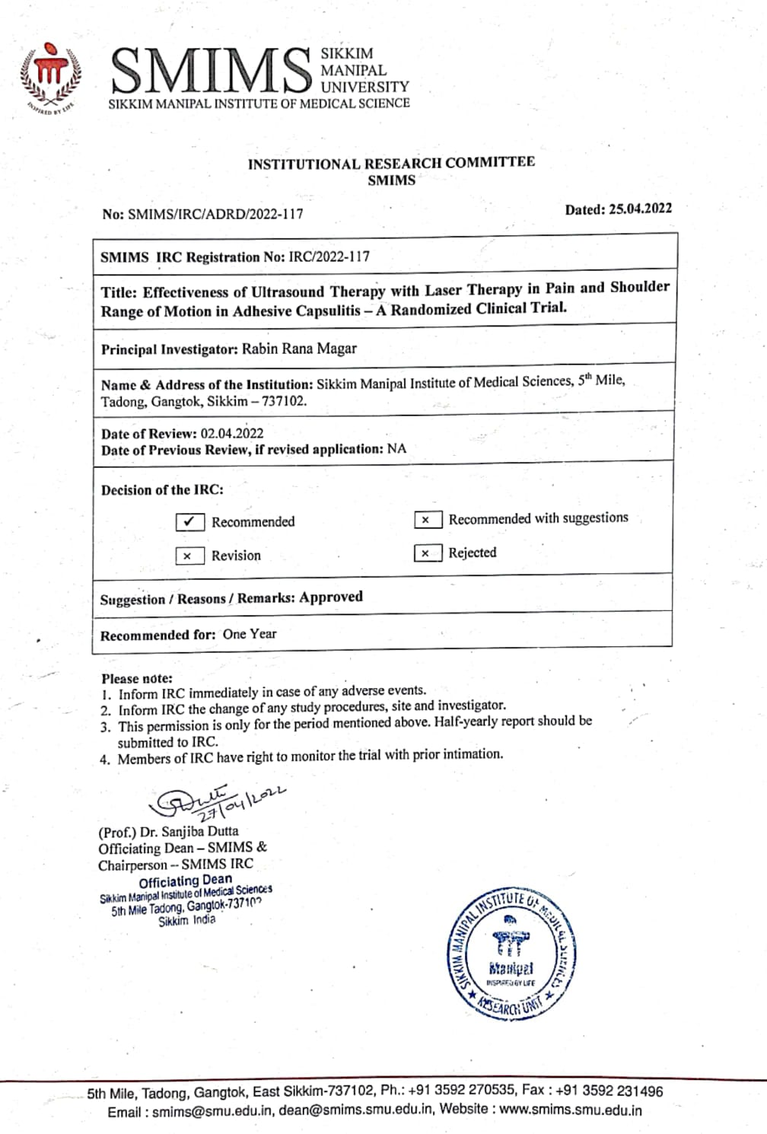

Appendix – II

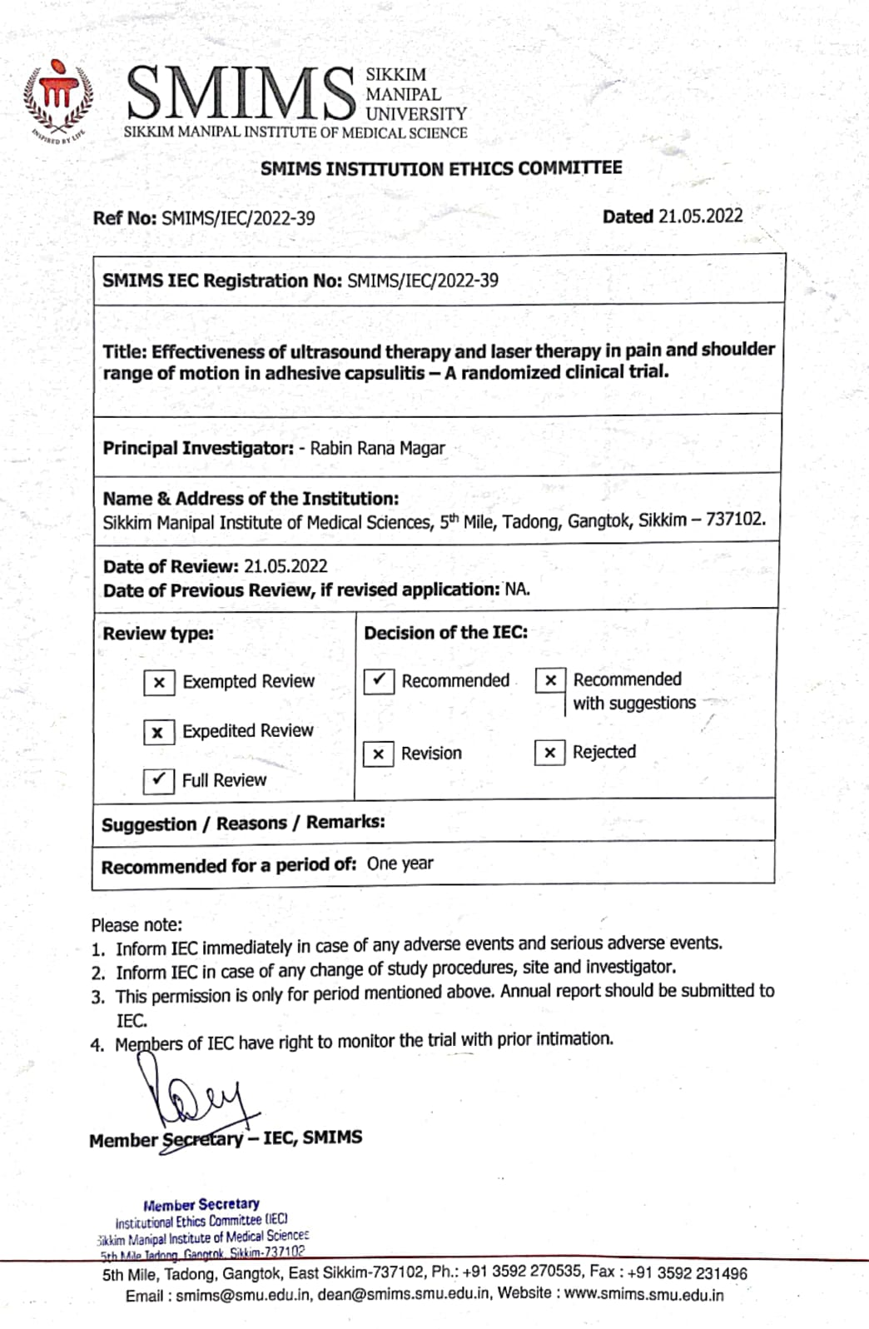

Appendix – III
Plagiarism check- Turnitin software



Appendix – IV

Participant Information Sheet

Study title: Effectiveness of ultrasound therapy and laser therapy in pain and shoulder range of motion in adhesive capsulitis- A Randomized Clinical Trial Study

Principle investigator: Rabin Rana Magar
Designation: Student pursuing Masters in Physiotherapy, SMCPT
Mobile number: 9019683129

Please read this form carefully. If you do not understand the language or any information in the document, please discuss with study doctor. Your participation in this study is voluntary, and you can enquire about all details before giving your written consent for the study.

- Introduction to the Research study:
This study is conducted to compare the effectiveness of ultrasound therapy with laser therapy in patients with adhesive capsulitis.

- Purpose of the study:
This study will help to decrease the multi modal treatment approaches for adhesive capsulitis to regain the normal ROM & reduce pain and to find which one is better between ultrasound and laser therapy.

- What will happen during the study?
Patients range of motion of shoulder joint will be taken three times a session that will be pre and post treatment on 1st ,6th, and 12th session. Patients will be getting two different modalities in their anterior and lateral border of acromion along with that patient will be getting mobilization in three slides that is anterior posterior glide, posterior anterior glide, and inferior glide in supine and prone position.

- What are the risks?
There are minimal risks involved in this study. Patients may present with inflammation, tenderness, burning, etc. which will be take care properly.

- Benefits to the participant:
There might be improvements seen in your physical activity, psychosocial and overall well-being.

- Compensation for injury:
There shall be no incentives/ remuneration for the data collected from you. Moreover, all the tests and interventions will be performed free of charge. However, any advice which pertains to hospital treatment costs towards physiotherapy services will be waived off only during the study period. If there is an acute exacerbation during the exercise, then I will be taking care of the patient’s later hospitalization and expenses.

- Confidentiality of information:
On completion of this study all your personal details will be made anonymous to ensure confidentiality of your participation. By enrolment to this research study, you are requested to follow only the intervention protocol instructed/ prescribed. Any other interventions undertaken by yourself may affect the study outcomes; hence your compliance is solicited. Noncompliant study subjects may have to be dropped from this study by the investigator.

- Whom to contact in case of any questions?
If you experience adverse effects because of taking part in this study, you may contact the Principal Investigator Rabin Rana Magar
If you have any questions about the informed consent process or your rights as a participant, the Principal Investigator shall give you details of the Member Secretary SMIMS IEC.
If you have any questions about this form or any study related issue, you may also contact the following person.
Name: Dr Pratik Chettri (PT)
Address: Dept. Of Physiotherapy, CRH, Manipal
Telephone No.: 9734941648

Appendix – V
सहभागी सूचना पत्र

अध्ययन शीर्षक: अल्ट्रासाउन्ड थेरापीको प्रभावकारिताको तुलनामा लेजर थेरापीको साथ दुखाइ र टाँसिने क्याप्सुलाइटिसमा गतिको काँध दायरा - एक अनियमित क्लिनिकल परीक्षण अध्ययन

सिद्धान्त अन्वेषकः रविन राना मगर
पदनाम: फिजियोथेरापी, SMCPT मा स्नातकोत्तर गर्दै विद्यार्थी
मोबाइल नम्बर : 9019683129

कृपया यो फारम ध्यानपूर्वक पढ्नुहोस्। यदि तपाईंले कागजातको भाषा वा कुनै जानकारी बुझ्नुभएको छैन भने, कृपया अध्ययन चिकित्सकसँग छलफल गर्नुहोस्।यस अध्ययनमा तपाईंको सहभागिता स्वैच्छिक हो, र तपाईंले अध्ययनको लागि आफ्नो लिखित सहमति दिनु अघि सबै विवरणहरूको बारेमा सोधपुछ गर्न सक्नुहुन्छ।

1. अनुसन्धान अध्ययनको परिचय:
यो अध्ययन टाँसिने क्याप्सुलाइटिस भएका बिरामीहरूमा अल्ट्रासाउन्ड थेरापीको प्रभावकारितालाई लेजर थेरापीसँग तुलना गर्नको लागि गरिन्छ।

२. अ यस अध्ययनले सामान्य ROM पुन: प्राप्त गर्न टाँसिने क्याप्सुलाइटिसको लागि बहु मोडल उपचार दृष्टिकोणहरू कम गर्न मद्दत गर्नेछ।ध्ययनको उद्देश्य:

३. अध्ययनको क्रममा के हुनेछ?
काँधको जोर्नीको गतिको बिरामी दायरा एक सत्रमा तीन पटक लिइनेछ जुन 1st, 6th र 12th सत्रमा पूर्व र पोस्ट उपचार हुनेछ। विरामीले आफ्नो एन्टरियर र पार्श्व किनाराको एक्रोमियनमा दुई फरक मोडालिटीहरू प्राप्त गर्नेछन् र ती बिरामीले तीनवटा स्लाइडहरूमा मोबिलाइजेसन पाउनेछन् जुन अघिल्लो पोस्टेरियर ग्लाइड, पोस्टरियर एन्टरियर ग्लाइड र सुपिन र प्रोन पोजिसनमा इन्फिरियर ग्लाइड हो।

4. जोखिमहरू के हुन्?
यस अध्ययनमा संलग्न न्यूनतम जोखिमहरू छन्। रोगीहरूमा सूजन, कोमलता, जलन, आदि हुन सक्छ जसको उचित हेरचाह गरिनेछ।

5. सहभागीलाई लाभहरू:
तपाईंको शारीरिक गतिविधि, मनोसामाजिक र समग्र कल्याणमा सुधारहरू देख्न सकिन्छ।

६. चोटपटकको क्षतिपूर्ति:
तपाईंबाट सङ्कलन गरिएको डाटाको लागि कुनै प्रोत्साहन/ पारिश्रमिक हुनेछैन। यसबाहेक, सबै परीक्षण र हस्तक्षेप नि: शुल्क प्रदर्शन गरिनेछ। यद्यपि, फिजियोथेरापी सेवाहरूमा अस्पतालको उपचार खर्चसँग सम्बन्धित कुनै पनि सल्लाह अध्ययन अवधिमा मात्र माफ गरिनेछ। यदि व्यायामको क्रममा तीव्र उत्तेजना छ भने, म बिरामीको पछिको अस्पतालमा भर्ना र खर्चको हेरचाह गर्नेछु।

७. सूचनाको गोपनीयता:
यो अध्ययन पूरा भएपछि तपाइँको सहभागिताको गोपनीयता सुनिश्चित गर्न तपाइँको सबै व्यक्तिगत विवरणहरू गुमनाम गरिनेछ। यस अनुसन्धान अध्ययनमा नामांकन गरेर, तपाईंलाई निर्देशन दिइएको/निर्धारित हस्तक्षेप प्रोटोकल मात्र पालना गर्न अनुरोध गरिन्छ। आफैले गरेको कुनै पनि अन्य हस्तक्षेपले अध्ययनको नतिजालाई असर गर्न सक्छ; त्यसैले तपाईको अनुपालन अनुरोध गरिएको छ। गैर-अनुकूल अध्ययन विषयहरू यस अध्ययनबाट अन्वेषकद्वारा छाड्नु पर्ने हुन सक्छ।

8. कुनै प्रश्न भएमा कसलाई सम्पर्क गर्ने?
यदि तपाईंले यस अध्ययनमा भाग लिँदा प्रतिकूल प्रभावहरू अनुभव गर्नुभयो भने, तपाईंले प्रमुख अन्वेषक रविन राना मगरलाई सम्पर्क गर्न सक्नुहुन्छ।
यदि तपाइँसँग सूचित सहमति प्रक्रिया वा एक सहभागीको रूपमा तपाइँको अधिकारको बारेमा कुनै प्रश्नहरू छन् भने, प्रमुख अन्वेषकले तपाइँलाई सदस्य सचिव SMIMS IEC को विवरण दिनुहुनेछ।
यदि तपाइँसँग यो फारम वा कुनै अध्ययन सम्बन्धित मुद्दाको बारेमा कुनै प्रश्नहरू छन् भने, तपाइँ निम्न व्यक्तिलाई पनि सम्पर्क गर्न सक्नुहुन्छ।
नाम: डा प्रतीक क्षेत्री (PT)
ठेगाना: फिजियोथेरापी विभाग, CRH, मणिपाल
टेलिफोन नम्बर: 9734941648

Appendix - VI

Informed Consent
Study Title: “Effectiveness of ultrasound therapy and laser therapy in pain and shoulder range of motion in adhesive capsulitis- A Randomized Clinical Trial Study”
I Mr./MS ………………………………. has been informed thoroughly about the study and my participation is voluntary. I understand that there is no harmful procedure in this study; there are no direct or immediate benefits from this study. The study aim is to check the effectiveness of ultrasound therapy and laser therapy in pain and shoulder range of motion in adhesive capsulitis.
I consent to provide medical information (if necessary) relevant clinical information to the researcher team if necessary. I understand that this information will not be used to identify me.
I am free to withdraw from the study anytime if I am not comfortable with the study.
Full name of the participant-
Full postal address-
Contact no-
Email-
Date: ____________________
Signature/Thumb impression of respondent
Date: ____________________
Signature/Thumb impression of witness
Date: ____________________
Signature of the researcher

Appendix – VII

सूचित सहमती पत्र

शीर्षक: : अल्ट्रासाउन्ड थेरापीको प्रभावकारिताको तुलनामा लेजर थेरापीको साथ दुखाइ र टाँसिने क्याप्सुलाइटिसमा गतिको काँध दायरा - एक अनियमित क्लिनिकल परीक्षण अध्ययन

म श्री / श्रीमती ………………………………। अध्ययनको बारेमा राम्ररी जानकारी दिइएको छ र मेरो सहभागिता स्वैच्छिक हो। म बुझ्दछु कि यस अध्ययनमा कुनै हानिकारक प्रक्रिया छैन; त्यहाँ यी अध्ययनबाट कुनै सीधा वा तत्काल फाइदा छैन। अध्ययनको उद्देश्य जमेको काँधका बिरामीहरूमा अल्ट्रासाउन्ड र लेजरको प्रभावकारिता ,र भविष्यवाणीको लागि मानक मानहरू विकास गर्न हो।म आवश्यक भएमा अनुसन्धान टोलीलाई चिकित्सा जानकारी प्रासंगिक क्लिनिकल जानकारी प्रदान गर्न सहमत गर्दछु। मैले बुझें कि यो जानकारी मलाई पहिचान गर्न प्रयोग हुने छैन। म अध्ययन संग कुनै पनि समय फिर्ता लिन स्वतन्त्र छु यदि म अध्ययन संग सहज छैन।
सहभागीको पूरा नाम-
पूरा हुलाक ठेगाना-
संपर्क नम्बर-ईमेल-
मिति: ____________________
उत्तरदाताको हस्ताक्षर / औंठा छापमिति: ____________________
साक्षीको हस्ताक्षर / औंठा छापमिति:
____________________

APPENDIX-VIII
Procedure picture
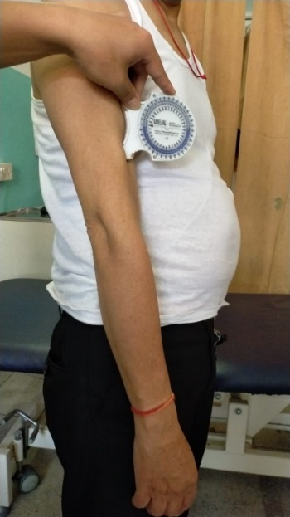 | 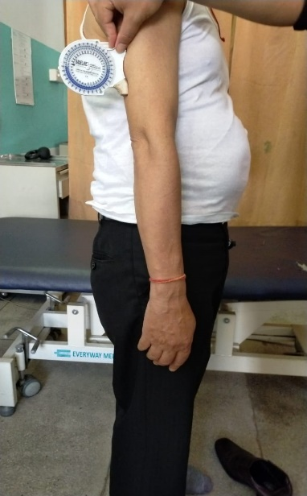
Figure : Shoulder flexion ROM | Figure : Shoulder extension ROM
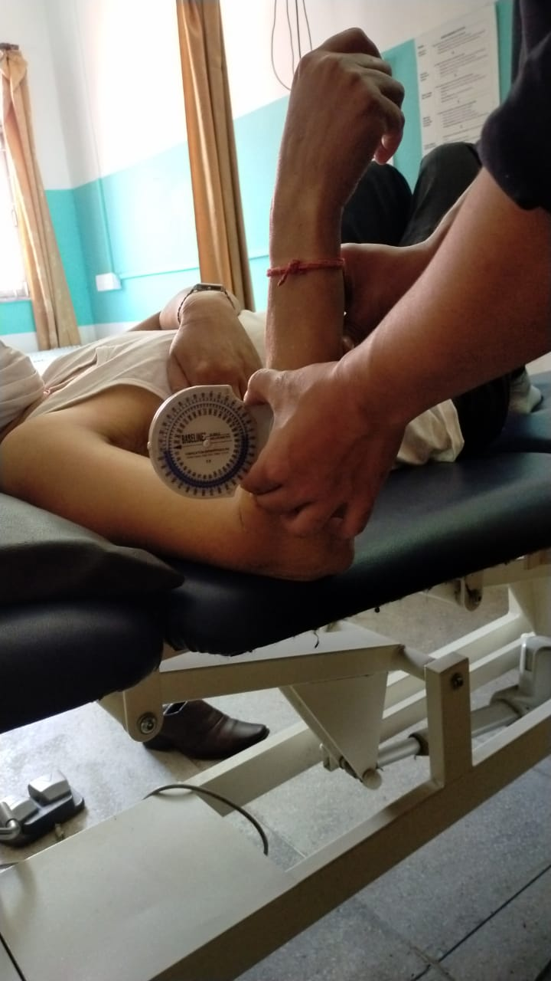 | 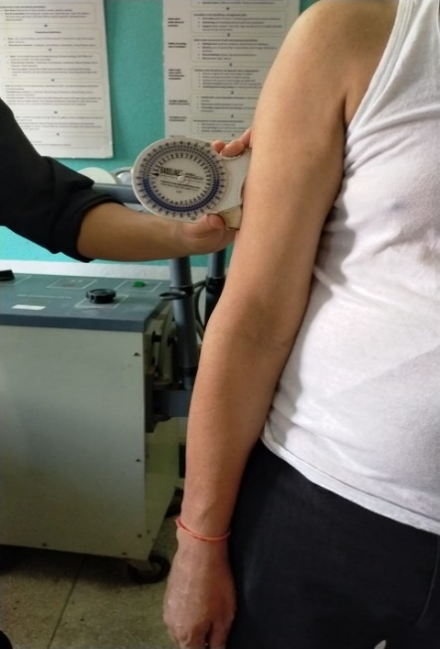
Figure: Shoulder internal and external rotation ROM | Figure: Shoulder abduction ROM
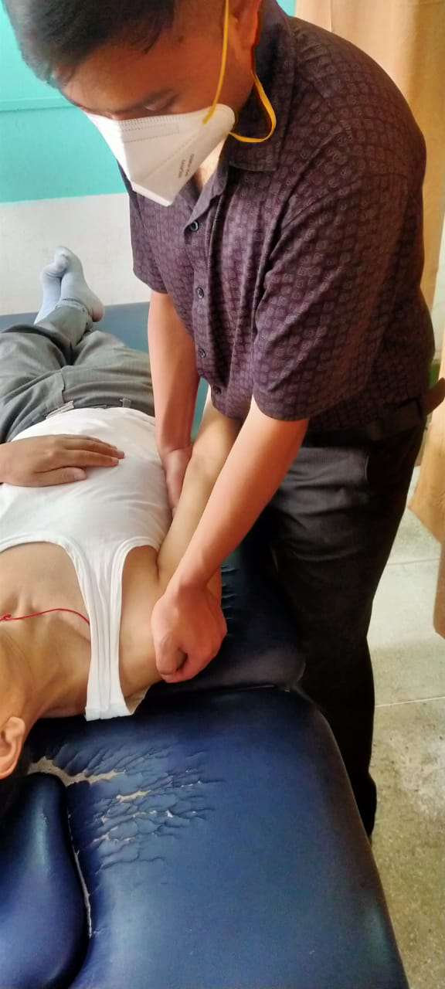 | 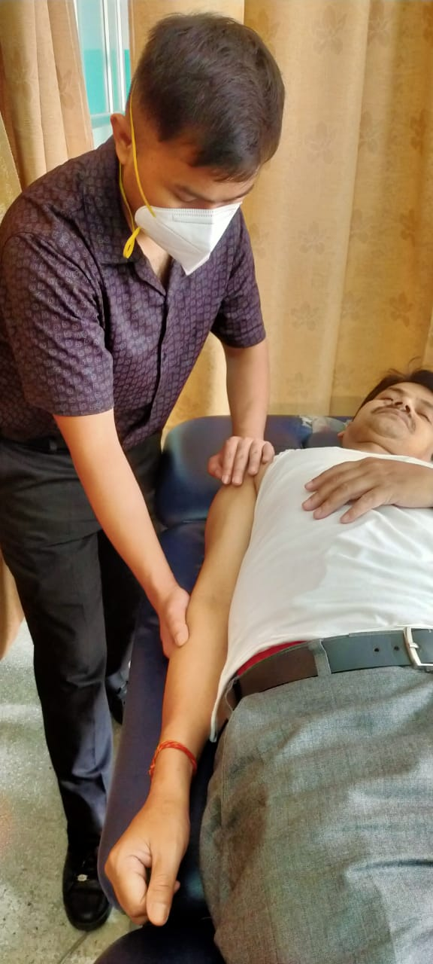
Figure: A-P glide | Figure: Inferior glide
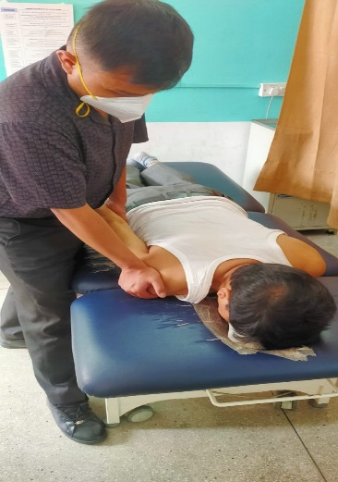 | 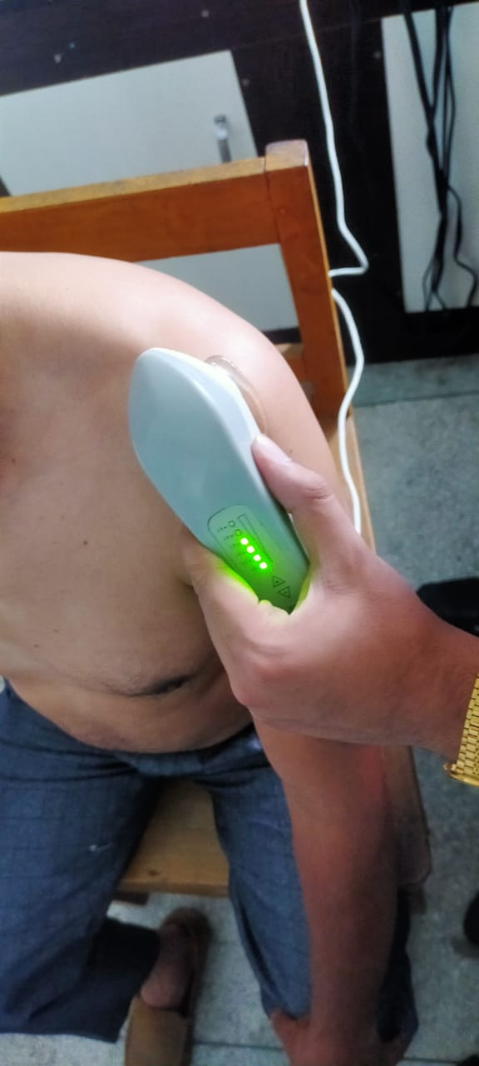
Figure: P-A glide | Figure: Ultrasound group (Group-A)
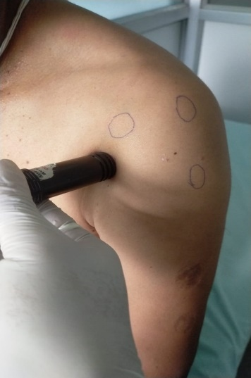
Figure: Laser group (Group-B)

Appendix-IX

Screening Performa

- First patients will be coming to the physiotherapy department and patients with the shoulder pain will be assisting according to the inclusion and the exclusion criteria.
- Demographic data was taken.
- Shoulder Rom was taken.
- Capsular pattern of involvement was check.
- scratch neck test was performed.
- Grade 1 and grade 2 stage of adhesive capsulitis was identified.

Appendix -X

DATA COLLECTION FORM
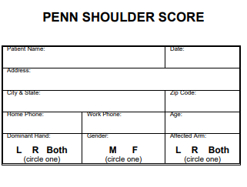

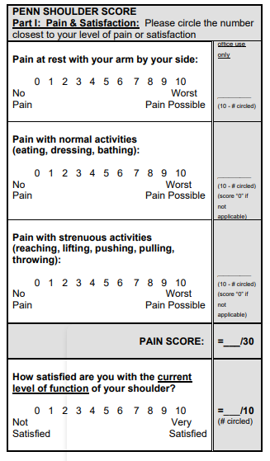

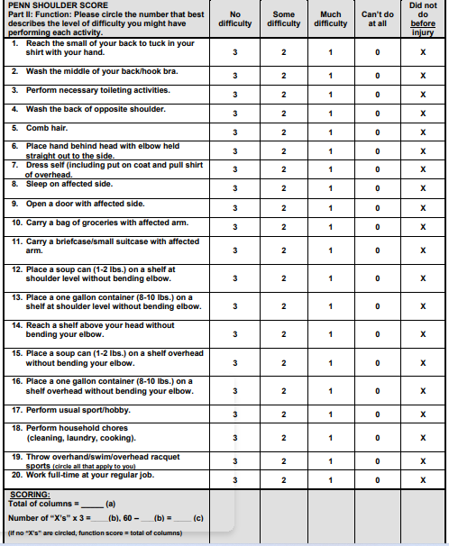

Baseline data Date:
Range of motion | Pre- treatment | Post-treatment
Flexion
Abduction
Extension
Internal rotation
External rotation

6th session Date:
Range of motion | Pre- treatment | Post-treatment
Flexion
Abduction
Extension
Internal rotation
External rotation

12th session Date:
Range of motion | Pre- treatment | Post-treatment
Flexion
Abduction
Extension
Internal rotation
External rotation

